Oracle 11g Installation Experience
(Jule 2008)
Peter Ping Liu

The following documented my experience with installation of Oracle 11g enterprise edition. Please note that your experience may vary depedning upon your system.

Computer: EIU# 154862
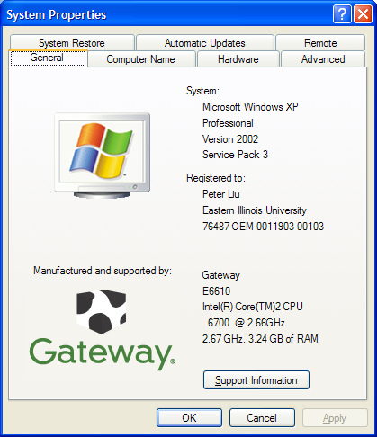
Windows XP Professional, SP 3

- Use the following link to download Oracel Enterprise Edition 11g: http://www.oracle.com/technology//index.html
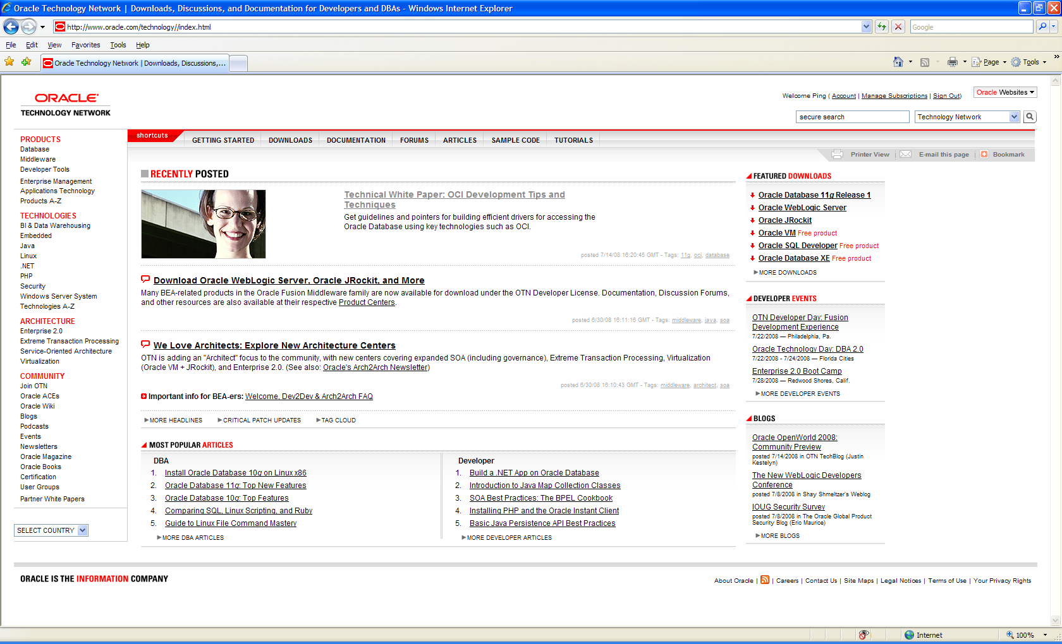
- Select Downloads—Database
- Select Microsoft Windows (32 bit): Unless you deal with real big servers, most probably your machine is a 32 bit. For my case, I selected “Oracle Database 11g Release 1 (11.1.0.6.0)
for Microsoft Windows (32-bit).”
- You will need to create a user account in order to download software. EIU has a lincense agreement with Oracle. Thus, you may legally download and use the Oracle products for our academic purpose.
- You need to accept the license agreement and download the zip file into your computer. Please note the download is a time consuming process. The file size is about 1.73 GB as of release 1. Plan accordingly.
- You need to unzip (extract) the zip file. For example, Iused “Extract All.” You will see something as follows.
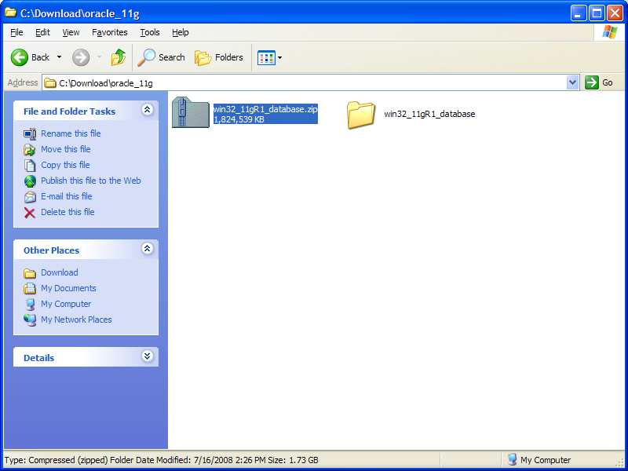

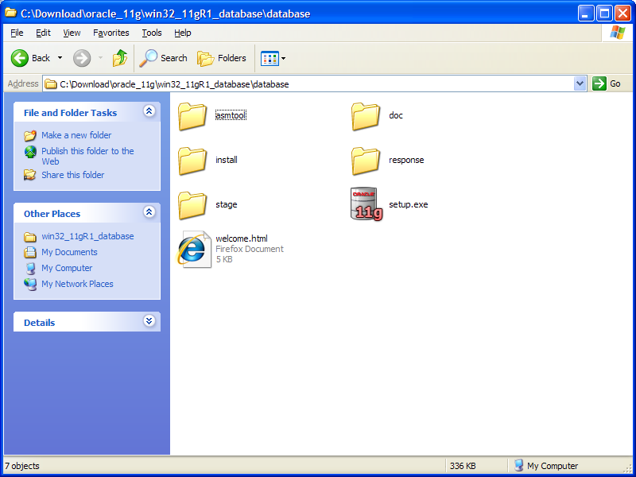

- When you start running a program, you may encounter the securiyt alert such as the one that follows. Click “Unblock.”
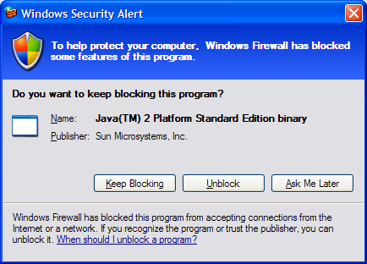
- Double click the setup.exe to run the Oracle Universal Installer.
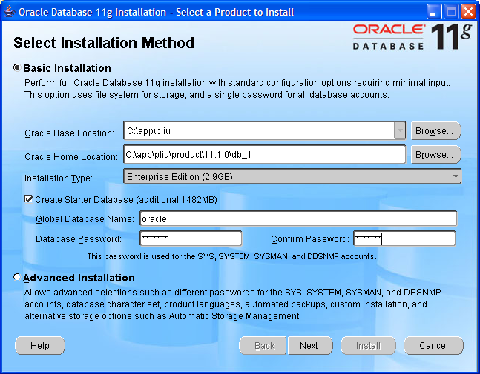
- I chose Basic Installation. Please take a note on the password you entered. My Global Database Name was oracle. You may use different name if you like (the default was orcl).
- Click Next. The installer check all system requirement. For my system, everything succeeded with a warning on network. Since this is only used as a development evironment, it does not affect. Click Next.
- You may skip the Oracle Configuration Manager Registration. Metalink is meant to organizations with service agreement with Oracle. Click Next.
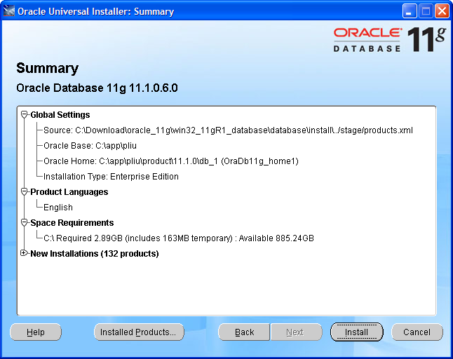
- After reviewing the product list, click Next.
- You may watch all the promotions from Oracle as the installer cranks the computer.
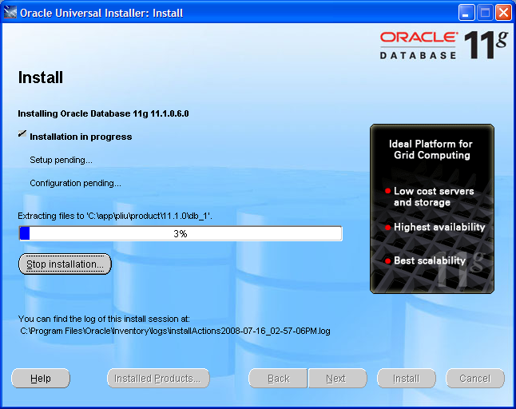
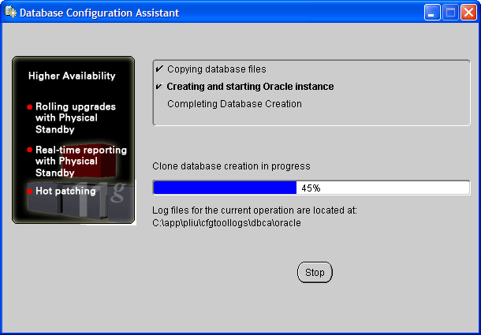
- The following page has valuable information regarding your database, particularly on Oracle Enterprise Manager (EM). Please do a screen shot and save it somewhere.
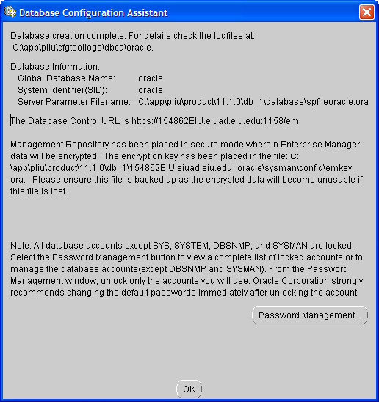
- Click “OK.”
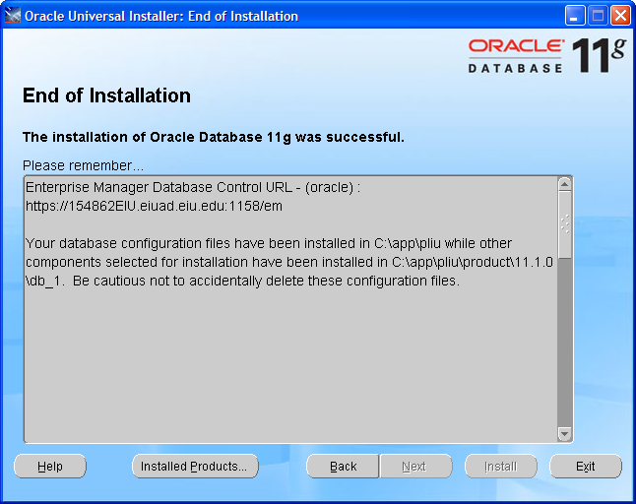
I would copy the following message and save them for future reference.

Enterprise Manager Database Control URL - (oracle) :
https://154862EIU.eiuad.eiu.edu:1158/em

Your database configuration files have been installed in C:\app\pliu while other components selected for installation have been installed in C:\app\pliu\product\11.1.0\db_1. Be cautious not to accidentally delete these configuration files.
- Click “Exit” and confirm it.
- You may test your database access after intallation. You may go: Start—All Programs –Oracle –Application Development—SQL Plus. Login with user name: system, and password (you entered ealier during installation.)
- After login, you may type “Show User.” The result will be similar to the following.
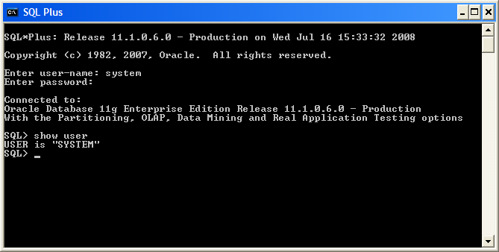
- I noticed that in my installation, the SQL Plus for windows no longer comes with Oracle 11g. I do not understand why. Well, for the time being, as long as we have the above screen, we are still ok.
- You may also login Oracle Enterprise Manager (EM), in microcomputer installation, which is also known as Database Control Console. Use the following link in your browser (Internet Explorer or Firefox).
- You may use user name of “system”, and password you entered earlier, and connect as normal.
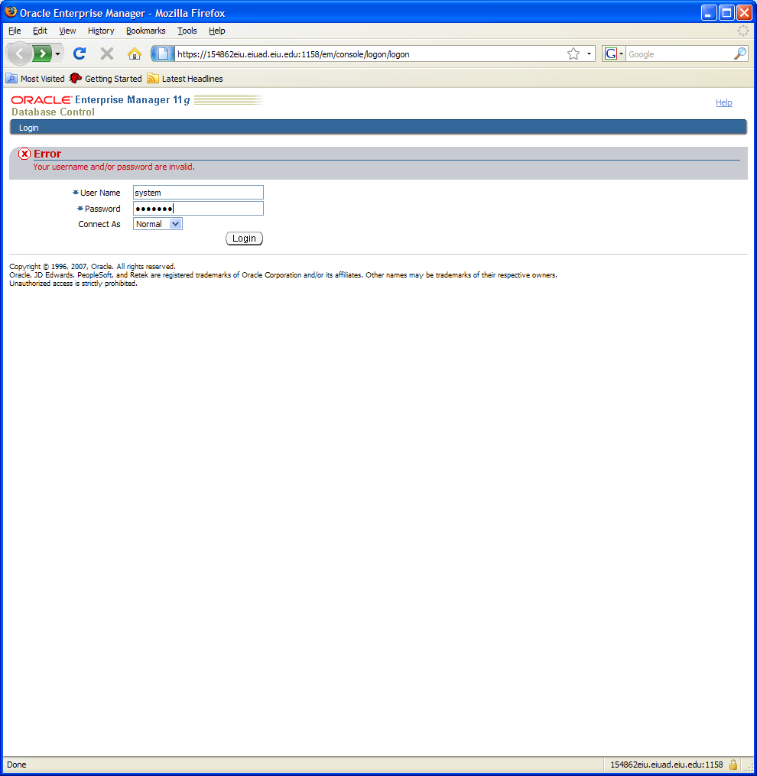
- Oracle Enterprise Manager is a graphic user interface (GUI) for managing the database. You will have some experience with it. Hoever, it does not require a class to run it. Thus, it is not the emphasis of this class.
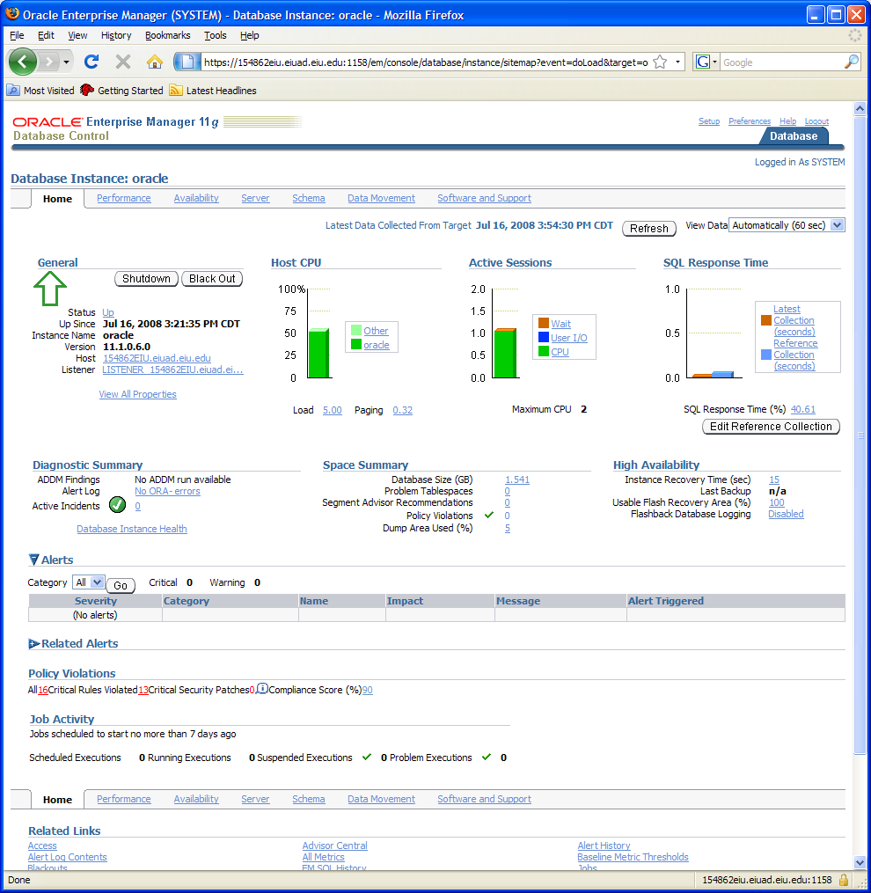
- You will have the following experience for your project 2: Click Server—Security—User
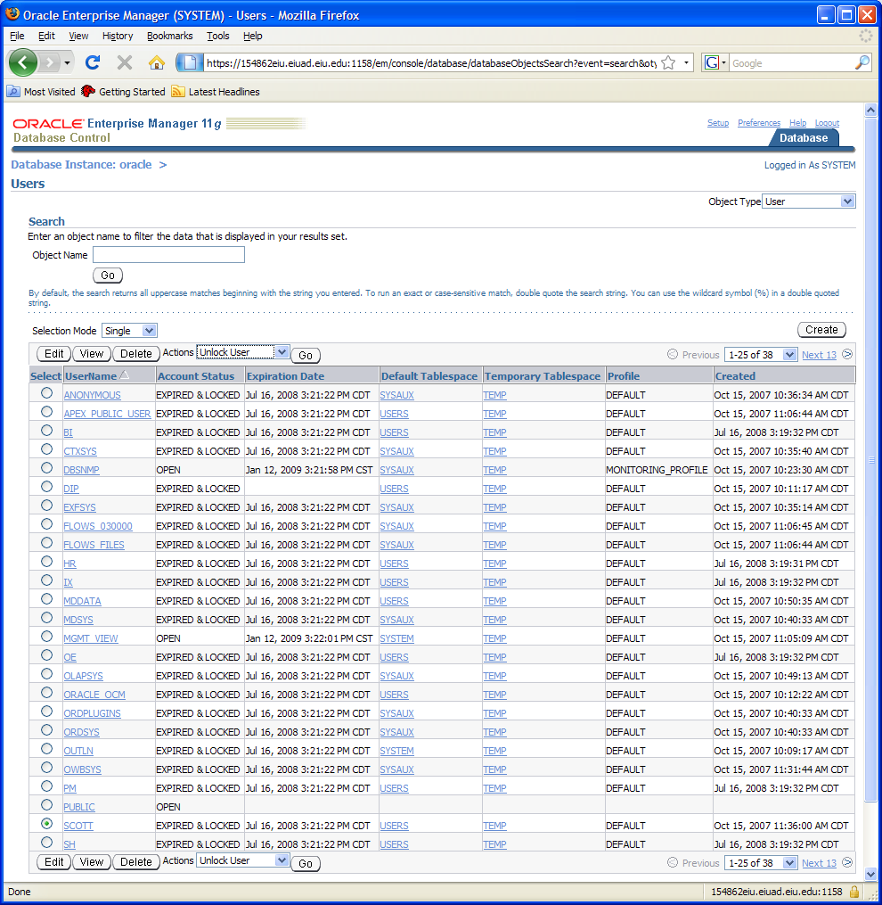
- Select the radio button in front of SCOTT and select Unlock User action and Go.
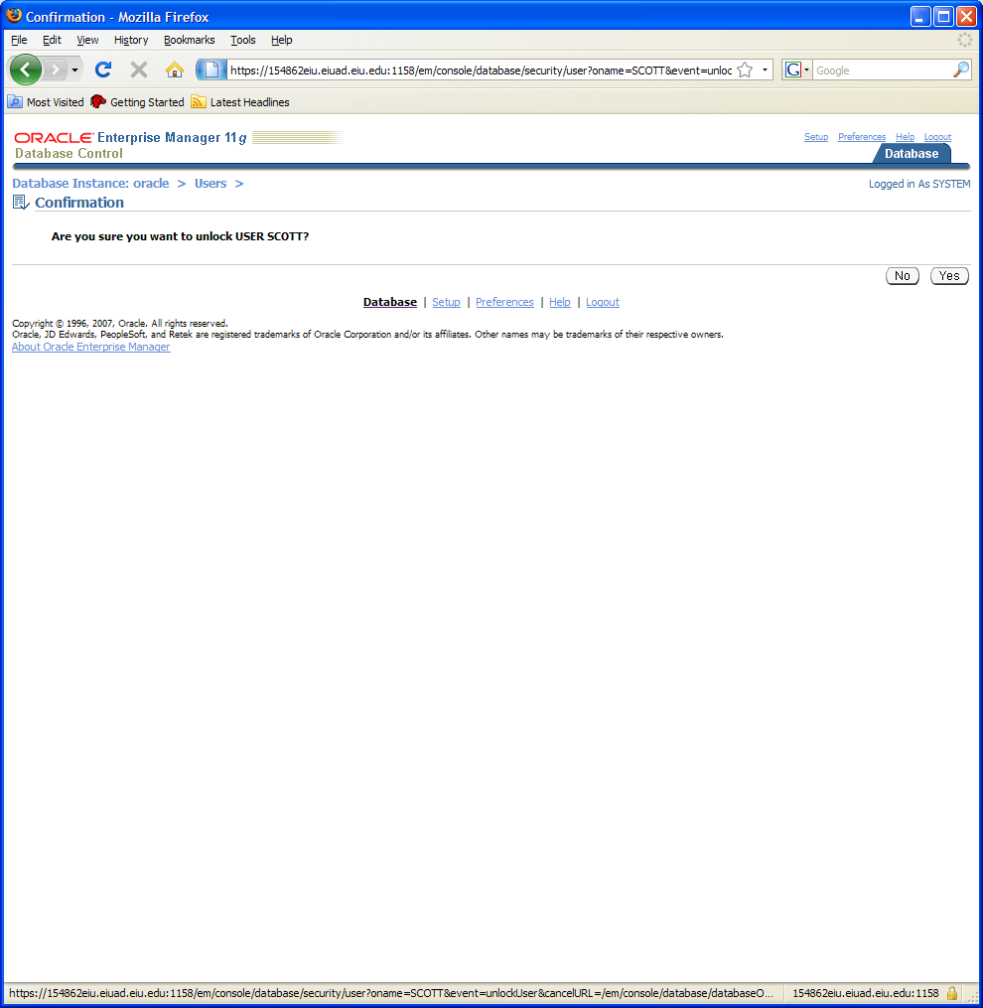
- Confirm it.
- You may also select SCOTT and click Edit.
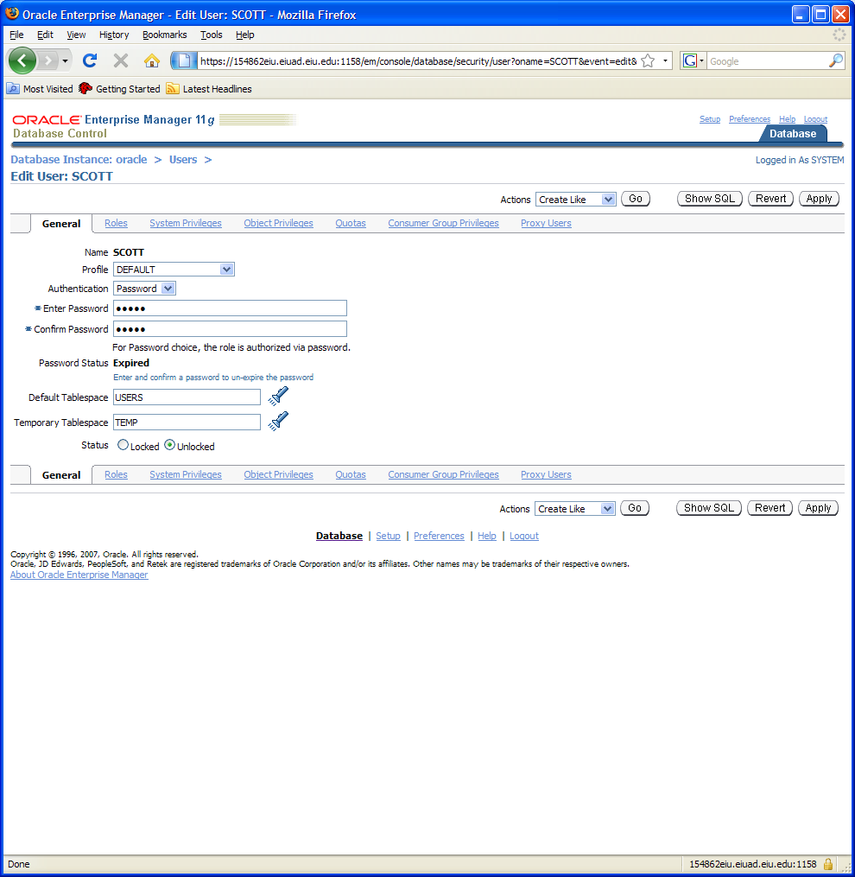
- Type in the password. In the profession, this account was known as scott/tiger. I will use it for practice purpose.
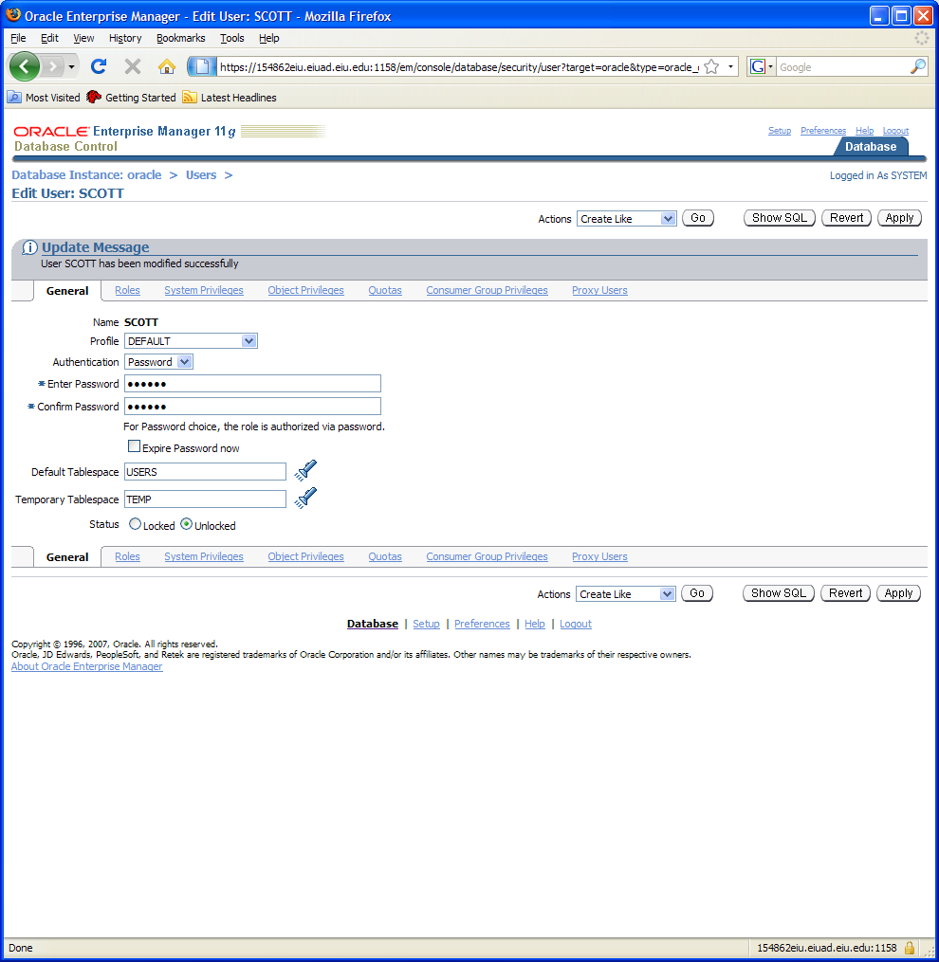
- You have changed the password and unlocked the account. You should be able to connect the acccount on SQL Plus as well.
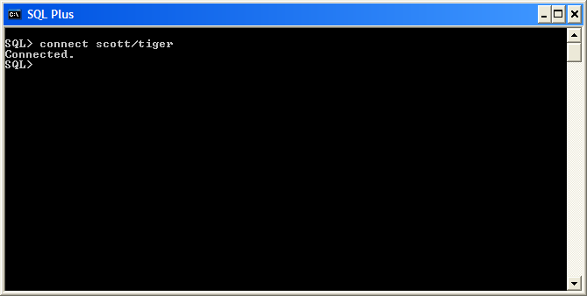
Congratulatins.
You have made your database accessible for practice. Have fun with it.

PS: If you look for something similar to Microsoft SQL Server interface, Oracle has SQL Developer. You may select Start—All Programs--Oracle Home—Application Development—SQL Developer
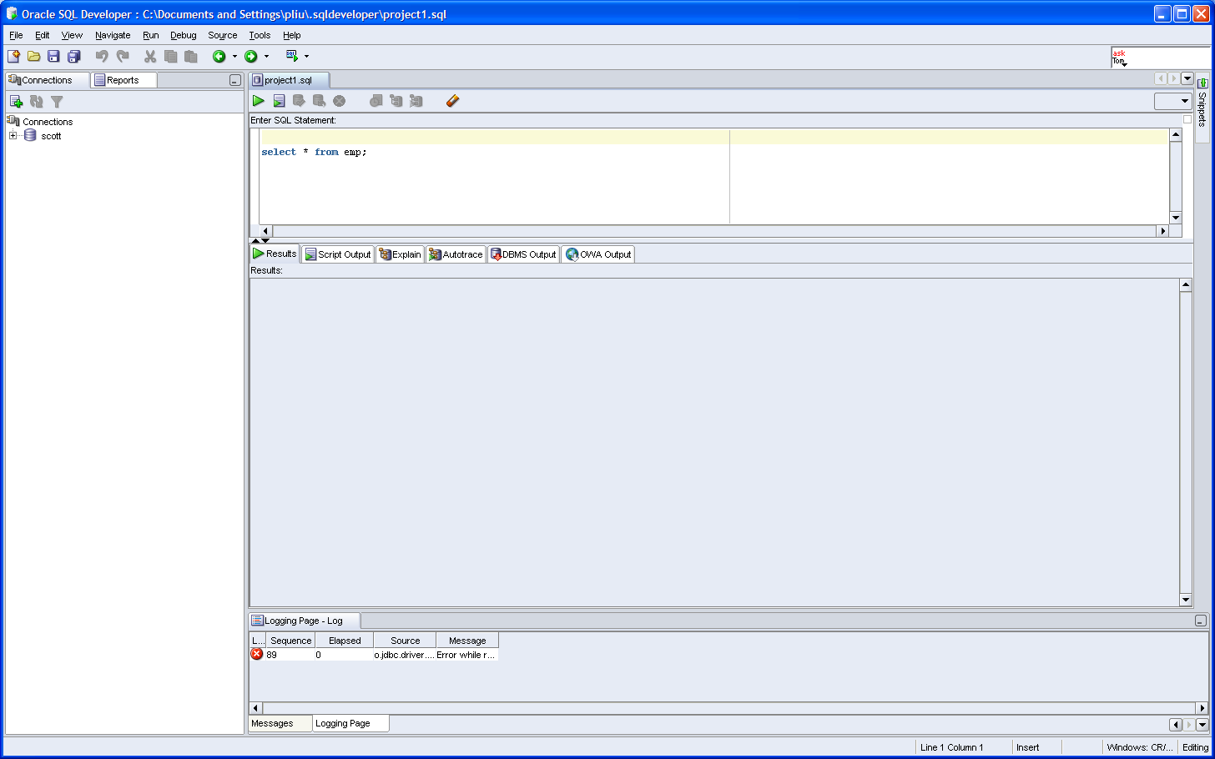
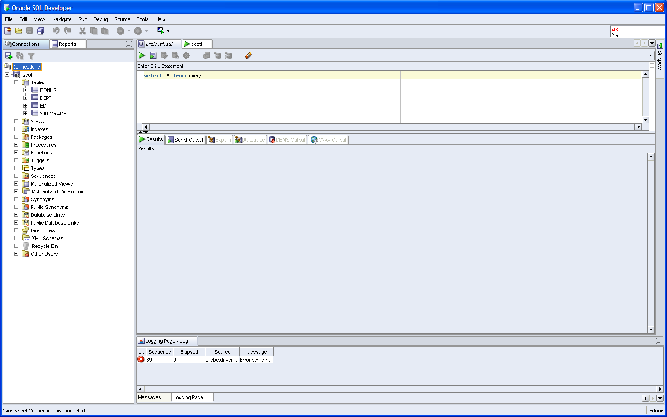

There are a lot into any database product. You will focus on the core technology, SQL and PL/SQL, in this class.

