SRC Meeting “Scrabble Blowout”
April 19, 2012
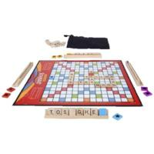
Hasbro Official Scrabble Web Site
http://www.hasbro.com/scrabble/en_US/
National Scrabble Association
http://www2.scrabble-assoc.com/index.asp
Scrabble Pages—Rules
http://www.scrabblepages.com/scrabble/rules/
The Scrabble Rules that Cause the Most Problems
http://www.word-buff.com/scrabble-rules.html
Scrabble Help
http://www.scrabblehelp.net/
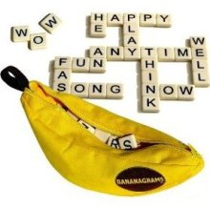
Bananagrams—How to Play and Win
http://www.toycrossing.com/bananagrams/

