Oracle Guide to Testing Connection After Using Ping & After Installation of Oracle Client

Okay, first of all, for this to work, you should test your connection to the School of Technology’s database by pinging, using either Command Prompt in Windows XP or MSDOS Prompt in Windows 98. Command Prompt can be found by doing the following:

Start->Programs->Accessories->Command Prompt

I’m not sure where MSDOS Prompt is at, but it should be found in a similar fashion. Once you find those, make sure you have connected to the internet, and then try pinging by typing in:

ping oracle1.eiu.edu

You should get 4 positive responses.

Also, another thing I did right after this is go back and install the Oracle Client 8i. It is on the same CD, right after the 8i Enterprise Edition selection (at least when I was installing XP). Select the bullet next to 8i Client and let it run you through installation. I don’t know if everyone did this step or not, but I didn’t do it at first, and when I tried to use SQL, I only got 12 names instead of 25. So don’t miss this step.

After the Oracle Client is installed, you’ll need to configure it. I configured mine using the Net 8 Assistant:

1. Go to Start->Programs->Oracle-OraHome81->Network Administration-> Net8 Assistant (figures 1, 2)

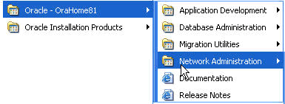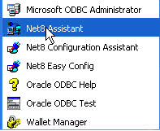

Figure 1 Figure 2

2. When you come to Net 8 Assistant, you will see a folder called Net Service Names. Double click this folder to open it up. Inside there will be one or two configurations, depending on how many times you have tried to configure or whatever Oracle has placed there based on previous information you have entered (figure 3). I immediately deleted anything I had in this folder and started over in order to get my SQL to work correctly (you don’t have to do this but it might help). To Delete these, select them and click the red X button. You will get a message asking to proceed (figure 4). Click OK.

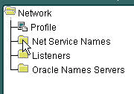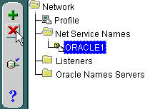
Figure 3 Figure 4

3. Next, you will want to create a new configuration. So what I did is highlight Net Service Names folder, then go up to the Edit menu, and select Create (figure 5).

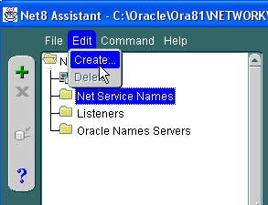
Figure 5

4. The Net Service Wizard will appear and you can start typing in the information that Dr. Liu provided for us at http://www.eiu.edu/~pingliu/tec5323/Notes/tec5323chapter3notes.htm under step 2.
Click next after you fill in the information for each step. See figures 6 – 9 to view this information .
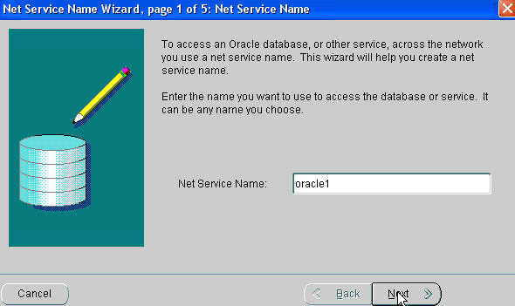
Figure 6
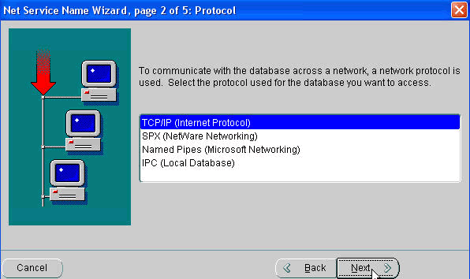
Figure 7
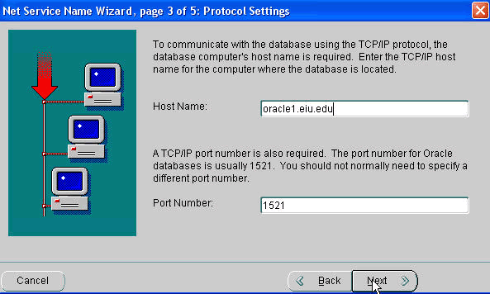
Figure 8
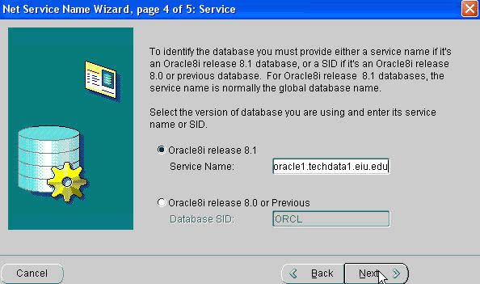
Figure 9

5. After you type in the Service Name field and hit next, you can test your configuration. Click on Test (figure 10). You should get a message that your test was successful (figure 11) and then you can click the close button after the test.

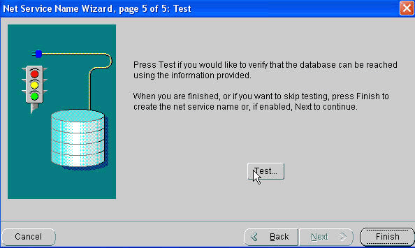
Figure 10
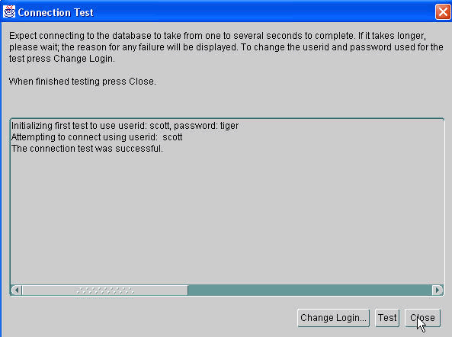
Figure 11

6. Once this process is complete, you can click the finish button (figure 12), and you will then return to the main screen of the Net Assistant and see that everything has been entered correctly (figure 13).

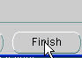
Figure 12

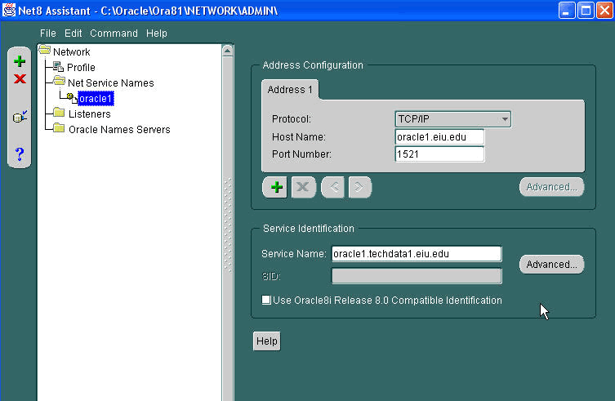
Figure 13

7. Once you are finished, you can either click on the red X button at the top right of the window or click on the file menu and select close. A window will open and asks if you want to save changes. Select Save (figure 14).

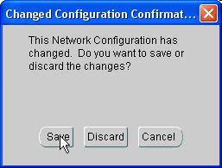
Figure 14

8. The next thing you will want to do is see if you can now use SQL plus and get into the School of Technology Database and view the information for Project 2 of week 4. First, go to:

Start->Programs->Oracle- OraHome->Application Development -> SQL Plus (figure 15).

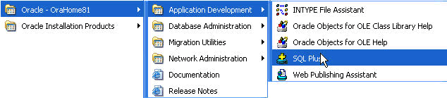
Figure 15

9. You will need to log on first, so make sure you are connected to your ISP (Internet Service Provider). When you first come into SQL, you will be asked for a username, password and Host String. This information is also found on the Supplemental reading for Chapter 3, Step 4 at http://www.eiu.edu/~pingliu/tec5323/Notes/tec5323chapter3notes.htm. Fill in the information as you see in figure 16.

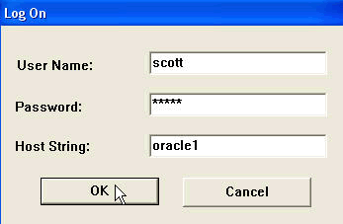
Figure 16
10. Once you are logged into SQL, you can begin to enter the information found in Step 4 of Supplemental reading at http://www.eiu.edu/~pingliu/tec5323/Notes/tec5323chapter3notes.htm. See figure 17.

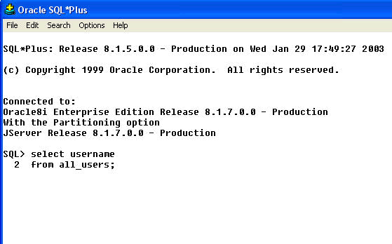
Figure 17

11. I would show you the answer, but that would be too easy then wouldn’t it. You should get a list of about 25 names or so after typing in the commands. Make sure you enter everything correctly or it won’t work at all. If you still get an error, try going back to Net Assistant 8 and erase anything else like I told you to do in step 2. See if that helps. Otherwise you should be successful and see a long list. Copy that list into a notepad file and send as attachment to Dr. Liu for Project 2.

Hope this helps.

