Download and Installation of Oracle10g
Jan. 19, 2004
By Peter Ping Liu and Naveed Baqir

Open Oracle Technology Network (http://otn.oracle.com). Click New to Oracle.

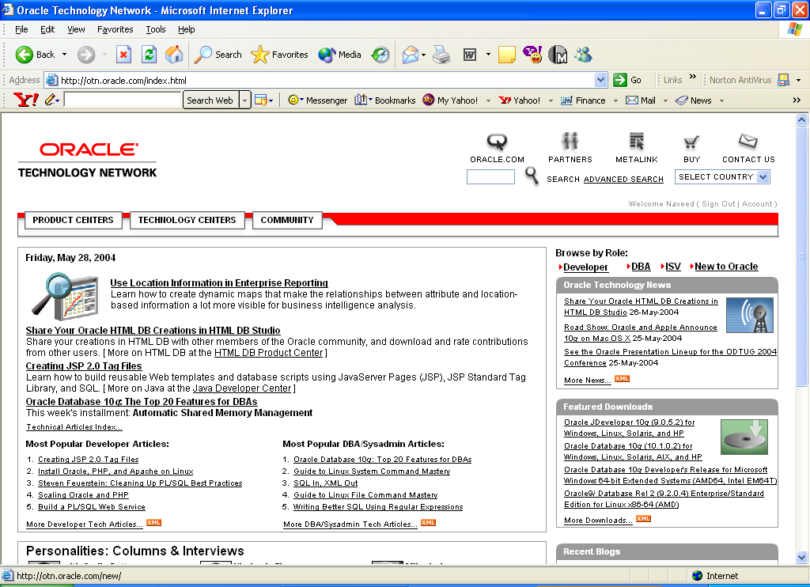
Choose Download Oracle Database 10g Standard Edition 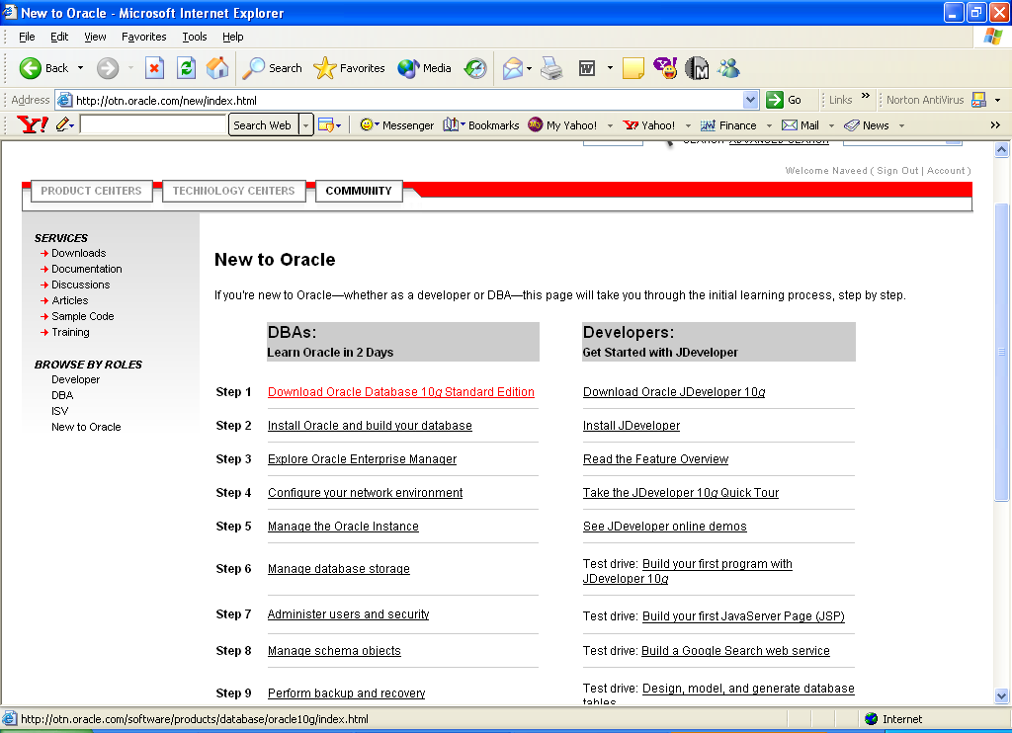

Select Oracle Database 10g Release 1 (10.1.0.2) for Microsoft Windows (32-bit)

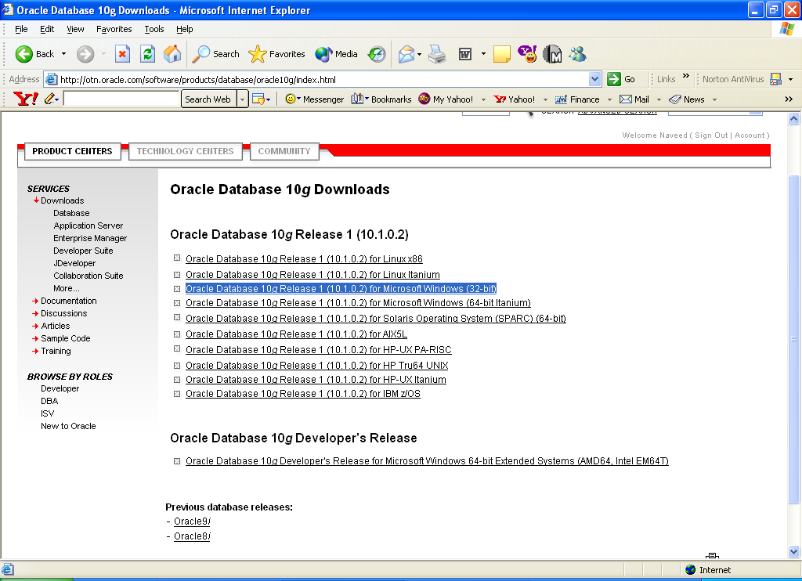
It will ask you to either sign in using Already have an account? Option
If you don’t have an OTN ID, Select Are you a new user? for a free account, provide the required registration information.
Click Continue.

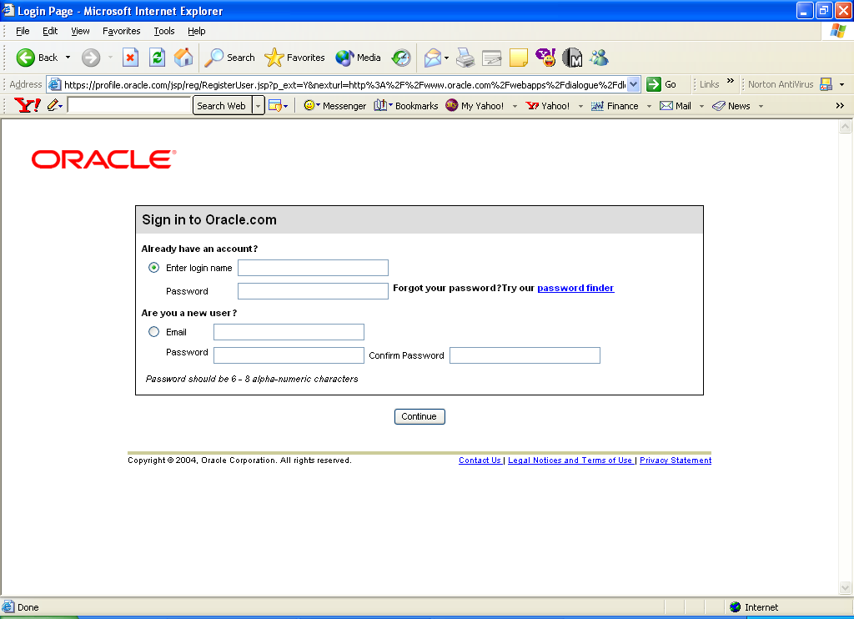

Click Download 10g
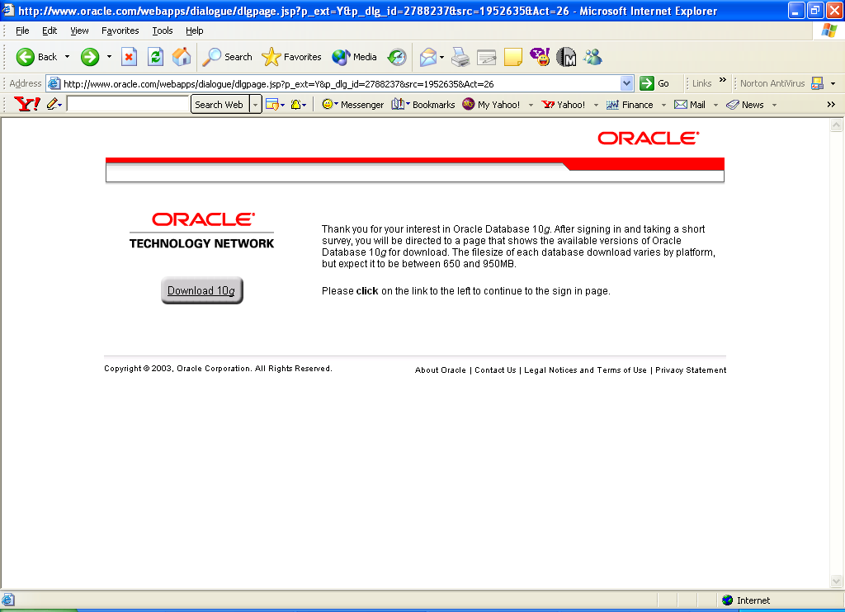

For example, my download location for the two files is at C:\pingliu\download\Oacle10g.

Installation Directions from Oracle:
- Before downloading, please review the product certification information for this product.
- Also see the Quick Start Guide reference list (Metalink).
- Verify that the file sizes listed on this page match the downloaded files on your local disk.
- Create directories Disk1, Disk2 and Disk3.
- cd to Disk1 and unzip the 92010NT_Disk1.zip here.
- repeat the above step for Disk2 and Disk3.
- After unzipping all the 3 disks in their respective directories, cd to Disk1 and run setup.exe to start the installer.

Extract Disk1, Disk 2 and Disk 3 to (for example)
C:\pingliu\Download\Oracle9i(32bitforOfficePC)\92010NT_Disk1
C:\pingliu\Download\Oracle9i(32bitforOfficePC)\92010NT_Disk2
C:\pingliu\Download\Oracle9i(32bitforOfficePC)\92010NT_Disk3

You may use your directory of choice which may be different from above.

Restart the computer. (It may or may not be necessary. But, it is a good idea to have a clean machine and memory before installing a large software.)

Run: setup.exe from Disk 1.
Start
Run
Browse to C:\pingliu\Download\Oracle9i(32bitforOfficePC)\92010NT_Disk1\setup.exe

Extract the downloaded zip file by right clicking the file and selecting “Extract Here” option from the pop-up menu. Click Next

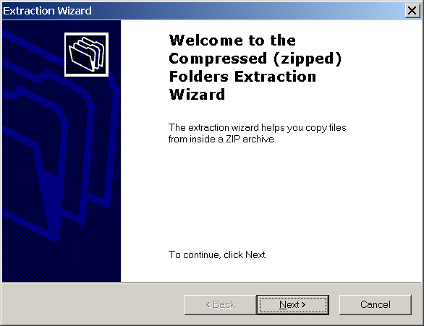
Browse the path of your choice for files extraction; Click Next
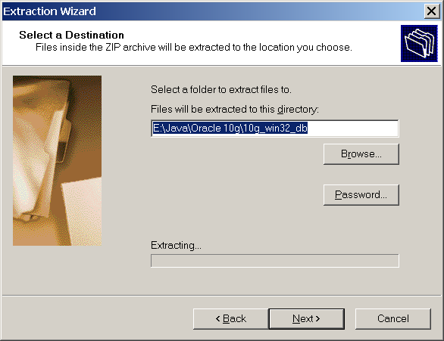

The extraction process will start once you have clicked Next.
Click Finish
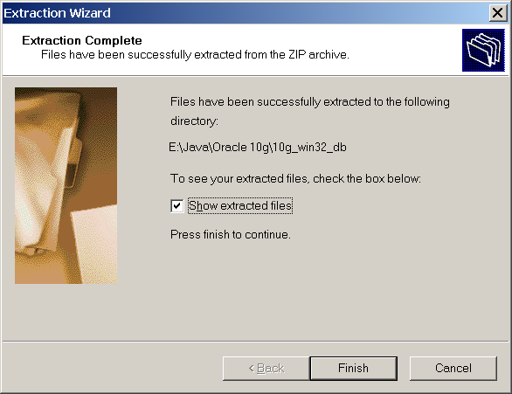

Open the Disk 1>>Install folder and double click setup.exe

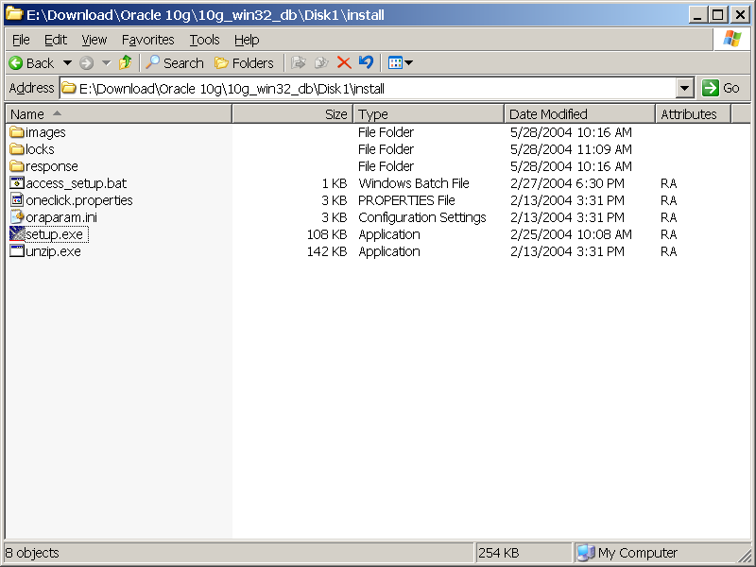
Universal Installer will be launched. Click Next
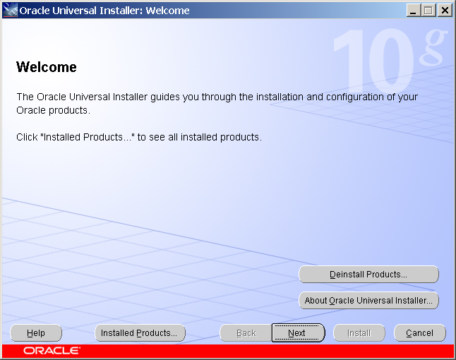

To see the already installed oracle products on your computer, click
Installed Products…
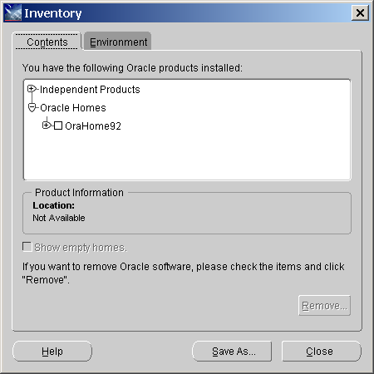 Click Next
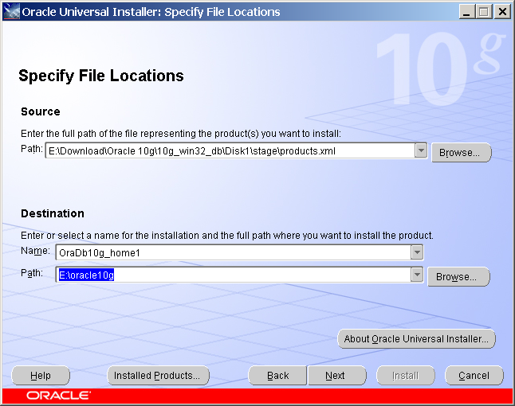

Please note the above Name and Path settings. You may choose the default setting. Since I have already installed another Oracle product in C:\OraHome1, I have to choose another location to install Oracle10g. In this case, I used E:\Oracle10g. If you have installed software using the CD from the book, you will have the same situation as mine.

Click Next
Choose Enterprise Edition (808MB)
Click Next
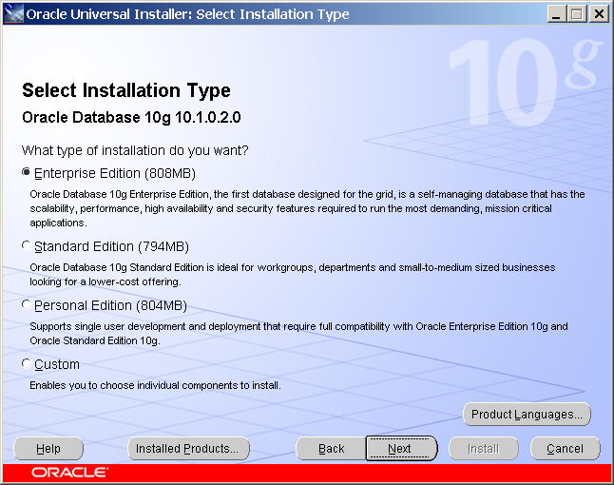

If Oracle 9i was already installed, the following screen will appear;
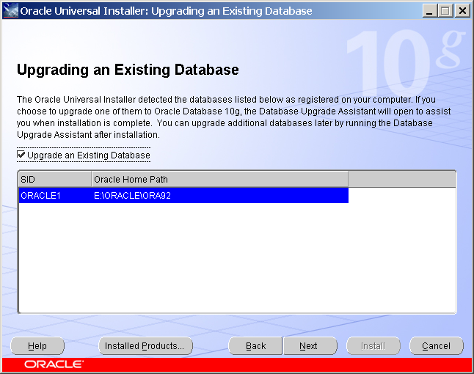

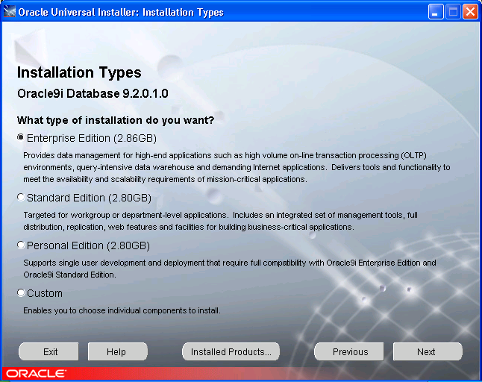

I chose Enterprise Edition because my computer hardware (including memory RAM and hard disk space) is able to handle the software. You need to do your detective work before installing the software. For the purpose of this course, all three editions may work well. There might be slight difference in terms of some commands and parameters.

Click Next.
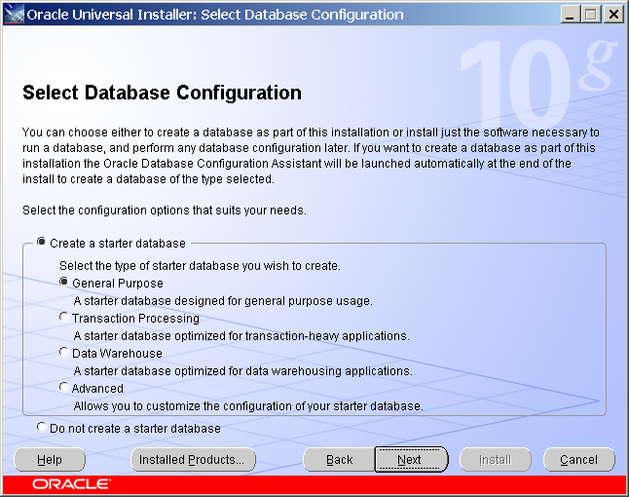

Select General Purpose.
Click Next.
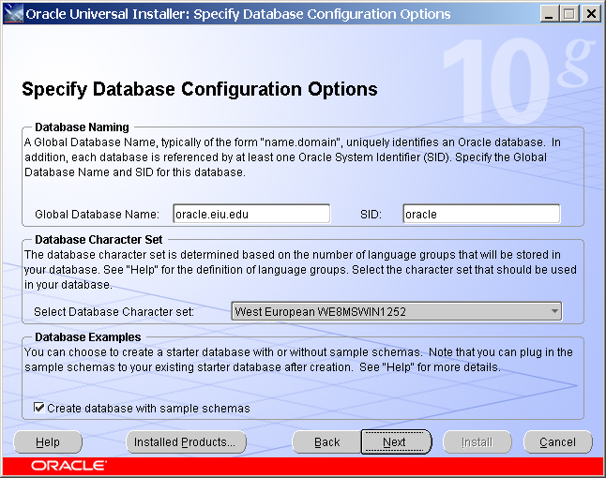

Specify Global Database Name and SID (You may choose the default name).
I have to change it from default values due to server configuration that might not be necessary for your installation.

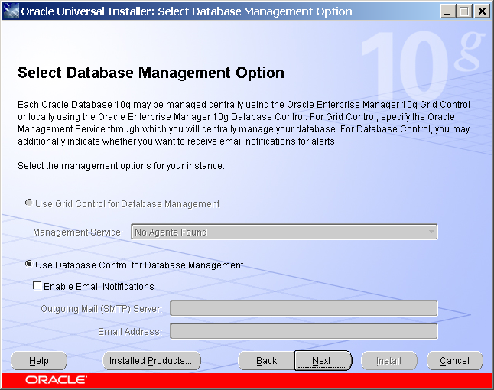
Click Next

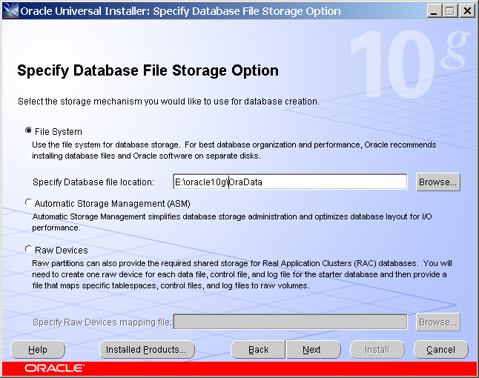

Specify Database File Storage Option by Specifying Database file location.
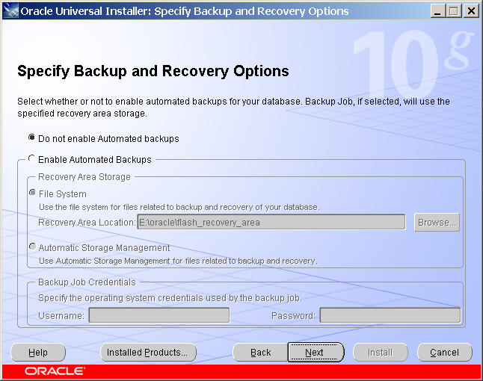

Click Next
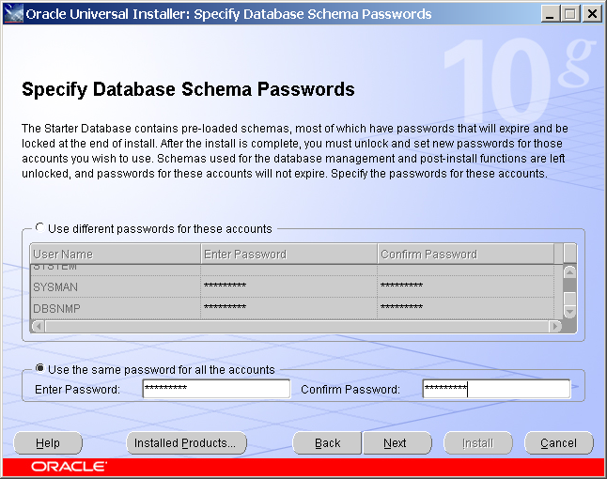

Specify Database Schema Passwords. Select Use the same password for all the accounts, (You may choose the first option and specify different passwords for different database schemas). Enter Passwords and Enter Confirm Passwords. Click Next
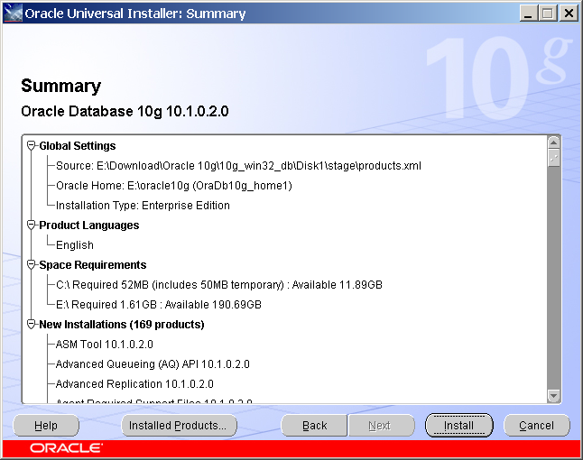

Click Install
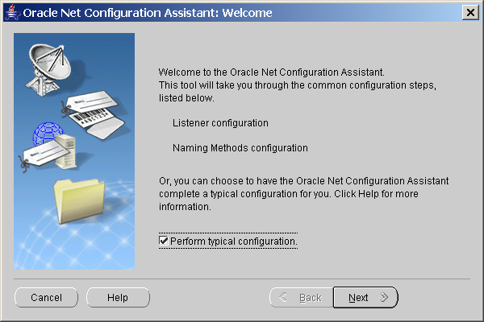

This dialog box will guide you through the Oracle Net configuration.
Check “Perform typical configuration”
Click Next

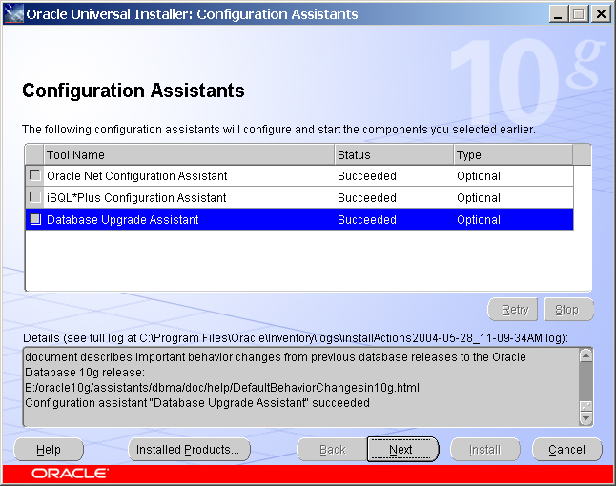
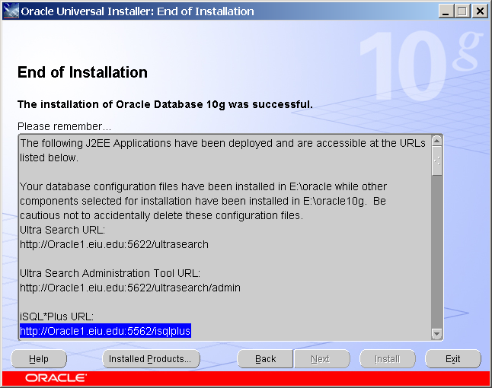

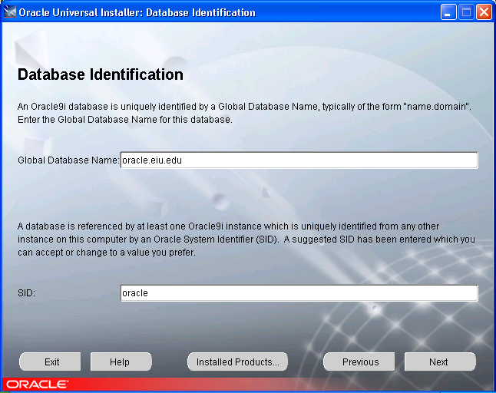

The above two parameters are important. I used global database name: oracle.eiu.edu. This is fine if your database is only on your PC. In real application, you should use real domain name. For example, I installed one Oracle9i database in our server known as oracle1.eiu.edu (oracle1 is a machine name). So I named the global database as oracle.techdata1.oracle1.eiu.edu. The global name means that you will be able to access the database anywhere in the world. For the course purpose, since we are networking the database, any domain name is fine.

SID is automatically defined.

Please take note on these two parameters since you will need them when you access the database later. They are super important.

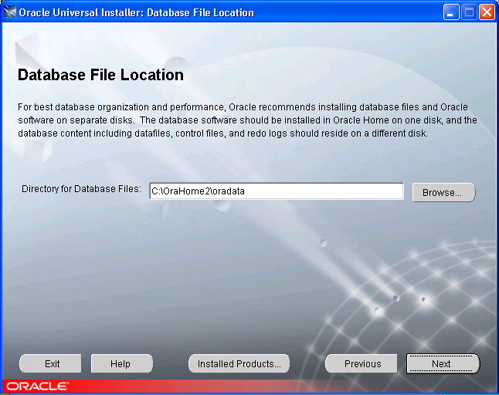

Use the default setting for Directory for Database Files: C:\OraHome2\oradata
Click Next.
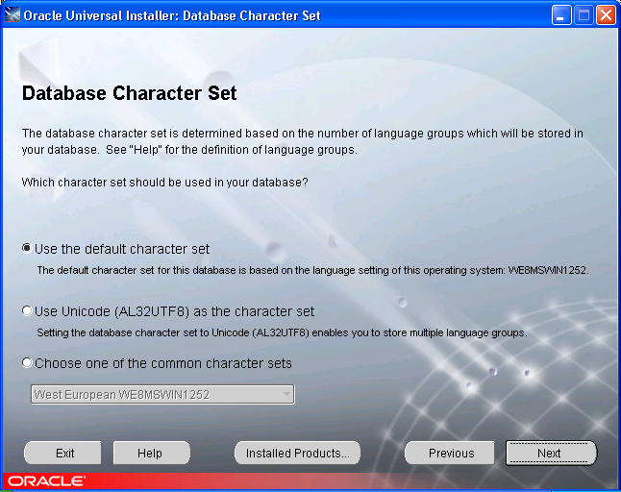
Use the default character set. If you use the database product in Germany, you will have to use Unicode or choose one of the common character sets.
Click Next.
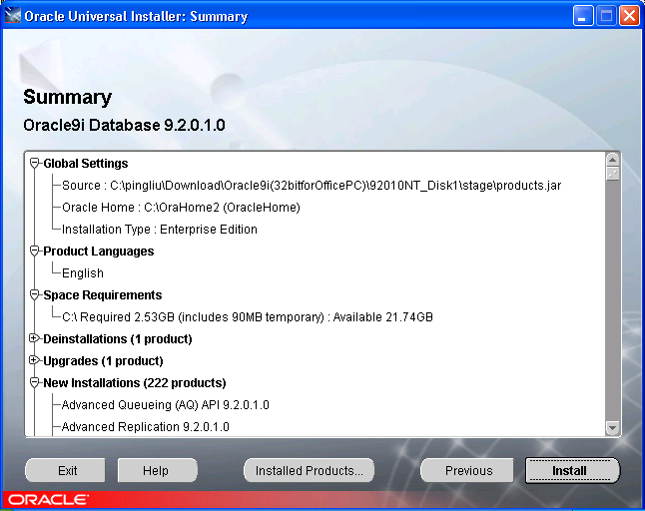

Please seriously review the files and parameters. Nothing has been done on your computer yet. It is much easier to correct problems at this stage. Do not take chances.

Click Install if you think everything is ok.
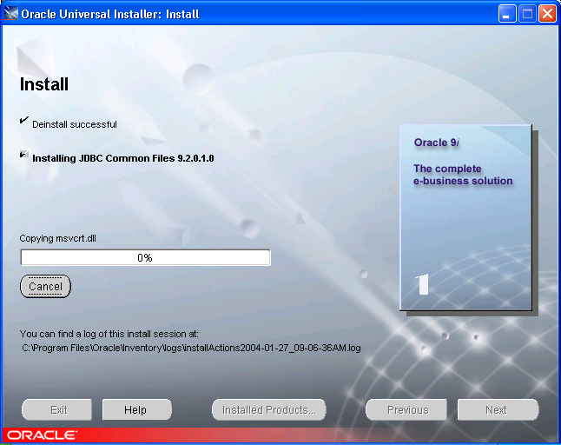

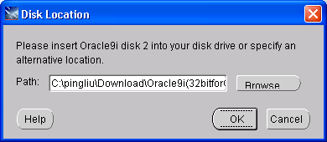

Browse to Disk 2.

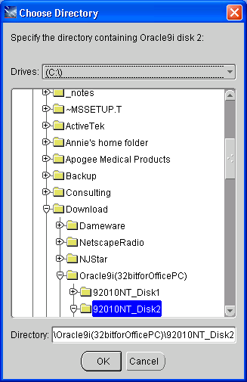

Click OK.
Wait…Drink a lot of water.

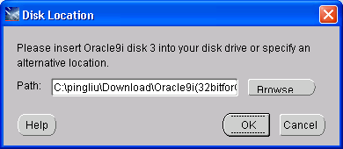
Browse to Disk 3. Click OK.
Wait...Drink a lot of water.
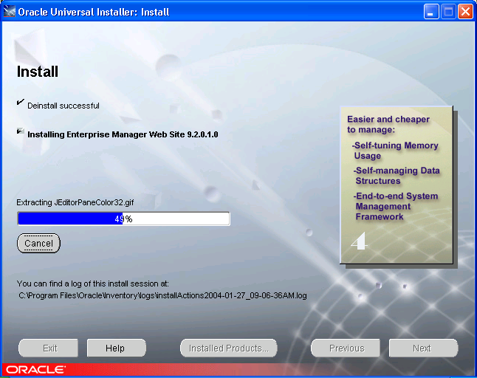

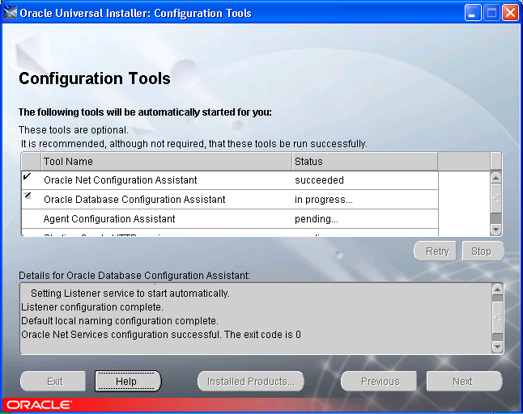

I have encounter problems with configuration tools. I decide to cancel it after waiting for 1 hour in Database Configuration Assistant.

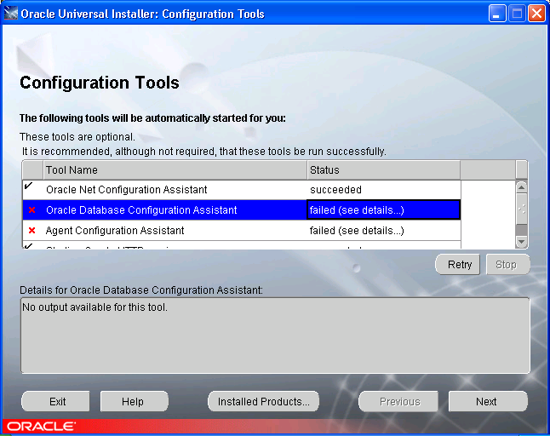

. I retried both failed components and did not work.

Click Next.

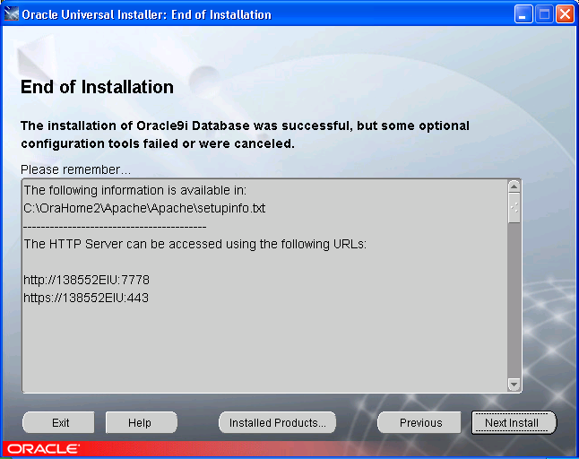

Exit.

Click Yes. That completes the installation.

To test if the database is running or not, do the following:
Start SQL Plus.
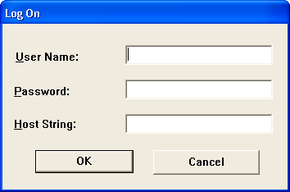

Login SQL Plus using username: scott, Password: tiger, and Host String:oracle. Host string is your SID. If you have used different SID during installation, please change it correspondingly.

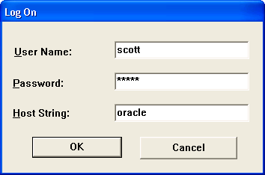

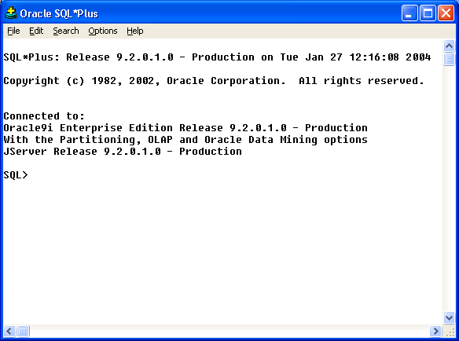

If you see your SQL Plus screen look like above, your installation is successful and your database is running.

At SQL> prompt, type “select * from dept;”

You will see the following output on the screen.

DEPTNO DNAME LOC
---------- -------------- -------------
10 ACCOUNTING NEW YORK
20 RESEARCH DALLAS
30 SALES CHICAGO
40 OPERATIONS BOSTON

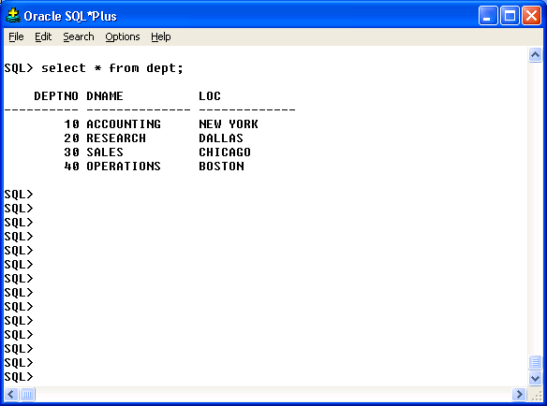

If you reach this point, you have successfully installed Oracle9i in your computer. Now you can email to the instructor and tell him you did it.

