Download and Installation of Oracle9i
Jan. 19, 2004
By Peter Ping Liu

Login Oracle Technology Network. Click Downloads.

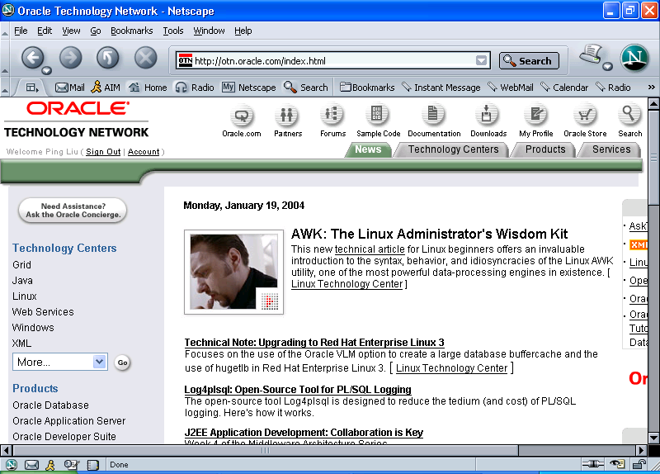
Choose Oracle9i Database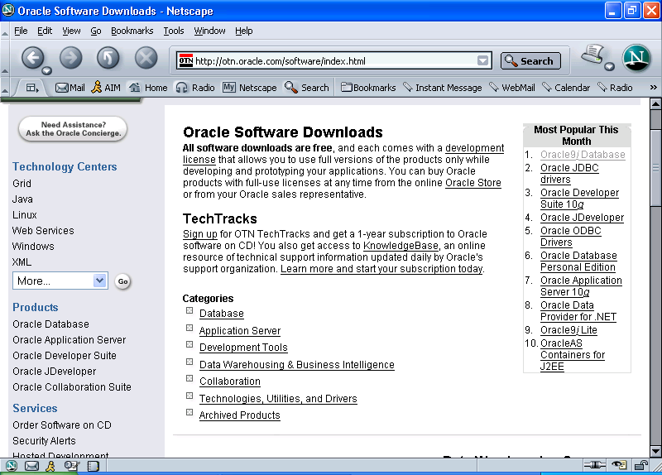

Select Oracle9i Database Release 2 Enterprise/Standard/Personal Edition for Windows NT/2000/XP
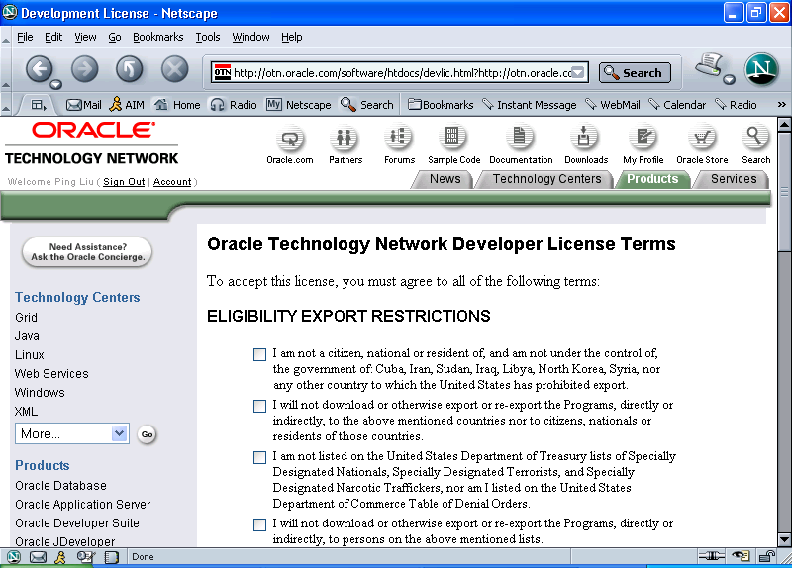

Accept the Software Agreement.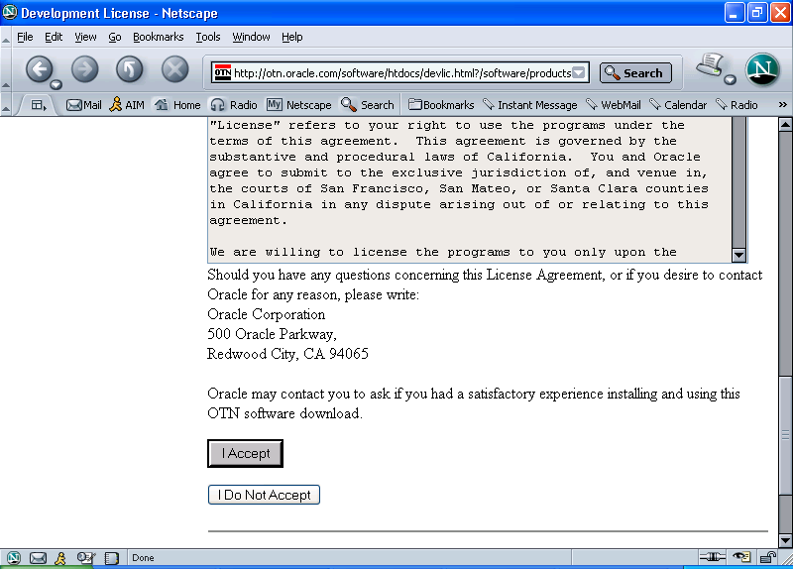
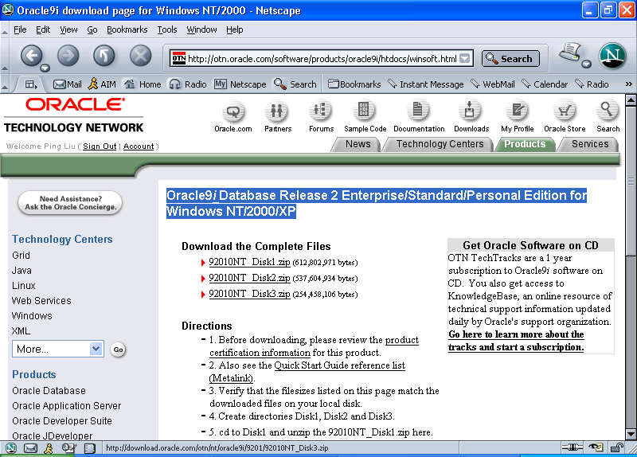

For example, my download location for the two files is at C:\pingliu\download\Oacle9i.

Installation Directions from Oracle:
- Before downloading, please review the product certification information for this product.
- Also see the Quick Start Guide reference list (Metalink).
- Verify that the file sizes listed on this page match the downloaded files on your local disk.
- Create directories Disk1, Disk2 and Disk3.
- cd to Disk1 and unzip the 92010NT_Disk1.zip here.
- repeat the above step for Disk2 and Disk3.
- After unzipping all the 3 disks in their respective directories, cd to Disk1 and run setup.exe to start the installer.

Extract Disk1, Disk 2 and Disk 3 to (for example)
C:\pingliu\Download\Oracle9i(32bitforOfficePC)\92010NT_Disk1
C:\pingliu\Download\Oracle9i(32bitforOfficePC)\92010NT_Disk2
C:\pingliu\Download\Oracle9i(32bitforOfficePC)\92010NT_Disk3

You may use your directory of choice which may be different from above.

Restart the computer. (It may or may not be necessary. But, it is a good idea to have a clean machine and memory before installing a large software.)

Run: setup.exe from Disk 1.
Start
Run
Browse to C:\pingliu\Download\Oracle9i(32bitforOfficePC)\92010NT_Disk1\setup.exe
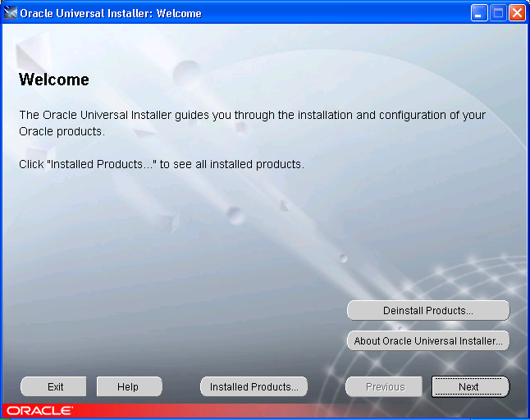

Click Next
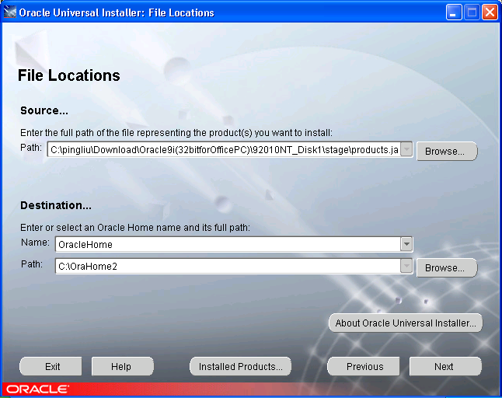

Please note the above Name and Path settings. You may choose the default setting. Since I have already installed another Oracle product in C:\OraHome1, I have to choose another location to install Oracle9i. In this case, I used C:\OraHome2. If you have installed software using the CD from the book, you will have the same situation as mine.
Click Next.
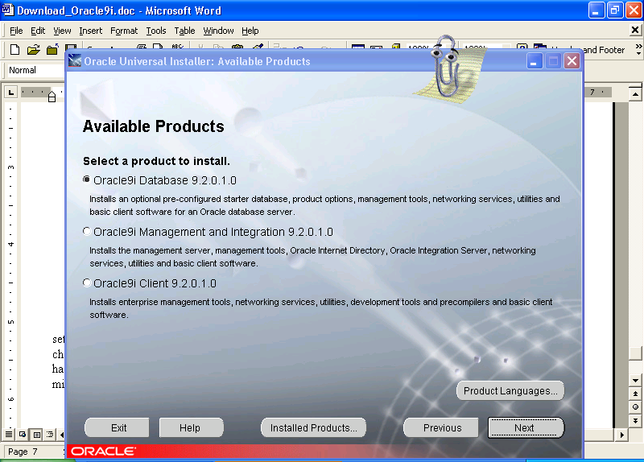

Choose Oracle9i Database 9.2.0.1.0.
Click Next.
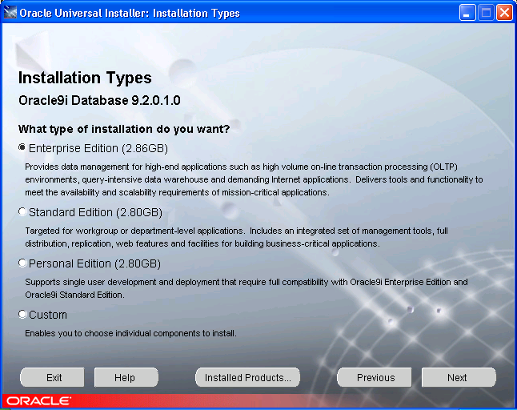

I chose Enterprise Edition because my computer hardware (including memory RAM and hard disk space) is able to handle the software. You need to do your detective work before installing the software. For the purpose of this course, all three editions may work well. There might be slight difference in terms of some commands and parameters.

Click Next.
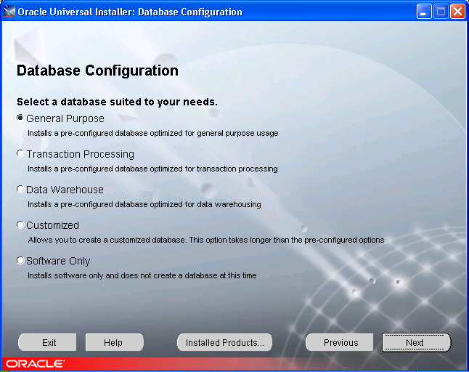

Select General Purpose.
Click Next.
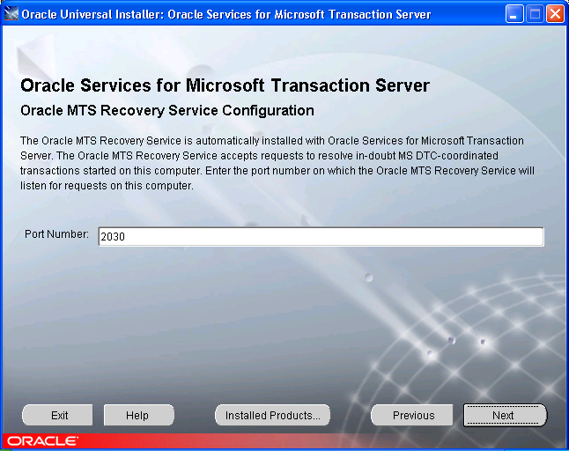

Chose default setting (if you do not know it.) Port Number: 2030.

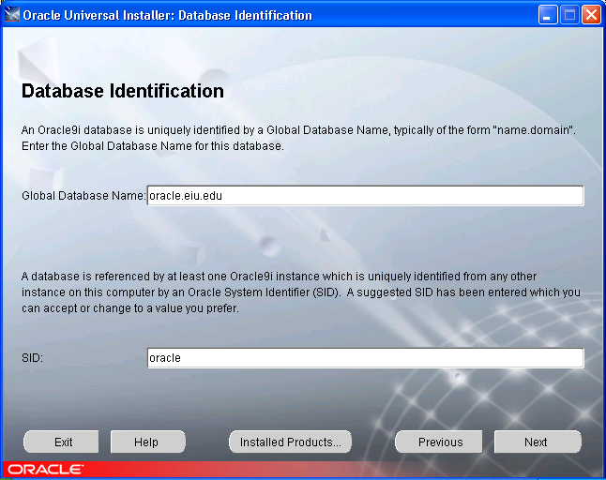

The above two parameters are important. I used global database name: oracle.eiu.edu. This is fine if your database is only on your PC. In real application, you should use real domain name. For example, I installed one Oracle9i database in our server known as oracle1.eiu.edu (oracle1 is a machine name). So I named the global database as oracle.techdata1.oracle1.eiu.edu. The global name means that you will be able to access the database anywhere in the world. For the course purpose, since we are networking the database, any domain name is fine.

SID is automatically defined.

Please take note on these two parameters since you will need them when you access the database later. They are super important.

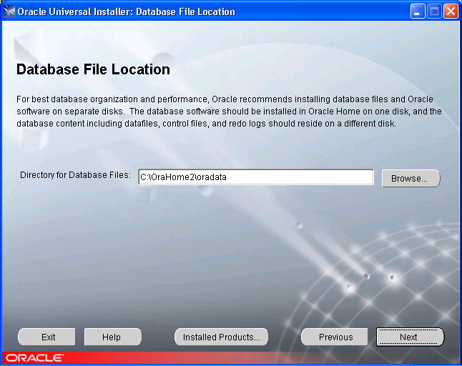

Use the default setting for Directory for Database Files: C:\OraHome2\oradata
Click Next.
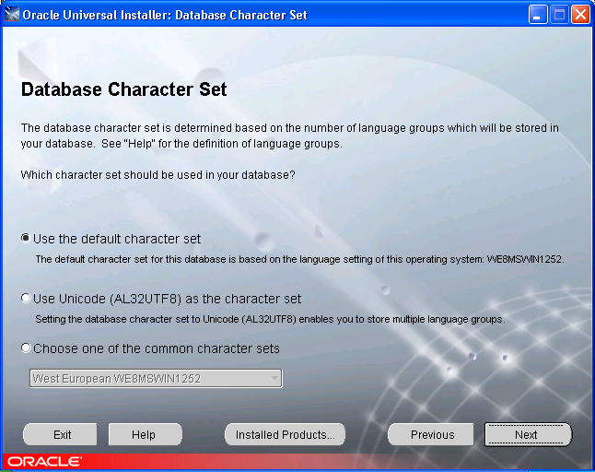
Use the default character set. If you use the database product in Germany, you will have to use Unicode or choose one of the common character sets.
Click Next.
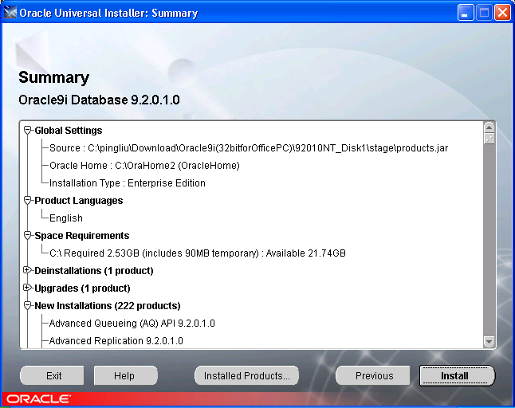

Please seriously review the files and parameters. Nothing has been done on your computer yet. It is much easier to correct problems at this stage. Do not take chances.

Click Install if you think everything is ok.
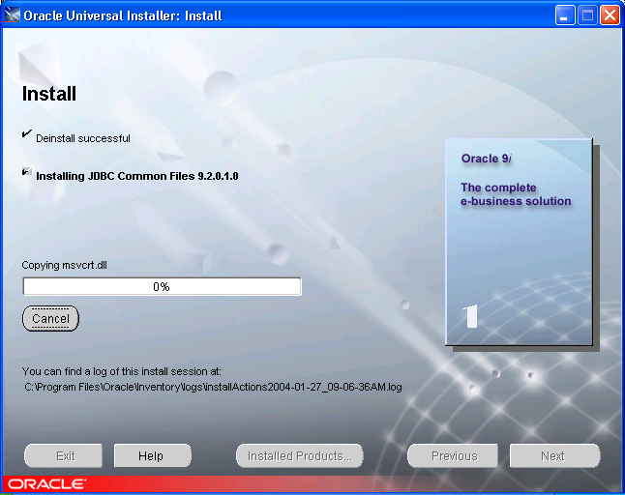

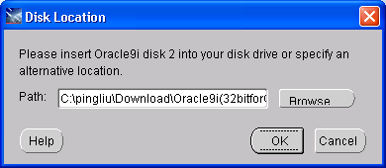

Browse to Disk 2.

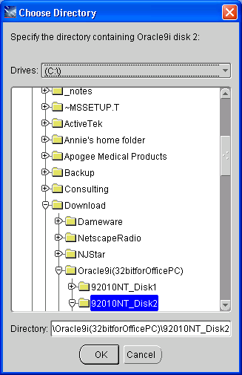

Click OK.
Wait…Drink a lot of water.

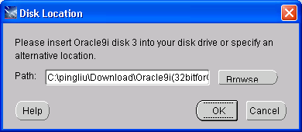
Browse to Disk 3. Click OK.
Wait...Drink a lot of water.
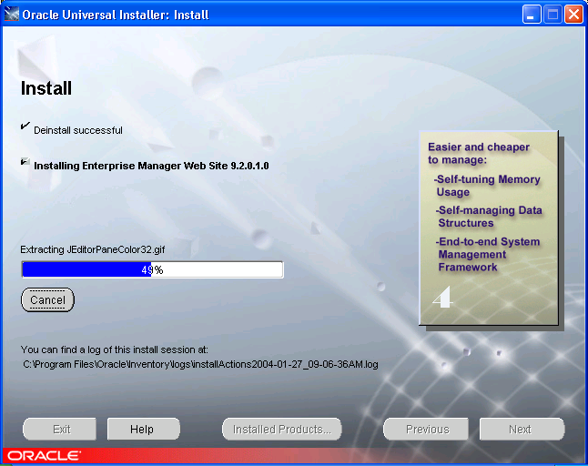

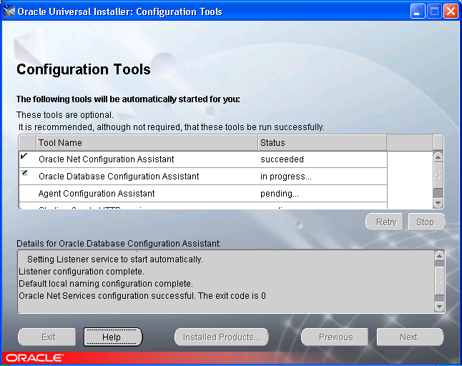

I have encounter problems with configuration tools. I decide to cancel it after waiting for 1 hour in Database Configuration Assistant.

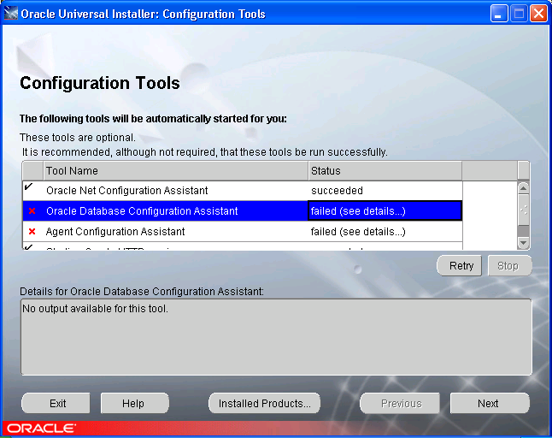

. I retried both failed components and did not work.

Click Next.

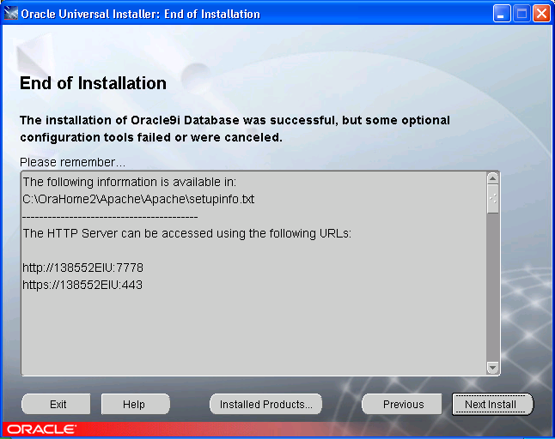

Exit.
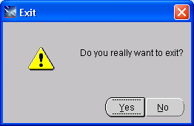
Click Yes. That completes the installation.

To test if the database is running or not, do the following:
Start SQL Plus.
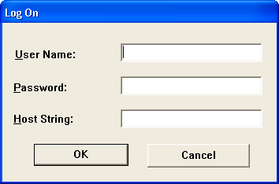

Login SQL Plus using username: scott, Password: tiger, and Host String:oracle. Host string is your SID. If you have used different SID during installation, please change it correspondingly.

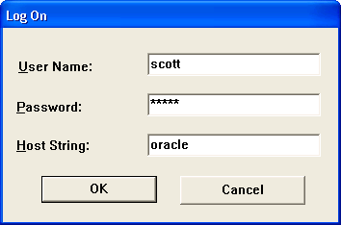

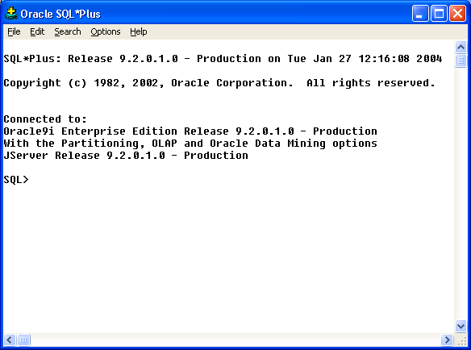

If you see your SQL Plus screen look like above, your installation is successful and your database is running.

At SQL> prompt, type “select * from dept;”

You will see the following output on the screen.

DEPTNO DNAME LOC
---------- -------------- -------------
10 ACCOUNTING NEW YORK
20 RESEARCH DALLAS
30 SALES CHICAGO
40 OPERATIONS BOSTON

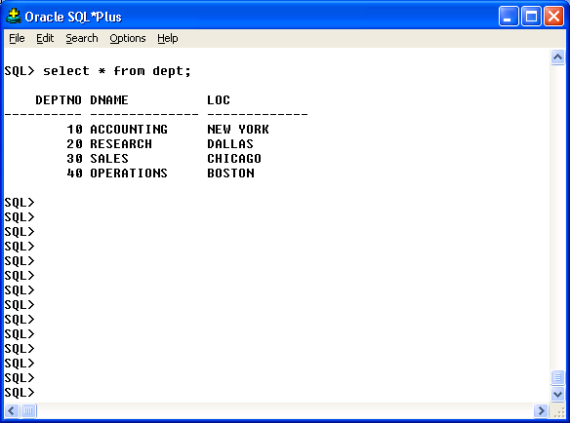

If you reach this point, you have successfully installed Oracle9i in your computer. Now you can email to the instructor and tell him you did it.

