DATABASE SECURITY
AND AUDTING

CHAPTER 1
Security Architecture
Acknowledgement:
During spring 2006 through summer 2006, Phanindra Maddhi, a graduate assistant in Technology devoted efforts in developing this course. In the process, he studied extensively the content of the text. He tested all the Oracle SQL codes presented in the textbook. We had a lot of good discussions in the process, which benefited me tremendously. The notes you will read here is a result of his hard work.
We understand that there might be inaccuracies in the notes. Please give us the feedback so that we can correct any mistakes or errors in the notes.

Peter Ping Liu
August, 2006 in Charleston

Introduction:
“Security Architecture” presents fundamental security concepts that serve as the building blocks to data and database security. This chapter covers important concepts such as information systems components, database management system functionalities, and major components of information security architecture. These concepts and others are presented and explained from a database security perspective.

Learning objectives:
- Define security.
- Describe an information system and its components
- Define database management system functionalities
- Outline the concepts of information security
- Identify the major components of information security architecture
- Define database security
- List type of information assets and their values
- Describe security methods

Security
Database Management systems that depend on operating systems cannot survive without the implementation of security model that enforce strict security measures. Most database management systems did not have a secure mechanism for authentication and encryption until recently, when serious research and development was initiated to add security components that enable database administrators to implement security policies.
Database Security is the degree to which all data is fully protected from tampering or unauthorized acts.

Information Systems
The integrity of the information depends on the integrity of its source data and the reliable processing of that data. Data is processed or transformed by a collection of components working together to produce and generate accurate information. These components are known as an information system.

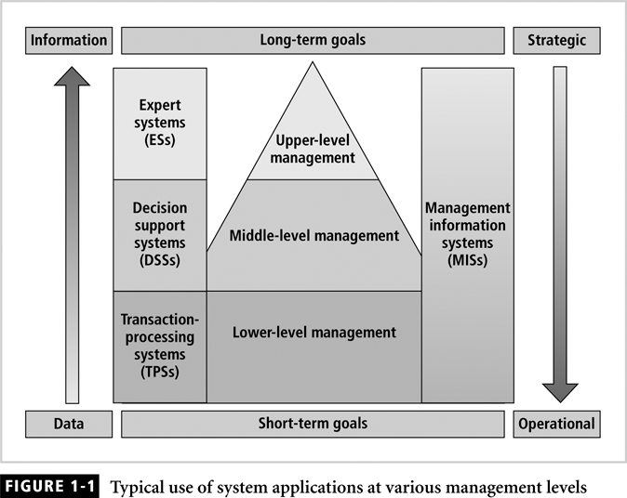

An information system can be the backbone of the day-to-day operations of a company as well as the as the beacon of long-term strategies and vision. Information systems can be categorized based on usage. Low-level management uses information systems that assist management and employees with operational tasks, such as inventory systems or point-of-sale (POS) systems. Middle-level management uses systems that deal with midterm goals, such as a forcasting systems that project sales for the following quarter. Upper-level management works with systems that assist with long-term goals, such as business model simulation and reasoning.
As illustrated in figure, Information system are classified mainly into three distinct categories: transaction-processing systems, decision support systems, and expert systems. Table describes the characteristics and typical applications for each type of system.

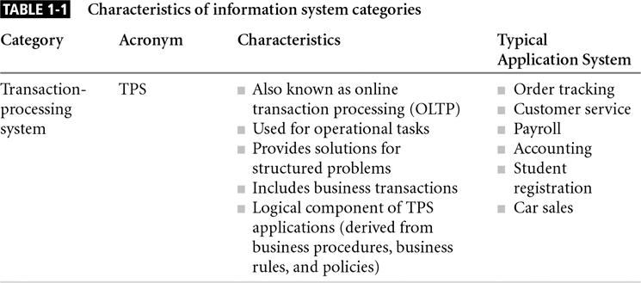
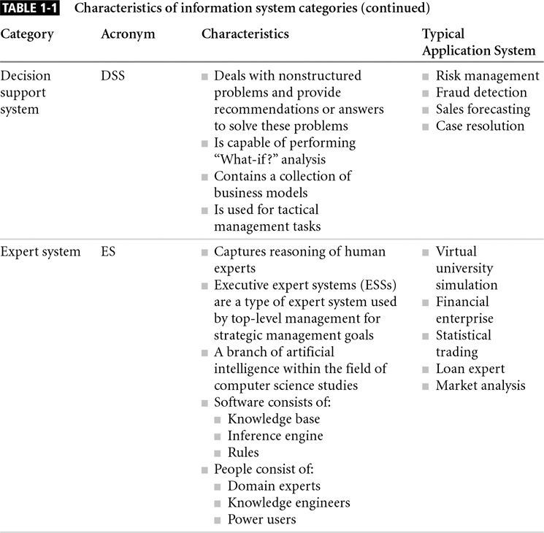

The type of information system and purpose, an information system consists of the following components:
Data: collected data and facts used as input for system processing, and data stored in the database for future reference or processing.
Procedure: Includes manual procedures, guidelines, business rules, and policies implemented in the system or used as part of the system.
Hardware: computer systems and devices such as disks, faxes, and printers.
Software: Application code, languages used to develop code, database management system, operating system used, and any other utilities or tools.
Network: A communication infrastructure to connect client process to the system.
People: Users, managers, business analysts, programmers, database administrators, and system administrators.

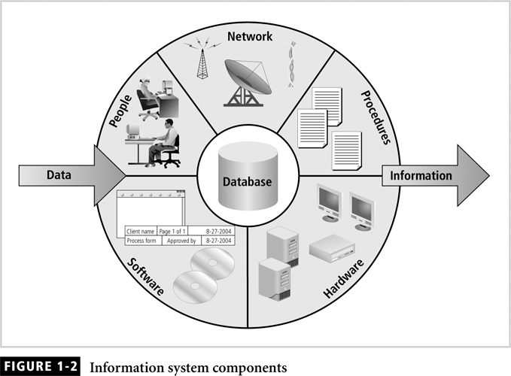

Figure shows that data is entered into the system to be processed immediately or to be stored in a database to be processed later when needed. The database is a core component in today’s most commonly used system architecture, which is a form of the client/server architecture. The concept behind a client/server application is based on the business model of a customer ordering a service or product and the representative of a business granting that request.
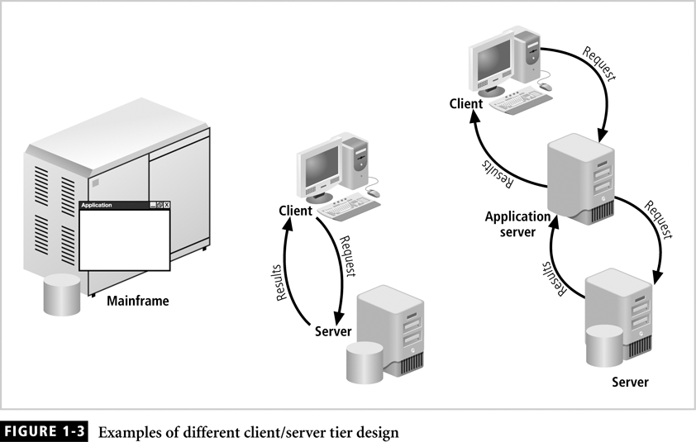
The architecture is composed of three layers, the first is the user interface, which is typically the clients: the second is the network layer, which is the backbone of the application architecture; and the third is the core of the client/server architecuture, which responds to all requests submitted by the client. The database is managed by a collection of programs whose main purpose is to allow users to store, manipulates, and retrive data efficiently. The collection of programs that manage the database is known as a database management system.

Database Management Systems
As the database is an integral part of an information system, the need for reliable and efficient programs to manage the database becomes essential to the success of the information system.
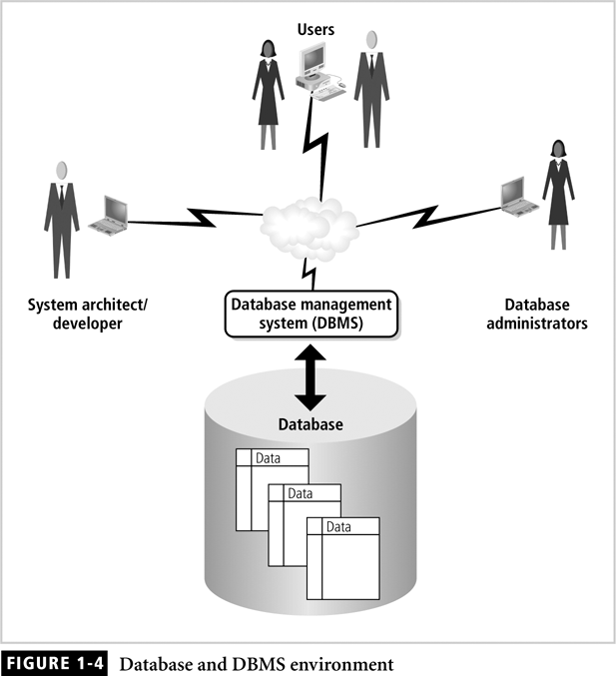
DBMS can offer more advance functions such as distributed transactions, replication, and parallel processing. Figure provides a view of the database and DBMS environment that illustrates the similarity between environment and information systems. Both consist of the same components- data, hardware, software, and database servers.

Information Security
Information security consists of the procedures and measures taken to protect each component of the information system involved in producing information. This means protecting data, hardware, software, network, procedures, and people all the components of the information system.
The C.I.A triangle is a framework for protecting information integrity and shield data from being tampered with by unauthorized persons, being modified accidentally by employees, or losing consistency because of the incorrect coding of business requirements and rules.

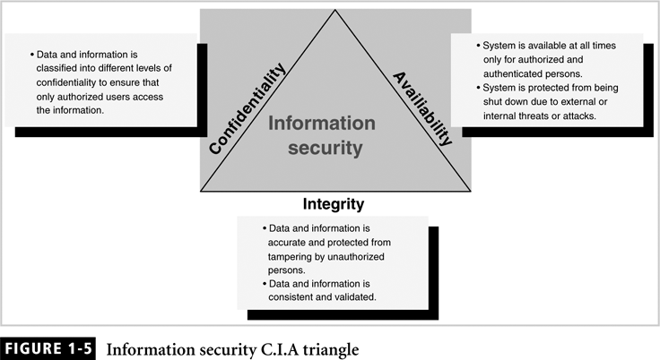

Confidentiality
Confidentiality is one of the three principles of the C.I.A triangle. Confidentiality addresses two aspects of security that have subtle differences. The first aspect is the prevention of unauthorized individuals from knowing or accessing secret information. The second aspect is the process of safeguarding confidential information and disclosing secret information only to authorized individuals by mans of classifying information.

Integrity
Integrity is the second principle of the C.I.A triangle. For information integrity to exist, the data upon which it is based must be consistent and accurate throughout the system. The integrity aspect of information security is vital, because if focuses attention on the most valuable asses, data, which in turn becomes information. Data is consistent to have integrity if it is accurate and has not been tampered with intentionally or accidentally. Data must be protected at all levels to achieve full integrity. The integrity of the information system is measured by the integrity of its data.

Availability
The availability principle with respect to information security means that the system should be available to individuals who are authorized to access the information, and the system should determine what an individual can do with that information.

Information security Architecture
An information system, is a collection of components working together to solve a problem. Because data is processed into viable information by the information system, security becomes an important aspect of the system. This means that the information system must protect data and the information produced from the data from having its confidentiality, integrity, and availability violated on any layer.
Figure shows that information security architecture is a model for protecting logical and physical assets. Information security architecture is the overall design of a company’s implementation of the C.I.A triangle. The architecture components range from physical equipment to logical security tools and utilities.

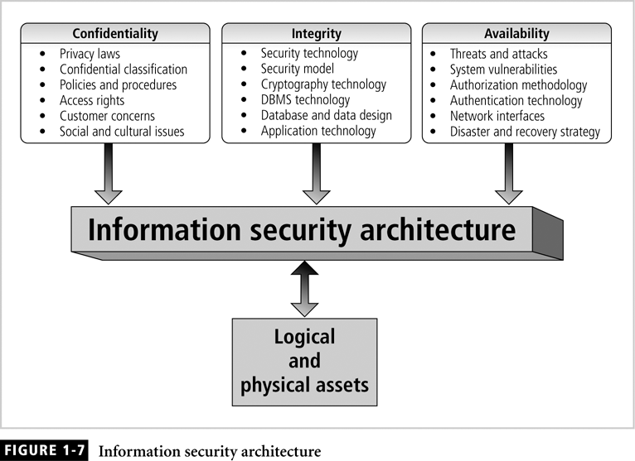

The following list outlines the components of information security architecture
- Polices and procedures: documented procedure and company policy that elaborate on how security is to be carried out.
- Security personal and administrators: people who enforce and keep security in order
- Detection equipment: Devices that authenticate employee and detect equipments that is prohibited by the company.
- Security programs: Tools that protect computer systems servers from malicious code such as viruses
- Monitoring equipment: Device that monitors physical properties, employees, and other important assists.
- Monitoring applications: Utilities and application used to monitor network traffic and internet activities, downloads, uploads, and other network activities
- Auditing procedures and tools: checks and control put in place to ensure that security measures are working

Database security
One of the functions of database management systems is to empower the database administrator to implement and enforce security at all levels of the database. A database administrator to protect valuable data stored in the database, we must know the various security access points that can make database vulnerable. A security access point is a place where database security must be protected and applied in other words implemented, enforced, and audited.
Figure presents all the major access points within a database environment where security measure must be applied, enforced, and audited.

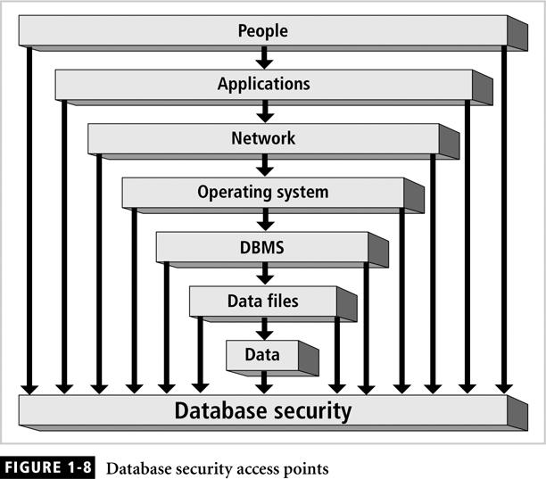
The security access points illustrated
People: individuals who have been granted privileges and permission to access applications, networks, workstations, servers, database, data file, and data.
Applications: Application design and implementation, which includes privileges and permissions granted to people.
Network: one of the most sensitive security access point.
Operating system: The operating system access point is defined as authentication to the system the gateway to the data.
DBMS: The logical structure of the database, which includes memory, executables, and other binaries
Data files: Another access point that influence database security enforcement is access to data files where data resides.
Data: This data access point with the data design needed to enforce data integrity, the application implementation needed to ensure data validity, and the privileges necessary to access data.

Security Gaps
Security gaps are points at which security is missing, and thus the system is vulnerable. Vulnerabilities are kinks in the system that must be watched because they can become Threats. In the world of information security, a threat is defined as a security risk that has a high possibility of becoming a system breach. The breach can be caused by either intentional or unintentional actions.
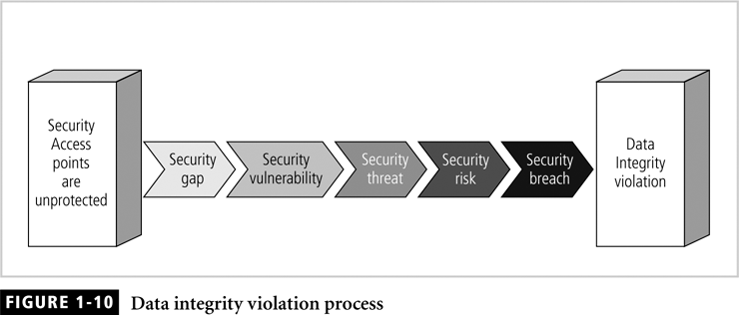

Database security Levels
A relational database is a collection of related data files; a data file is a collection of related tables; a table is a collection of related rows; and a row is collection of related columns.
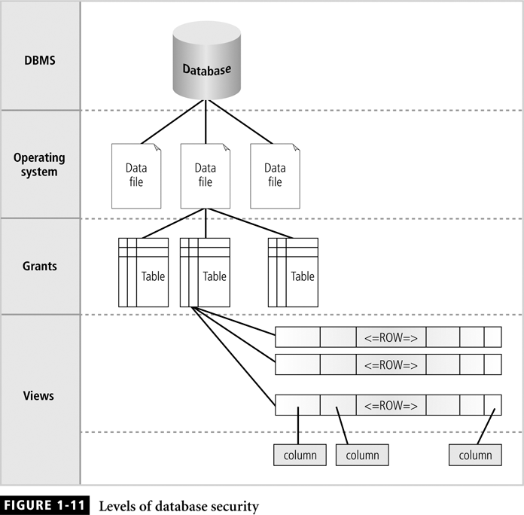

Menaces to Database
The following sections describe the kind of menaces to database securities that are commonly by today organizations. The section describes database vulnerabilities, threats, and risks, it is important that we need understand the differences among these three terms.
Security Vulnerability: A weakness in any of the information system components that can be exploited to violate that integrity, confidentiality, or accessibility of the system.
Security threat: A security violation or attack that can happen any time because of security vulnerability.
Security risk: A known security gap that a company intentionally leaves open
Type of vulnerabilities
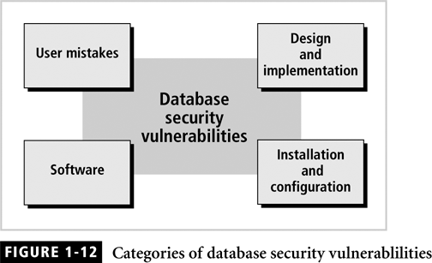

To protect system from these attacks, we must understand the types of vulnerabilities that
may be found in your information security architecture. To conduct a review and examination of the different types of database security vulnerabilities, we need to understand how vulnerabilities are categorized.
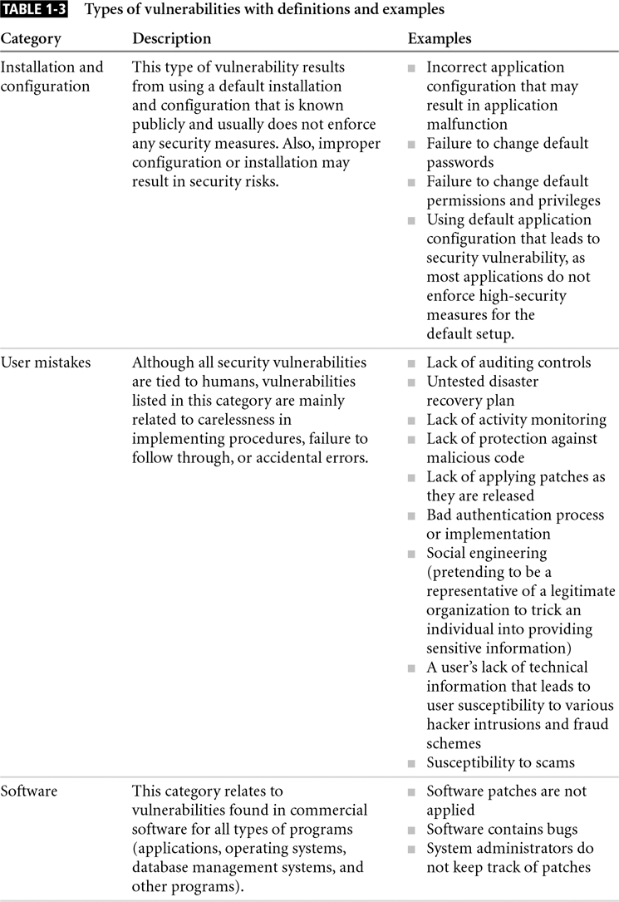
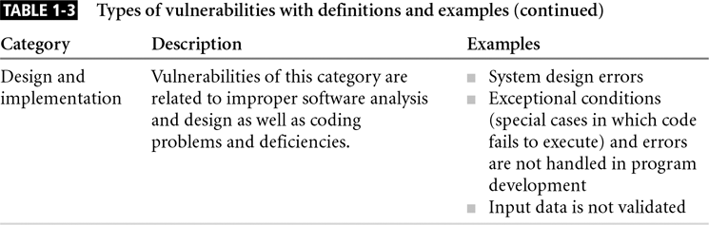
Type of Threats
As database administrator, database manager, or information security administrator, we need to be aware of these vulnerabilities and threats to protect organization and its assets.
As with the categorization of vulnerabilities, threats are categorized to ensure that everything that contributes to security risks is covered.
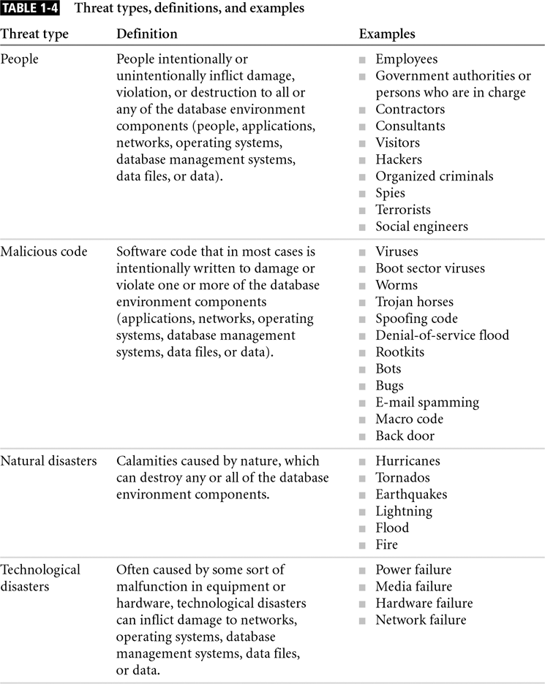

Types of Risks
Managers at all level are constantly working to assess and mitigate risks to ensure the continuity of departmental operations. We need not only to understand system weakness and threats, the probability of these threats actually occurring.
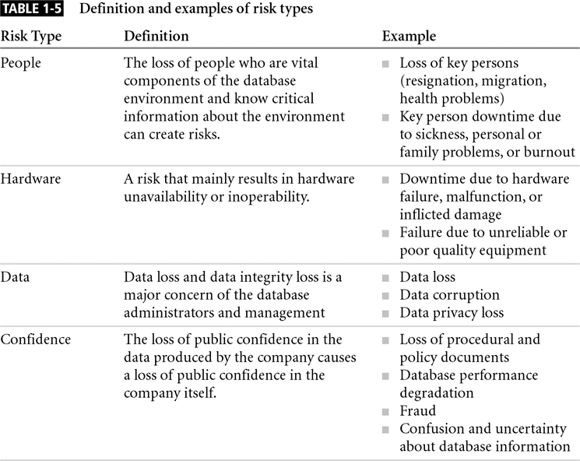

Assets Types and Their value
People always tend to protect assets regardless of what they are. The degree of protection we provide is directly based on how much we value the assets. Assets are the infrastructure of the company operation. Depending on the type of asset and how much the company values it, the company builds security policies and procedures and executes actions to protect these assets. There are four main types of assets:
Physical assets: Also known as tangible assets, these include buildings, cars, hardware, and so on.
Logical assets: Logical aspects of an information system, such as business applications, in house programs.
Intangible assets: Business reputation, quality, and public confidence
Human assets: Human skills, knowledge, and expertise.

Security Methods:
Security technology comprises a variety of methods that protect specific aspects of security architecture. In this section we explore most common methods used to secure the database environment.
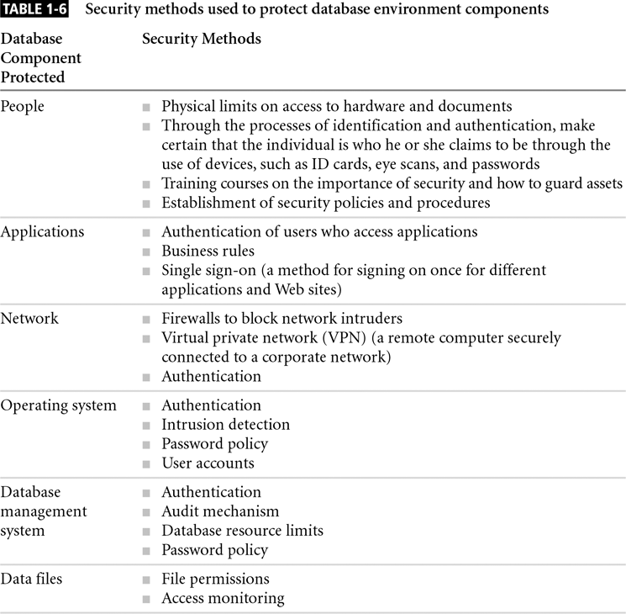
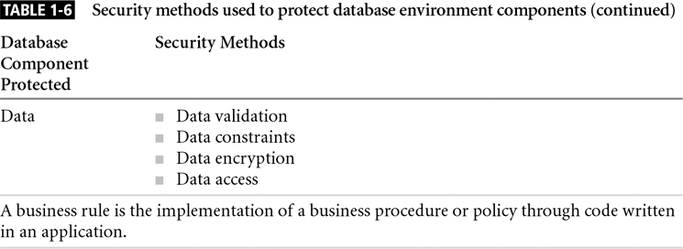

Database security Methodology:
This section presents an implementation process that can be used as a framework or methodology to outline the security tasks required for each stage. This process consists of phase similar to those of most software enginerring methodology.
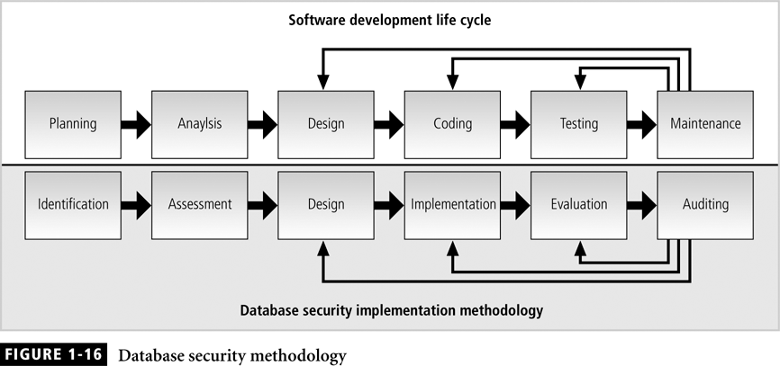

Figure presents database security methodology side by side with the software development life cycle (SDLC) methodology. First phase in the SDLC is to plan for resource and device a high-level project outlining. As a security architect or administrator, at the planning phase we are executing tasks in the identification phase. One of the task is this phase is identifying the security policy that will be adopted for this project.
Identification: This phase entails the identification and investigation of resource required and policies to be adopted.
Assessment: This phase includes analysis of vulnerabilities, threats, and risk for both aspects of database security.
Design: This phase results in a blueprint shows how security measures are implemented to enforce security.
Implementation: Code is developed or tools are purchased to implement the blue print outlined in the previous phase.
Evaluation: In this phase evaluate the security implementation by testing system against typical software attacks, hardware failure, natural disasters, and human errors.
Auditing: After the system goes into production, security audits should be performed periodically to ensure the security state of the system.

Database security definition revisited
Database security is a collection of security policies and procedures, data constraints, security tools blended together to implement all necessary measures to secure the integrity, accessibility, and confidentiality of every component of the database environment. These components include people, applications, networks, operating systems, database management systems, data files and data

