DATABASE SECURITY
AND AUDTING

CHAPTER 2
Operating System Security Fundamentals

Acknowledgement:
During spring 2006 through summer 2006, Phanindra Maddhi, a graduate assistant in Technology devoted efforts in developing this course. In the process, he studied extensively the content of the text. He tested all the Oracle SQL codes presented in the textbook. We had a lot of good discussions in the process, which benefited me tremendously. The notes you will read here is a result of his hard work.
We understand that there might be inaccuracies in the notes. Please give us the feedback so that we can correct any mistakes or errors in the notes.

Peter Ping Liu
August, 2006 in Charleston

Introduction:
Operating system security Fundamental” provides a quick but essential tour of the operating system functionalities from a security perspective. The focal points of the chapter are an explanation of the components of the operating system security environment, operating system vulnerabilities, and password policies. This chapter presents, from a database perspective, an overview of operating system security issues that help us to gain an understanding of how security violations occur and where to focus efforts to protect a database.

Learning objectives:
- Explain the functions of an operating system
- Describe the operating system security environment from a database perspective
- List the components of an operating system security environment
- Explain the differences between authentication methods
- Outline useful user administration best practices
- List the criteria of strong password policies
- Describe operating system vulnerabilities
- Describe security risk posed by e-mail services.

Operating system overview

The operating system is one of the main access point to the database management system. When we want to access the database locally or remotely, we are authenticated by the operating system. Once we are authenticated to the system, we can operate or access the resource for which we have authorized, based on the set of privileges granted. Since the database resides on a machine operated by the operating system, the operating system becomes the first line of defense for any database security violation and infringements.
An operating system is a collection of programs that allows the user to operate the computer hardware.
The following describe the three layers of a computer system,
- The inner layer represents the computer hardware, which is managed and controlled by the middle layer.
- The middle layer is the operating system
- The outer layer represents all the different software used by users to solve a problem or perform specific task.
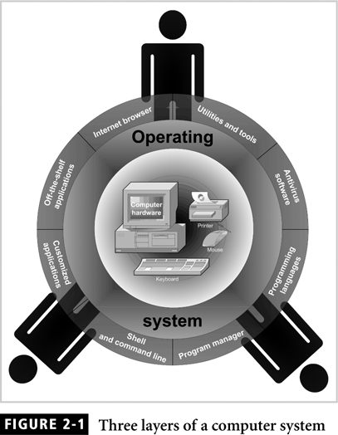

An operating system has a number of key function and capabilities as outlined in the following list:
- Performs multitasking
- Performs multisharing, that is, allow multiple users to use the computer hardware at the same time.
- Manage computer resource such as CPU, memory, input and output devices, and disk storage.
- Controls the flow of activities.
- Provides a user interface to operate the computer
- Administers user actions and accounts
- Runs software utilities and programs
- Provides functionality to enforce security measure
- Schedule job and task to be run
- Provide tools to configure the operating system and hardware.

The Operating system security environment
The operating system component of the database environment can open the door to unlawful individuals who contravene rules imposed to protect the database and its data.
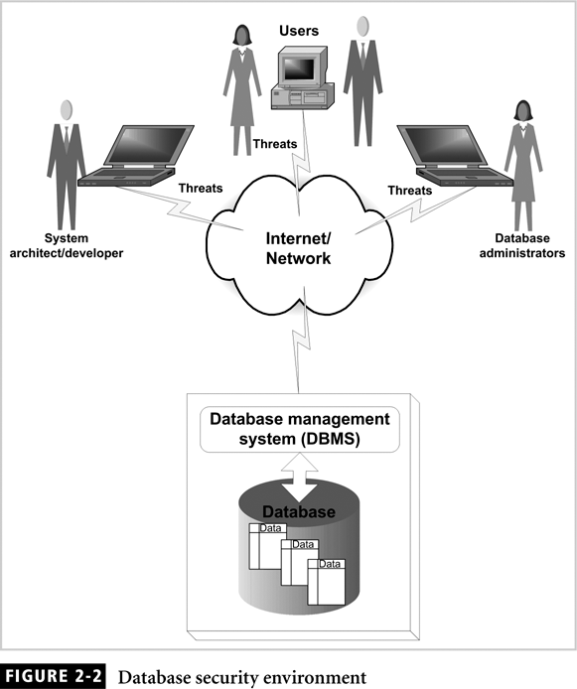

The components of an operating system security environment
The components that make up the operating system security environment are used as access point to the database. These access points are weak and insecure links to data within the database. The three components of the operating system are represented memory, services, and files. The service component comprises such operating system feature and functions as network service, file management, and web service.
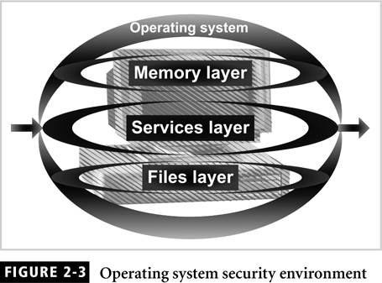
The memory component is the hardware memory available on the system, whereas the file component consists of the file stored on the disk.

Authentication Methods
Authentication is a fundamental service of the operating system. It is a process that verifies the identity of the user to permit access to the operating system. A weak authentication method exposes the system to security risks and threats. Most security administrators implement two types of authentication methods, physical and digital.
The physical authentication method allows physical entrance to the company property.
The digital authentication method is the process of verifying the identity to the user by means of a digital mechanism or software. The following section list digital authentication mechanisms used by many operating systems and implemented by many organization.

Digital Certificate
A digital certificate is a type of authentication that is widely used in e-commerce. A digital certificate is a digital passport that identifies and verifies the holder of the certificate.
Digital Token
A digital token is a small electronic device that users keep with them to be used for authentication to a computer or network system. Usually, this device displays a number unique to the token holder, which is used with the users PIN as the password.
Digital card
A digital card is also known as a security card or smart card. This card is similar to a credit card in dimensions but instead of a magnetic strip, it has an electronic circuit that stores user identification information such as name, ID, password, and other related data.
Kerberos
Kerberos was developed by the to enable two parties to exchange information over an open network by assigning a unique key, called a ticket, to each user. This ticket is used to encrypt communicated message.
Lightweight Directory Access Protocol (LDAP)
LDAP is an authentication method uses a centralized directory database storing information about people, offices, and machines in a hierarchical manner. An LDAP directory can be easily distributed to many network servers. We can use LDAP to store information
- Users
- Passwords
- Internal telephone directory
- Security keys
LDAP servers are effective for reading information from the directory but are not suited for data that is frequently changing. Many operating systems and applications

NTLM
NT LAN Manager employs a challenge/response authentication protocol that uses an encryption and decryption mechanism to send and receive passwords over the network.

Public Key Infrastructure (PKI)
PKI, also know as public key encryption, is an authentication method in which a user keeps a private key and the authentication firm hold a public key. Thes e two key are used to encrypt and decrypt communication message between the two parties.. The private key is usually kept as a digital certificate on the user’s system.

Radius
Remote Authentication Dial-in user services is an authentication method commonly used by network device to provide a centralized authentication mechanism.

Secure Socket Layers
Secure socket layers is a method in which authentication information is transmitted over the network in an encrypted form. This method is commonly used by web site t secure client communication.

Secure Remote Password
SRP is a protocol in which the password is not stored locally in encrypted or plain text form. This method is very much easy to install and does not require client or server configuration.

Authorization:
Authentication is the process of proving that users really are who they claim to be Authorization, is a process that decides where users are permitted to perform the functions they request.

User Administration
Authentication and authorization are essential service that every operation system provides in order to secure access to the computer’s logical and physical resources
. Administrators use this functionality to create user accounts, set password policies, and grant privileges to users. Although hackers do not often tap into user administration, improper use of this feature can lead to security risks and threats.

Password policies
A good password policy is the first line of defense against the unwanted accessing of an operating system. In most cases hackers utilize tools that use the dictionary method to crack passwords. These tools use the permutations of word in the dictionary to guess the password.
The following password practices can be employed to devise a policy plan that suits company.
Password aging: Tells the system how many days a password can be in effect before it must be changed.
Password reuse
Password history
Password encryption: A method that encrypts the password and stores in a way that it cannot be read directly.
Password storage: The place where the password is stored and kept hidden from the public
Password complexity: This is one of the most important password practices that should be implemented for any policy.
Logon retires: unsuccessful users try to logon up to three times
Password Protection:
Proper measure need to taken to store the password.
Single sign-on: Single sign-on allows to sign on once to a server and then not have to sign on again.

Email Security
E-mail may be the tool most frequently used by hacker to exploit viruses, worms, and other computer system invaders. This is true no doubt because e-mail is the tool most widely used by public and private organizations as a means of communication. To prevent this e-mail server on a machine in which sensitive data resides, and do not disclose technical details about the e-mail server without a formal written request from the technology group manger.

