DATABASE SECURITY
AND AUDTING

CHAPTER 7
Database Auditing Models
Acknowledgement:
During spring 2006 through summer 2006, Phanindra Maddhi, a graduate assistant in Technology devoted efforts in developing this course. In the process, he studied extensively the content of the text. He tested all the Oracle SQL codes presented in the textbook. We had a lot of good discussions in the process, which benefited me tremendously. The notes you will read here is a result of his hard work.
We understand that there might be inaccuracies in the notes. Please give us the feedback so that we can correct any mistakes or errors in the notes.

Peter Ping Liu
August, 2006 in Charleston

Introduction:
“Database Auditing Models” is a fundamental chapter for understanding database auditing. The chapter explains the difference between and the interdependence of security and auditing. This chapter defines the role and responsibilities of the auditor and presents a full discussion of the auditing environment and auditing benefits and side effects. This chapter is fundamental for next 2 chapters.

Learning objectives:
- Overview of auditing fundamentals
- Understand the database auditing environment
- Create a flowchart of the auditing process
- List the basic objectives of an audit
- Define the differences between auditing classification and types
- Benefits and side effect of an audit
- Creating of our own auditing models

Symbols:

 Important points Note

In this chapter another key aspect of data confidentiality, integrity, and accessibility is presented database auditing, thus providing the full complement to database security. The two concepts are inseparable. Together they ensure that your data is protected. We ensure that data is well guarded through database auditing. Database security is not effective without database auditing and vice versa. To prevent data violations, the best practice is to have both database security and auditing in place.
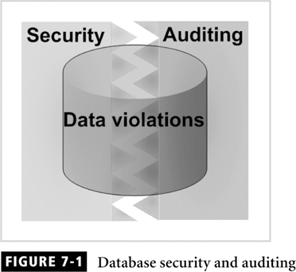

Auditing overview
We need to know some fundamentals about auditing itself. In this section we learn the definition of basic auditing terms. The goals of an audit are usually consistent. In general, an audit examines the documentation that reflects the actions, practices, and conduct of a business or individual. Then it measures the compliance to policies, procedures, processes, and law. The following list contains both general auditing and database auditing definitions.
Audit/ Auditing: The process of examining and validating documents, data, processes, procedures, system, or other activities to ensure that the audited entity complies with its objectives.
Audit log: A document that contains all activities that are being audited ordered in a chronological manner. Usually, an automated system generates the log.
Audit objectives: A set of business rules, system controls, government regulations, or security policies against which the audited entity is measured to determine compliance.
Auditor: A person who is authorized to examine, verify, and validate documents, data, processes, procedures, systems, or activities and to produce an audit report.
Audit procedure: A set of step-by-step instructions for performing the auditing process.
Audit report: A document that contains the audit findings and is generated by individuals conducting the audit.
Audit trail: A chronological record of document changes, data changes, system activities, or operational events.
Data audit: A chronological record of data changes stored in a log file or a database table object.
Database auditing: A chronological record of database activities, such as shutdown, startup, logons, and data structure changes of database objects.
Internal auditing: An examination, verification, and validation of documents, processes, procedures, systems, or activities conducted by staff members of the organization being audited.
External auditing: An examination, verification, and validation of documents, processes, procedures, systems, or activities conducted by staff members outside of the organization being audited.

Auditing Activities
Auditing activities are performed as a part of an audit, audit process, or audit plan. Some of these activities can be thought of as the auditor’s responsibilities or they can be incorporated into an organization’s audit policies.
The importance of these responsibilities is exemplified in the strict guidelines of the financial industry. Their standards and regulations dictate that all financial transactions must be stored for a specific time and all change to an account must be recorded, including the name of the person who performed the change, the time of change, and the pervious state before it was changed.

Auditing Environment
An auditing can be conducted as a review of the enforcement of security policies and procedures. These are only a few of the many reasons for audits. However, as diverse as these audits are, they all take place in an auditing environment. In this section we learn about the general auditing environment and its components and how it compares to the database auditing environment.
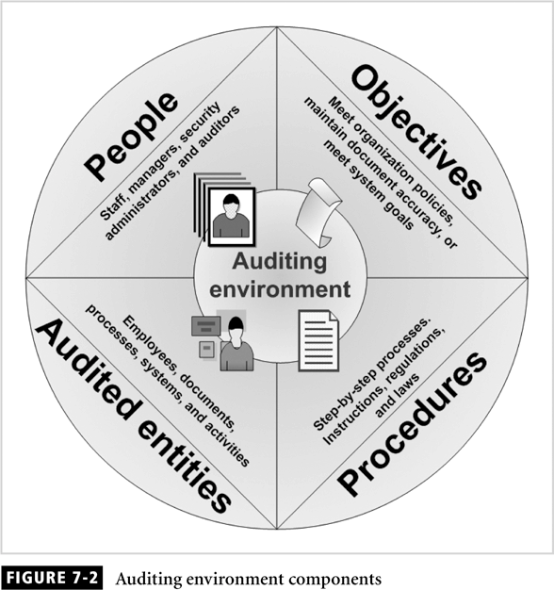

Objectives: An audit without a set of objectives is useless. To conduct an audit we must know what the audit entity is to be measured against.
Procedures: To conduct an audit, step-by-step instructions and tasks must be documented ahead of time.
People: Every auditing environment must have an auditor, even in the case of an automatic audit.
Audited entities: This includes people, documents, processes, systems, activities, or any operations that are being audited.
The auditing environment present is applicable to all aspects of the business including the database. The auditing environment for database auditing differs slightly from the generic auditing environment in that it distinguishes the database from the other auditable entities.
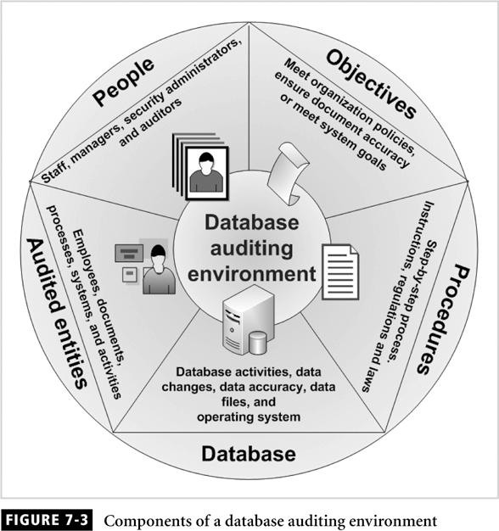
When designing an auditing model for database application. We need to account for all the components shown in the figure to ensure auditing model is complete and effective. Design and develop an application system or business process that requires auditing, we must think about every objective related to these components.

Auditing Process
The auditing process ensures that the system is working and complies with the policies, standards, regulations, or laws set forth by the organizations. Auditing is also not the same as performance monitoring. Their objectives are totally different. The main objective of performance monitoring is to observe if there is degradation in performance at various operation times, which is totally different from auditing. Auditing validates compliance to policy, not performance.

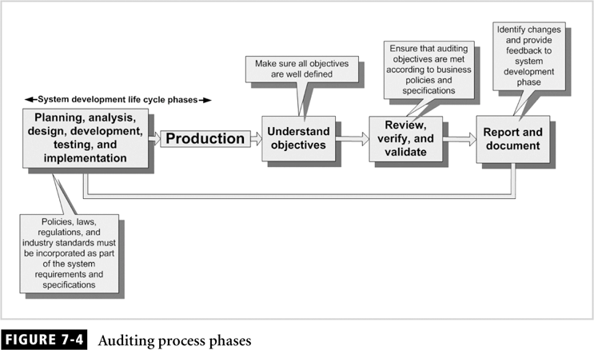

The first block on the left is the full system development life cycle, known as SDLC. In this block the system goes through a structured process of development. One of the phases in this block is QA testing, which is designed to identify bug in the code and make sure the system fulfills the requirements of the functional specifications. The first phase of the process is to understand the objectives of the audit and plan a procedure to execute the auditing process. The second phase is to review, verify, and validate the system according to the objectives set in the previous phase. Divergence from the auditing objectives is documented. In this phase we are observing what is happening. The last phase is to document the results of the audit and recommend changes to the system.
Auditing Objectives
Auditing objectives are established and documented for the following reasons
Complying: identify all company policies, government regulation, laws, and the industry standards with which company comply.
Informing: All policies, regulations, law, and standard must be published and communicated to all parties involved in the department and operation of the audited entity.
Planning: All the objectives enables the auditor to plan and document procedures to assess the audited entity.
Executing: without auditing objectives, the person conducting the audit cannot evaluate, verify, or review the audited entity and cannot determine if the auditing objectives have been met.

Here are the top ten database auditing objectives:
Data integrity: Ensure that data is valid and in full referential integrity.
Application users and roles: Ensure that users are assigned roles that correspond to their responsibilities and duties.
Data confidentiality: Identify who can read data and what data can be read.
Access control: Ensure that the application records times and duration when a user logs onto the database or application.
Data changes: create an audit trail of all data changes.
Data structure changes: Ensure that the database logs all data structure changes.
Database or application availability: Record the number of occurrences and duration of application or database shutdowns and all startup times.
Change control: Ensure that a change control mechanism in incorporated to track necessary and planned changes to the database or application.
Physical access: Record the physical access to the application or the database where the software and hardware resides.
Auditing reports: Ensure that reports are generated on demand or automatically, showing all auditable activities

Auditing classification and types
Every industry and business sector uses different classifications of audits. In addition, the definition of each classification can differ from business to business. In this section we learn the most generic definitions of audit classifications. These categories are applicable to all industries.

Audit classifications
This section outlines the different audit classifications.
Internal Audit
An internal audit is an audit that is conducted by a staff member of the company being audited. The purpose and intention of an internal audit is to;
- Verifty that all auditing objectives are met by conducting a well-planned and scheduled audit.
- Investigate a situation that was prompted by an internal event or incident. This audit is random, not planned or scheduled.
- Investigate a situation that was prompted by an external request. This audit is random, not planned

External Audit
An external audit is conducted by a party outside the company that is being audited. The purpose and intention of this audit it to
- Investigate the financial or operational state of the company.
- Verity that all auditing objectives are met. This is a planned and scheduled.

Automatic Audit
An automatic audit is prompted and performed automatically. These audit are used mainly for systems and database systems. Some systems that employ this type of audit generate report and logs.

Manual Audit
Manual Audit is performed completely by humans. The audit team uses various methods to collect audit data, including interviews, document reviews, and observation.

Hybrid Audit
A hybrid audit is a combination of automatic and manual audits. Most audits fall into this classification.

Audit types
The following types of audit are conducted by various business sectors;
Financial audit: Ensure that all financial transactions are accounted for and comply with the law.
Security audit: Evaluates if the system is as secure as it should be. This audit identifies security gaps and vulnerabilities.
Compliance audit: Verifies that the system complies with industry standards, government regulations, or partner and client policies.
Operational audit: Verifies if an operation is working according to the policies of the company.
Investigative audit: performed in response to an event, request, threat, or incident to verify the integrity of the system.
Product audit: performed to ensure that the product complies with industry standards. This audit is sometimes confused with testing; it should not be.
Preventive audit: Performed to identify problems before they occur.

Benefits and side Effects of Auditing
Audit benefits should enhance understanding of the importance of audit.
Conducting audits more frequently than necessary causes side effects.

Auditing Models
Security and auditing are the two inseparable elements of data and database integrity. Database auditing can be implemented by utilizing built-in feature of the database or by creating own mechanism. Both methods serve the same purpose.
If we decide to build own auditing utility, this section will help in designing an audit model to fit business requirements.
It is important that we need to understand how auditing is processed for data and database activities. The flowchart shows what happens when a user performs and action on a database object. Specific checks occur to verify if the action, the user, or the object are registered repository.
- State of the object before the action was taken along with the time of the action.
- Description of the action that was performed
- Name of the user who performed the action

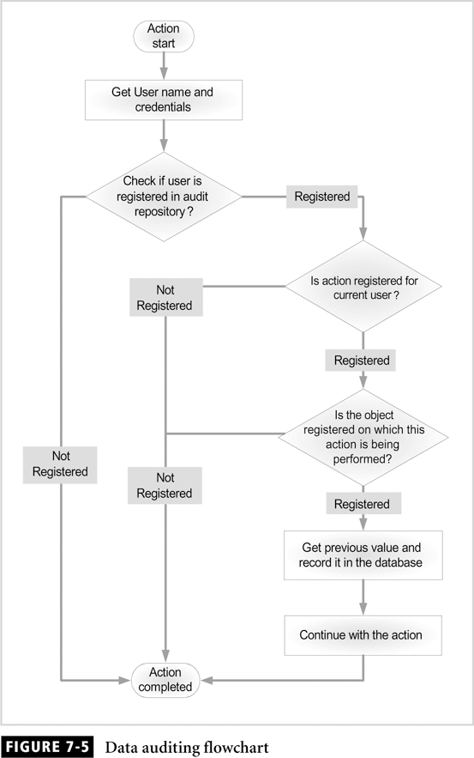

Simple Auditing Model 1:
The first auditing model is called “simple” because it is easy to understand and develop.
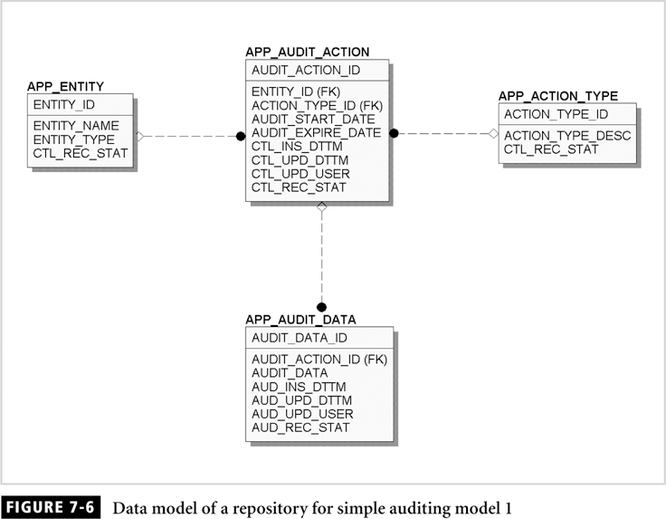

An entity can be a user, table, or column, and an activity can be DML transaction or logon and off times. The repository is used by the auditing process to check if the user, action, and object are to be audited.
Tables 7-2 and 7-3 for brief description of the tables and columns presented in this model

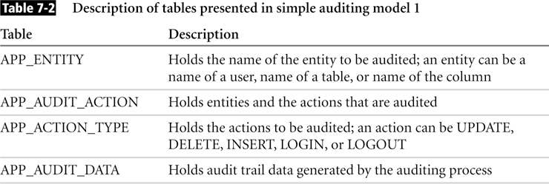

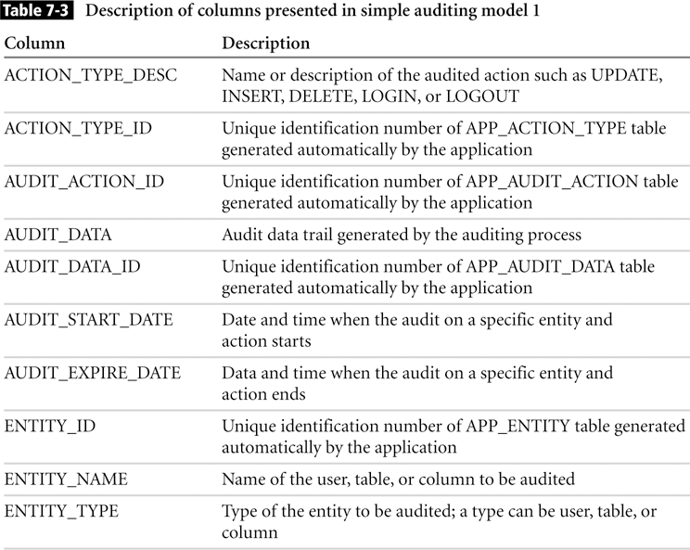

A control column is a placeholder for data that the application inserts automatically when a record is created or updated. It stores data about the current record, such as date and time the record was created and updated.

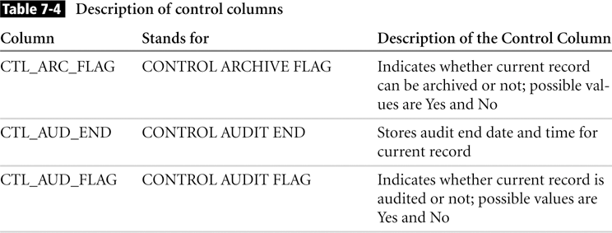
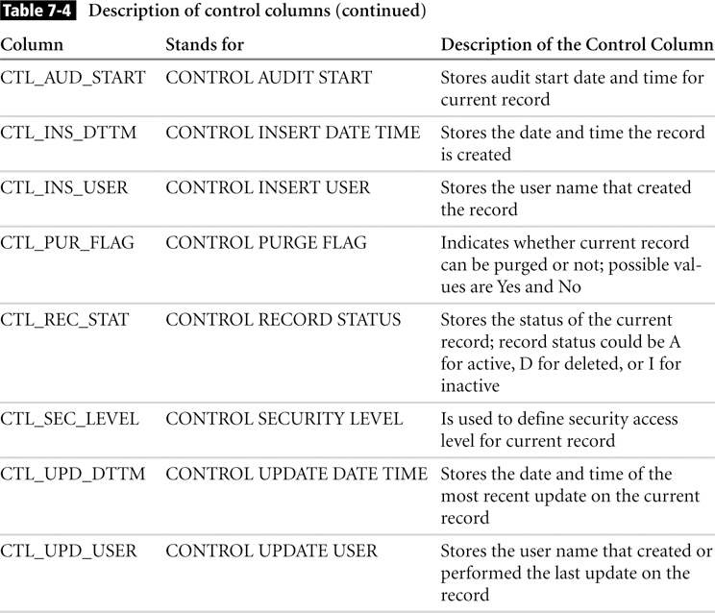

Simple Auditing model 2
In this model, only the column value changes are stored for audit purpose. The audit data table APP_AUDIT_DATA contains chronological data on all changes on columns that are registered in APP_AUDIT_TABLE. In this model there is a mechanism to help reduce the amount of data stored in the database. In addition, the AUDIT_DATA column in the APP_AUDIT_DATA table must be large object data type in order to fit all column values being audited.
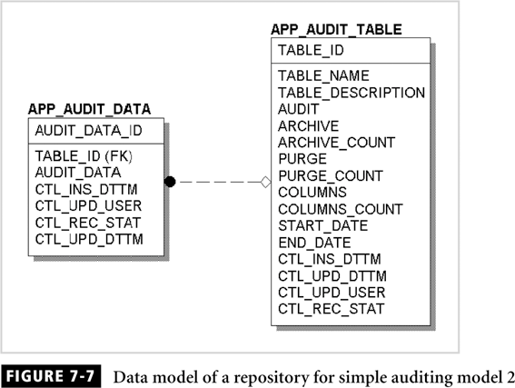
Tables 7-6 and 7-7 for brief description of the tables and columns presented in this model

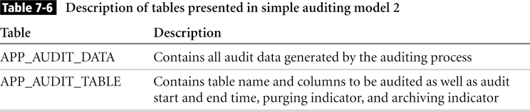

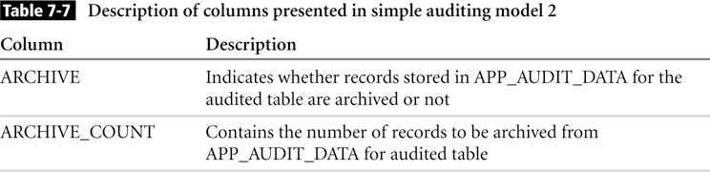
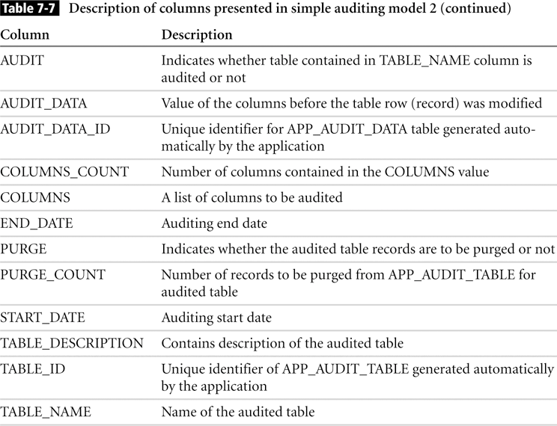
Advance Auditing Model
This model is called “advanced” because of its flexibility. It is more flexible than the simple model because it can be used as an auditing application with a user interface.

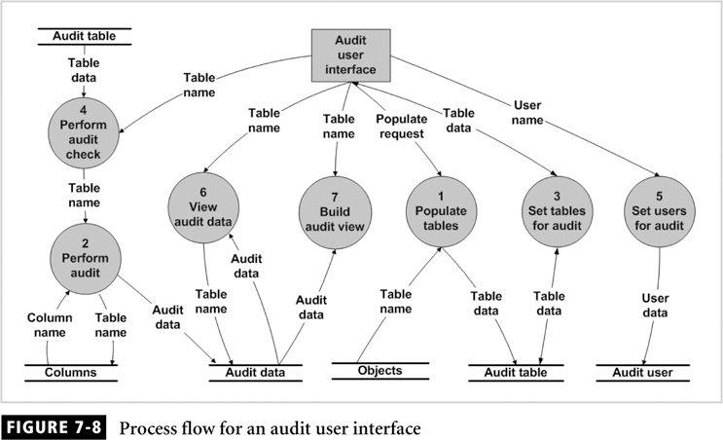

The responsitory for this model is more complex than previous models. It contains data stores to register all entities that can be audited. The auditing level of the model is referred to as fine grained. The model can handle auditing users, actions, table and column entities.

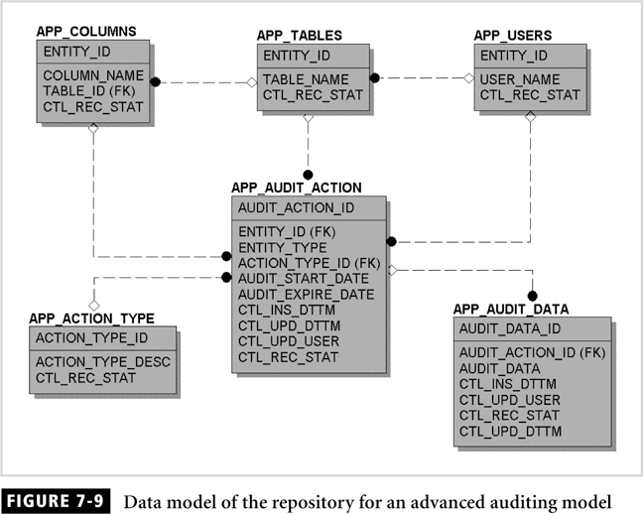

Tables 7-8 and 7-9 for brief description of the tables and columns presented in this model
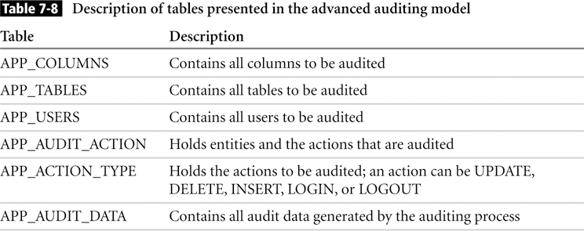
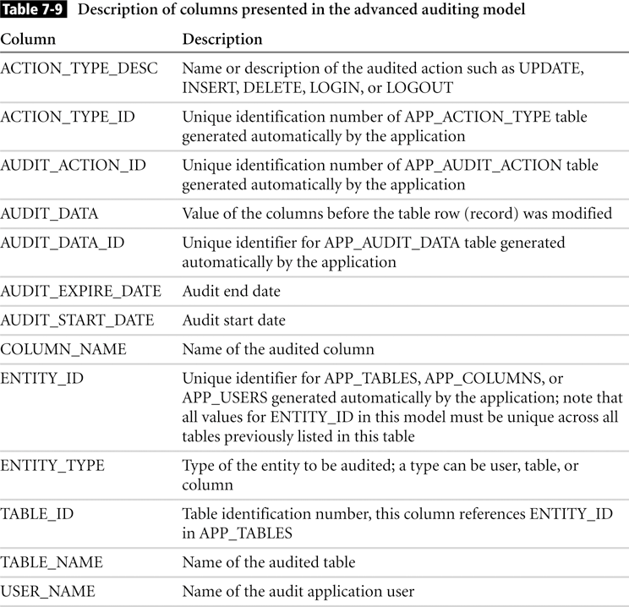

Historical Data Model
This model is used for applications that require a record of the whole row when a DML transaction is performed on the table. This model is typically used in most financial application. With this model, the whole row is stored in the HISTORY table, before it is
Changed or deleted.
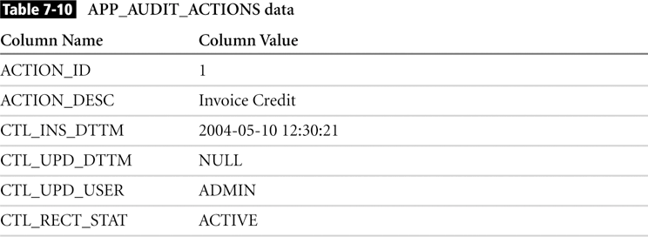

Auditing Application Actions Model
There may be requirement for an application to audit specific operations or actions, as illustrated. For example we may want to audit a credit to an invoice, the reason for it being credited, the person who credited it, and the time it was credited.
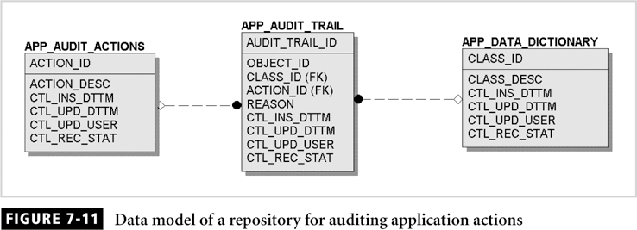

The sample data in these tables would look like the data presented in Tables 7-10, 7-11, and 7-12.
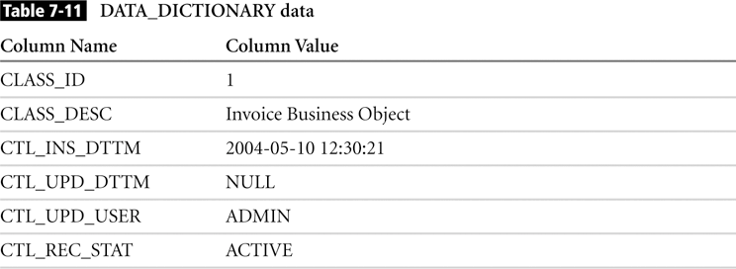
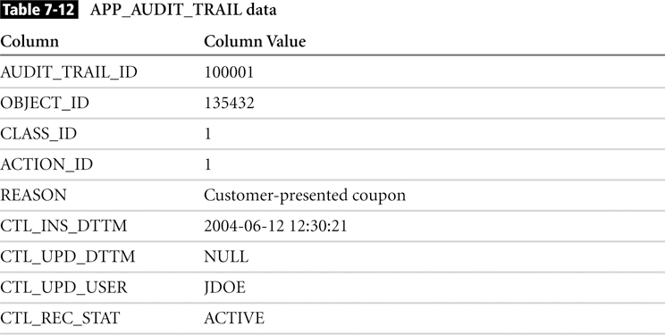

The OBJECT_ID column of the APP_AUDIT_TRAIL table is the ID of the invoice record. As we see, the model doesn’t track changes to data in specific columns or rows, but rather identifies an operation performed within the application itself.

