Starting/Stopping Oracle Service at command line --
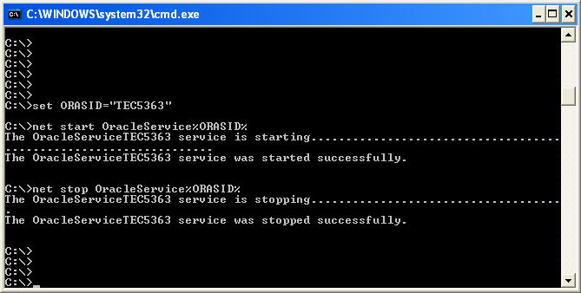

Using a dos bat file --
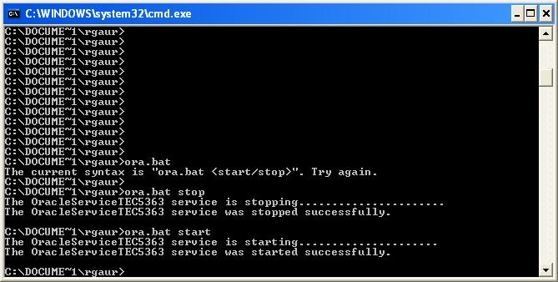
Contents of “ora.bat”
(I named my Oracle instance “TEC5363”. Replace it w/ your instance name) –

@echo off
set ORASID="TEC5363"
if "%1" == "stop" goto stop
if "%1" == "start" goto start
goto noparm

:start
net start OracleService%ORASID%
goto :end

:stop
net stop OracleService%ORASID%
goto :end

:noparm
echo The current syntax is "ora.bat <start/stop>". Try again.

:end

