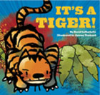
It’s A Tiger
By David LaRochelle

Action Verbs

Review with the students what an action verb is, something that you do. Read the story to the students showing the pictures as you go. Every time the students hear an action verb in the story, they must act it out (running in place, jumping etc). As a follow up activity to the book, have students pull an action verb out of a container and act it out while the other students try to guess what the verb is. This is a good activity to give students extra practice and exposure to figuring out what an action verb is.

