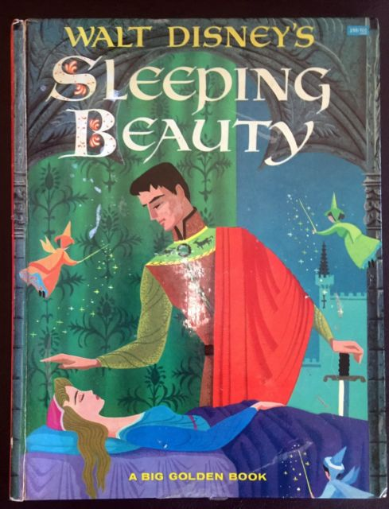
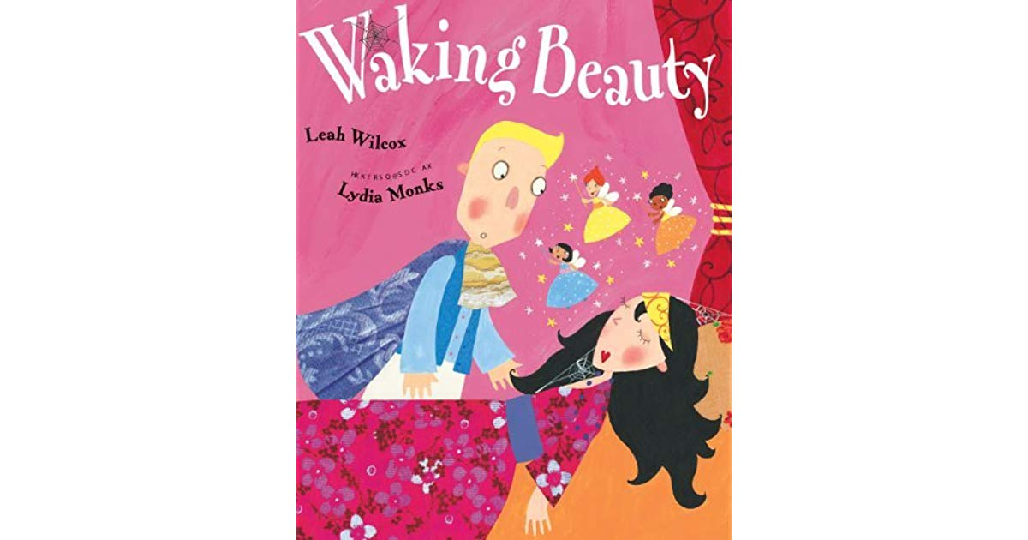

Title: Walt Disney’s Sleeping Beauty as told by Jane Werner Watson
and Waking Beauty by Leah Wilcox
Illustrator: Walt Disney’s Sleeping Beauty – pictures by the Walt Disney Studio
Waking Beauty – illustrations by Lydia Monks
Grade level: 2nd – 3rd
Synopsis: Sleeping Beauty is a story about a princess who becomes cursed by an evil fairy. The good fairies raise her in the forest, but the curse comes true on the eve of her sixteenth birthday. She falls into a deep sleep and can only be awoken by true loves kiss. In the end, she finds her prince and they live happily ever after.
Synopsis – Waking Beauty takes the original fairy tale and give it a twist. The prince has a hard time realizing that he must kiss the princess for her to wake up. He eventually does kiss her, but when she wakes up she is mad he kissed her without her permission. She hits him and then he is the one asleep. The princess wakes HIM with a kiss.
Resources: http://thinkerlife.fun/editable-venn-diagram/editable-venn-diagram-venn-diagram-program-new-blank-brain-diagram-blank-template-free/
Materials:
- Venn Diagram
- Colored pencils or
- Markers or
- Crayons

Activity:
- After listening to both “Sleeping Beauty” and “Waking Beauty”, students will make a Venn Diagram
- Students will compare and contrast the stories
- The sides that say “different” will have events that only happen in one of the stories
- The middle column says “both” and will have events that occur in both stories
- Students can use a different colored writing utensil for each section

