EIU ACS-SA
January 21, 2015

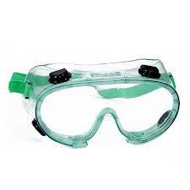
Thank you for all that helped with goggle sales and class talks!
We also will be selling goggles on Thursday (January 22) if you still need to get them.


Like us on Facebook and checkout our website (http://castle.eiu.edu/~acssaeiu/) to stay updated on all ACS-SA events!

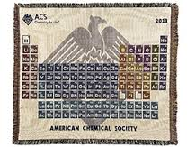
Points System
Meetings- 1 point
Volunteering, selling (goggles, bake sale)- 2 points
Field trips- 3 points

First prize is a periodic table blanket.
Second prize is a Jimmy Johns gift card.

There will be prizes through out the semester as well.


Back to school event
Movie night! “The Interview”
Next Wednesday (January 28) at 4 in Phipps. (You will be notified if there is a change in location).

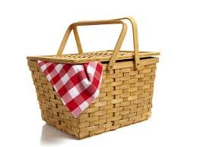
Spring Picnic
April 10th
At Morton Park (across from Taco Bell), in the conference room if there is bad weather.
There will be hamburgers, hotdogs, veggie burgers, etc.
Frisbee, volleyball, and other activities!

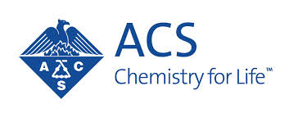
T-shirts
If you have an idea send it to Caroline (ckohout@eiu.edu) by February 4th.
If your design wins you get a free shirt! Otherwise they are usually around $11.

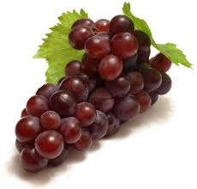
Field Trip
Brewery or Winery
A couple brewery options:
- Goose Island –Chicago
- Budweiser Busch Brewery –St. Louis
E-mail Savannah (sckapper@eiu.edu) if you have an idea for a field trip or activity.

Upcoming events and volunteer opportunities:
- Poster session with the University of Illinois
  - Great way to network and see what students at other schools are doing.
  - We have a poster for ACS if you would like to present but don’t have a poster.
- Faculty vs. student jeopardy (February)
- Blood drive (February/March)
- Food pantry volunteering
- Fox Ridge clean up (April)
- Polar Plunge
  - Feb 28th at Lake Sarah in Effingham
  - Raises money for the Special Olympics
- Relay for Life
  - Sunday, April 12th on the Panther Trail
- The next meeting will be Wednesday February 4th at 4 p.m. (if there is no seminar).
  - Check the boards in your classrooms for a possible time change.

