Table of Contents
- Defining Terms
- Provided Feature Layers
- Creating the Feature Layers
  - Preparatory Stage
  - Filtering Stage
  - Aggregation and Look-Up Table Creation Stage
  - Simplification and Smoothing Stage
- Further Filtering Your Data
- Methods of Look-Up
- Index of Fields
  - Feature Layer
  - Lookup Table

Defining Terms
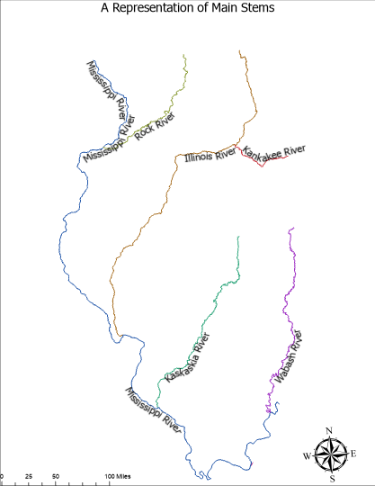
Figure 1: A map illustrating the concept of main stems.
Main Stem: A full river extended up to its headwaters. Discernable within NHD data by stream level and level path identifier. A demonstration of main stems can be seen in figure 1.

Provided Feature Layers
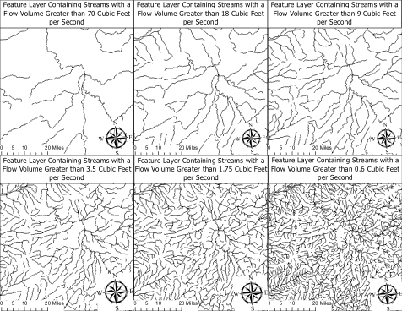
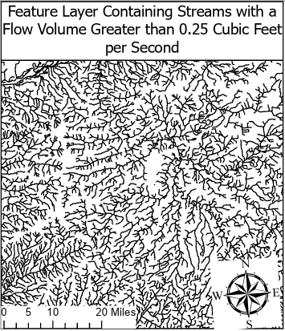
Figure 2: Maps centered on Springfield showing each of the provided feature layers

Flow Volume Cutoff | Recommended Scale
70 Cubic Feet per Second | 1:5,000,000
18 Cubic Feet per Second | 1:2,000,000
9 Cubic Feet per Second | 1:1,000,000
3.5 Cubic Feet per Second | 1:500,000
1.75 Cubic Feet per Second | 1:250,000
0.6 Cubic Feet per Second | 1:100,000
0.25 Cubic Feet per Second | 1:50,000
Figure 3: Table providing recommended scale for each feature layer.
The IL Hydro project currently provides seven feature layers illustrated in the above image. Through a comparison with the visibility filter field included within the NHD dataset we have targeted specific recommended scales during the filtering stage of our workflow. The above table illustrates the recommended scales for each of our provided feature layers.

Creating the Feature Layers
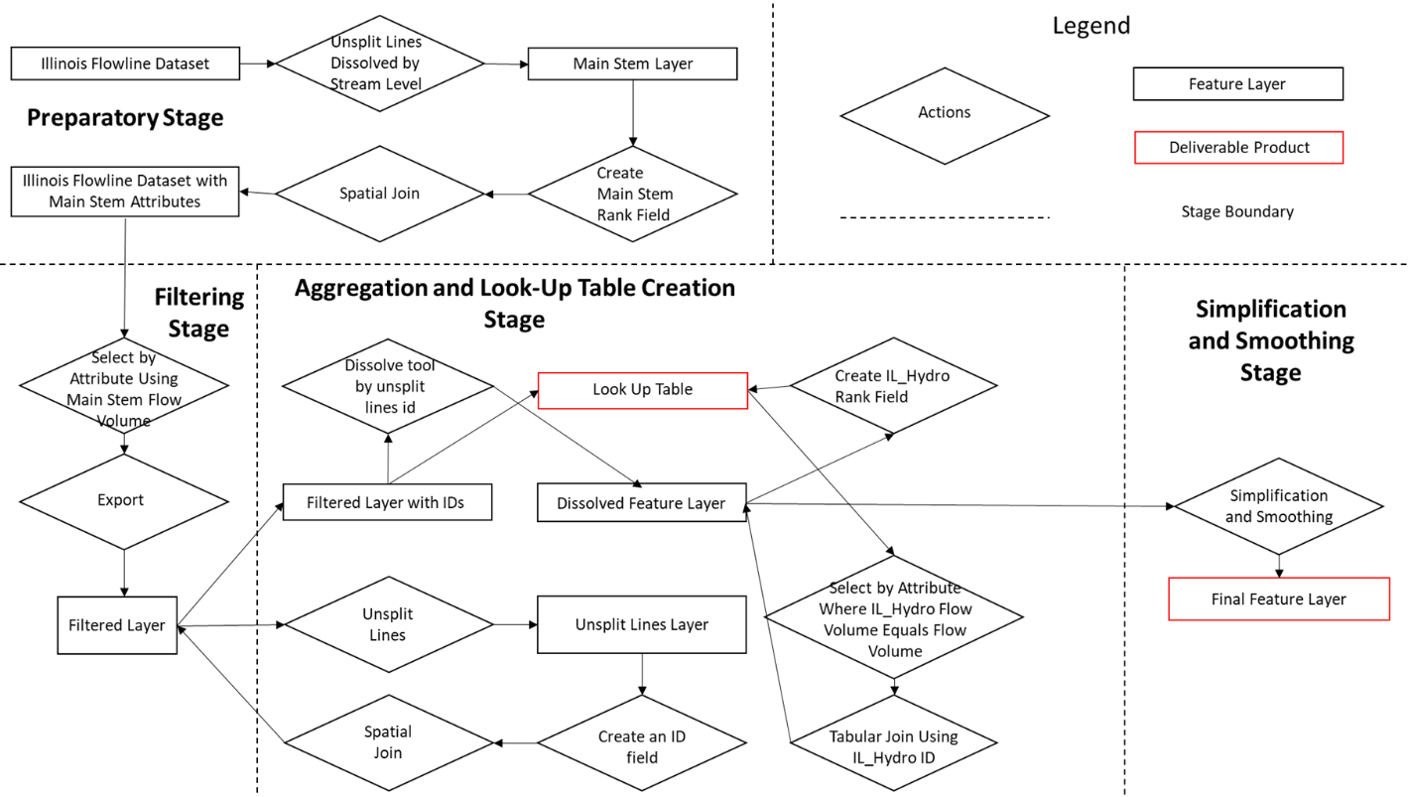
Figure 4: A visual representation of the work flow used to create the feature layers provided on our website.
Preparatory Stage
Using NHD Plus data in the form of several HU-4 subregions, we first clipped reach of the HU-4 datasets to a buffered border of the state of Illinois using a polygon feature taken from (natural earth link). We then merged each of the flowlines feature classes, the EROMMA, and the Flowlines VAA tables to receive versions of each for the state of Illinois. Performing tabular joins using the NHDPlusID attribute we create the Illinois Flowline Dataset seen in the top right of figure 4.
To create a feature layer representing the main stems of the flowlines, for the purpose of standardizing values across the main stem, we use the unsplit lines tool dissolved by stream level. The majority of main stem attributes represent the maximum values of the component streams. An exception to this is the main stem name field, which is the most common value among all main stems. We then use a spatial join to import the main stem attributes into the initial dataset.
Filtering Stage
Using a select by attribute query we select all streams with greater than a specific main stem flow volume. We then export the results into a new feature layer.
Aggregation and Look-Up Table Creation Stage
This newly created filtered layer is then run through a unsplit lines operation to remove obsolete stream junctions created during the filtering process. Unfortunately, due to a peculiarity of the unsplit lines tool line features are created as multipart features, which inhibits the use of simplification algorithms. To avoid this problem, we first create an id field, IL Hydro ID, for each of the unsplit lines features and then use a spatial join to import IL Hydro IDs into the filtered dataset. We then use the dissolve tool, which does not have the multipart feature issue, dissolved by the IL Hydro ID field. We then use a python tool to rank each of the dissolved streams by flow volume.
As a consequence of merging together multiple stream segments we remove the ability of the user to cross reference the final dataset with other NHD data. To reference between the IL Hydro feature layers and look-up tables, we use the IL Hydro ID field. The look-up table is created using a spatial join back onto the filtered feature layer and then exporting the table as a standalone table. To provide a means of joining NHD data on IL Hydro Data, we create a representative id field using the constituent stream with the highest flow volume. This field is transferred from the look-up table to the feature layer using a tabular join.
Further Filtering Your Data
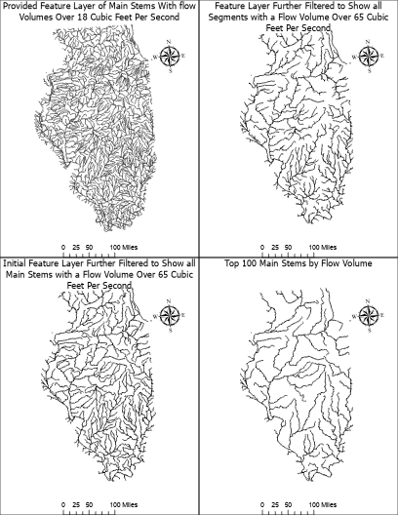
Figure 5: A demonstration of how an IL Hydro feature layer can be further filtered by the end user.
We provide several attributes that enable the end-user to further filter their feature layer. We provide main stem flow volume, which allows the filtering of streams while preserving headwaters, IL Hydro Flow Volume, which enables the user to remove headwaters, flow volume rankings of both main stems and the IL Hydro features, and main stem length.
Methods of Lookup
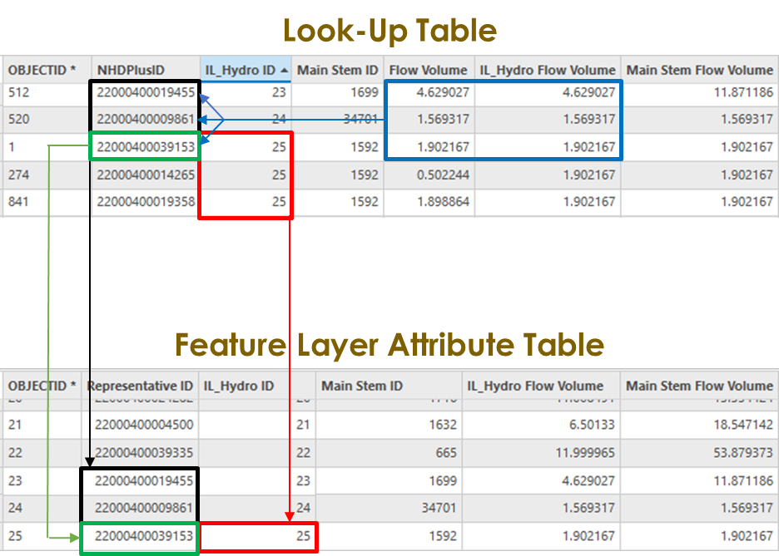
Figure 6: A demonstration of the connections between the feature layer and the look-up table.
The IL Hydro Project offers two methods of look-up, a look-up table and a representative id field. The look-up table allows a comparison between the IL Hydro feature layer and NHD data using the IL Hydro ID. Figure 6 demonstrates how the look-up table, on the top, connects to the attribute table of the feature layer, on the bottom. The black and green shows which features in the look-up table directly connect to features in the attribute table of the IL Hydro feature layer. The red demonstrates how multiple features within the look-up table aggregate into a single feature in the IL Hydro feature layer.
The Representative ID is the NHD ID of the component stream with the highest flow volume value. This id field allows for joins with other NHD data. However, the use of this method can have some negative impacts on the precision of data. This method means that a single data point is being used to represent several features, which can mean that data patterns are lost or values are misrepresented.
Index of Fields
Feature Layer
- Representative ID: The NHDPlusID of the component stream feature with the highest flow volume within the provided feature. This field can be used to create joins to other NHD data. However, this may not provide the full picture as it is only a representative portion against the full feature. Additionally, there may be inconsistencies where a feature’s component with the greatest flow volume is an artificial path.
- IL_Hydro ID: An ID field used to link together the feature layer and the lookup table.
- Main Stem ID: ID field inherited from the main stem feature layer used to produce all main stem attribute fields. Denotes which main stem a stream segment is a component of.
- IL_Hydro Flow Volume: Flow volume estimate taken from the NHDPlus EROMMA table measured in cubic feet per second. Described in the NHDPlus user guide as “mean annual flow from runoff.” Aggregated during the unsplit lines process using the max aggregation method.
- Main Stem Flow Volume: The largest flow volume value from all constituent streams of the main stem. The flow volume is derived from the FlowEstARunoffMA attribute field and is measured in cubic feet per second.
- Stream Level: attribute used to distinguish main stems from tributary streams. The number correlates to the number of main stems a stream segment is removed from the coastline.
- IL_Hydro Length: An automatically generated attribute denoting the length of the stream feature in the units of the feature class’s coordinate system.
- Main Stem Length: The Shape Length Value of the main stem feature associated with the stream segment.
- IL_Hydro Name: The GNIS_Name attribute value aggregated across the IL_Hydro feature using the mode operation.
- Main Stem Name: The GNIS_Name attribute value aggregated across the main stem using the mode operation.
- IL_Hydro Rank: A field denoting the ranking of each feature in the dataset measured using IL_Hydro Flow Volume.
- Main Stem Rank: A field denoting the ranking of each main stem measured using Main Stem Flow Volume during the preparatory stage of the work flow.
Lookup Table
- NHDPlusID: An ID field present within the NHDPlus used to identify features across all NHDPlus data.
- IL_Hydro ID: An ID field used to link together the feature layer and the lookup table.
- Main Stem ID: ID field inherited from the main stem feature layer used to produce all main stem attribute fields. Denotes which main stem a stream segment is a component of.
- Flow Volume: Flow volume estimate taken from the NHDPlus EROMMA table measured in cubic feet per second. Described in the NHDPlus user guide as “mean annual flow from runoff.”
- IL_Hydro Flow Volume: Flow volume estimate taken from the NHDPlus EROMMA table measured in cubic feet per second. Described in the NHDPlus user guide as “mean annual flow from runoff.” Aggregated during the unsplit lines process using the max aggregation method.
- Main Stem Flow Volume: The largest flow volume value from all constituent streams of the main stem. The flow volume is derived from the FlowEstARunoffMA attribute field and is measured in cubic feet per second.
- Stream Level: attribute used to distinguish main stems from tributary streams. The number correlates to the number of main stems a stream segment is removed from the coastline.
- Shape Length: An automatically generated attribute denoting the length of the stream feature in the units of the feature class’s coordinate system.
- Main Stem Length: The Shape Length Value of the main stem feature associated with the stream segment.
- GNIS_Name: The NHD data dictionary for feature classes refers to the GNIS Name field as “The Geographic Names Information System (GNIS) assigned proper name, specific term, or expression by which a particular geographic entity is known.”
- IL_Hydro Name: The GNIS_Name attribute value aggregated across the IL_Hydro feature using the mode operation.
- Main Stem Name: The GNIS_Name attribute value of the stream segment with the highest flow volume in the main stem.
- IL_Hydro Rank: A field denoting the ranking of each feature in the dataset measured using IL_Hydro Flow Volume.
- Main Stem Rank: A field denoting the ranking of each main stem measured using Main Stem Flow Volume during the preparatory stage of the work flow.

United States Department of the Interior, 2019, User’s Guide for the National Hydrography Dataset Plus (NHDPlus) High Resolution, https://pubs.usgs.gov/of/2019/1096/ofr20191096.pdf, pg. 18.
United States Department of the Interior, 2019, User’s Guide for the National Hydrography Dataset Plus (NHDPlus) High Resolution, https://pubs.usgs.gov/of/2019/1096/ofr20191096.pdf, pg. 40.
United States Department of the Interior, 2019, User’s Guide for the National Hydrography Dataset Plus (NHDPlus) High Resolution, https://pubs.usgs.gov/of/2019/1096/ofr20191096.pdf, pg. 18.
United States Department of the Interior, 2019, User’s Guide for the National Hydrography Dataset Plus (NHDPlus) High Resolution, https://pubs.usgs.gov/of/2019/1096/ofr20191096.pdf, pg. 18.
United States Department of the Interior, 2019, User’s Guide for the National Hydrography Dataset Plus (NHDPlus) High Resolution, https://pubs.usgs.gov/of/2019/1096/ofr20191096.pdf, pg. 40.
“National Hydrography Dataset (NHD) Data Dictionary Feature Classes,” USGS, United States Geological Survey, accessed July 28, 2025, https://www.usgs.gov/ngp-standards-and-specifications/national-hydrography-dataset-nhd-data-dictionary-feature-classes.

