PHP Work:

- Install PHP 5.3, VC6 for Apache. (8/1/2009)
http://windows.php.net/download/

VC 6, Non thread safe, Installer

Run the Installer after downloading.

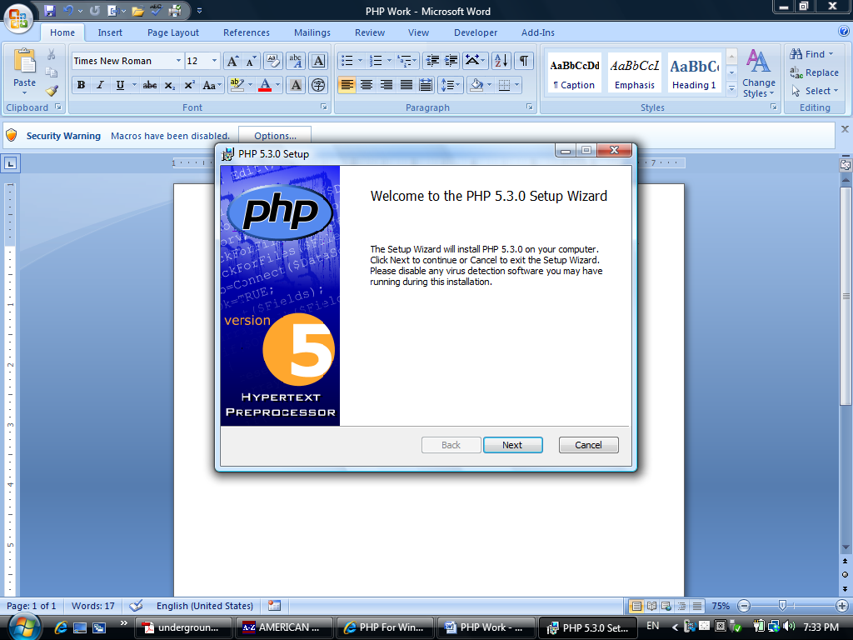

Accept the agreement.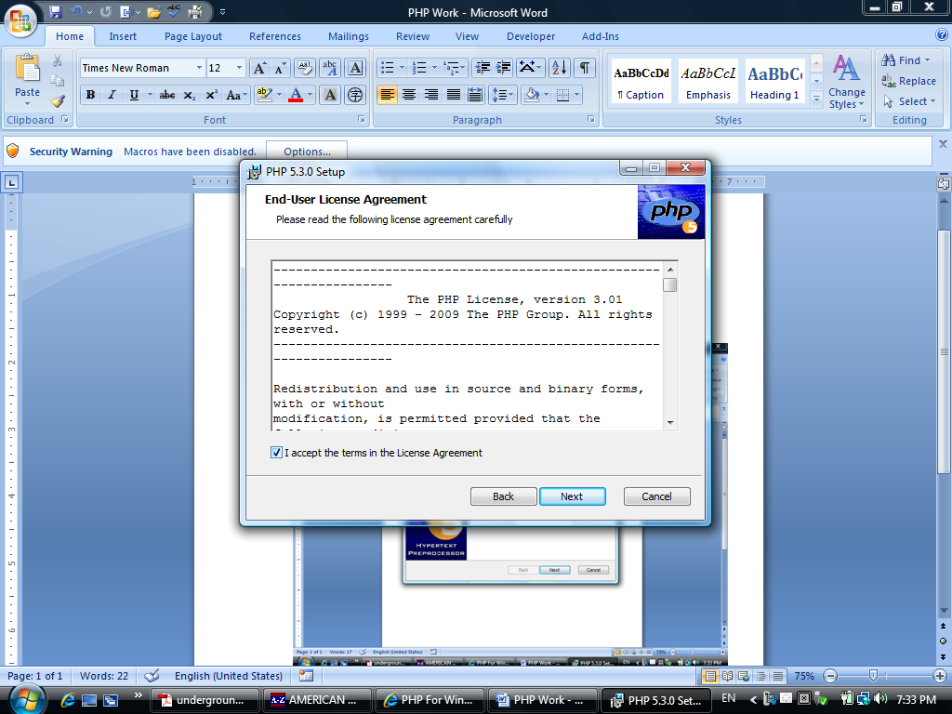

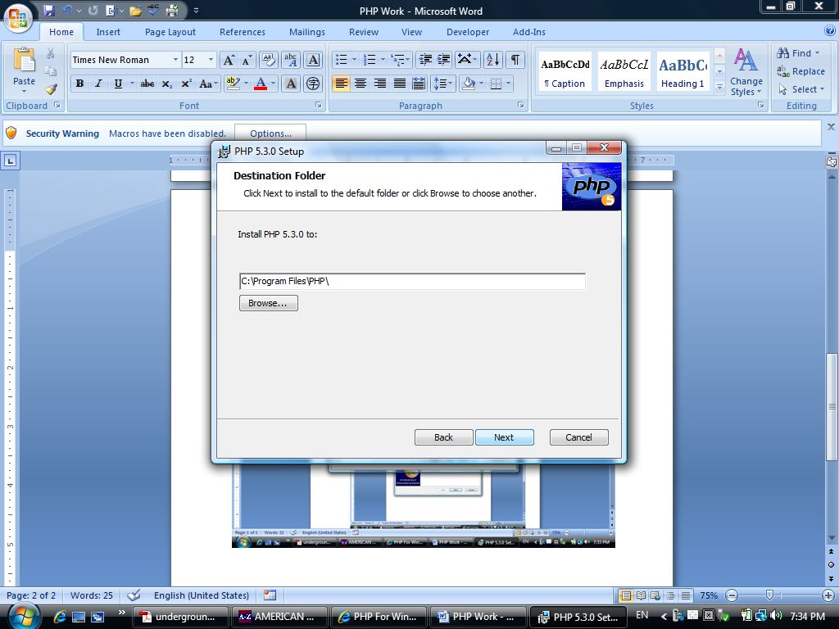

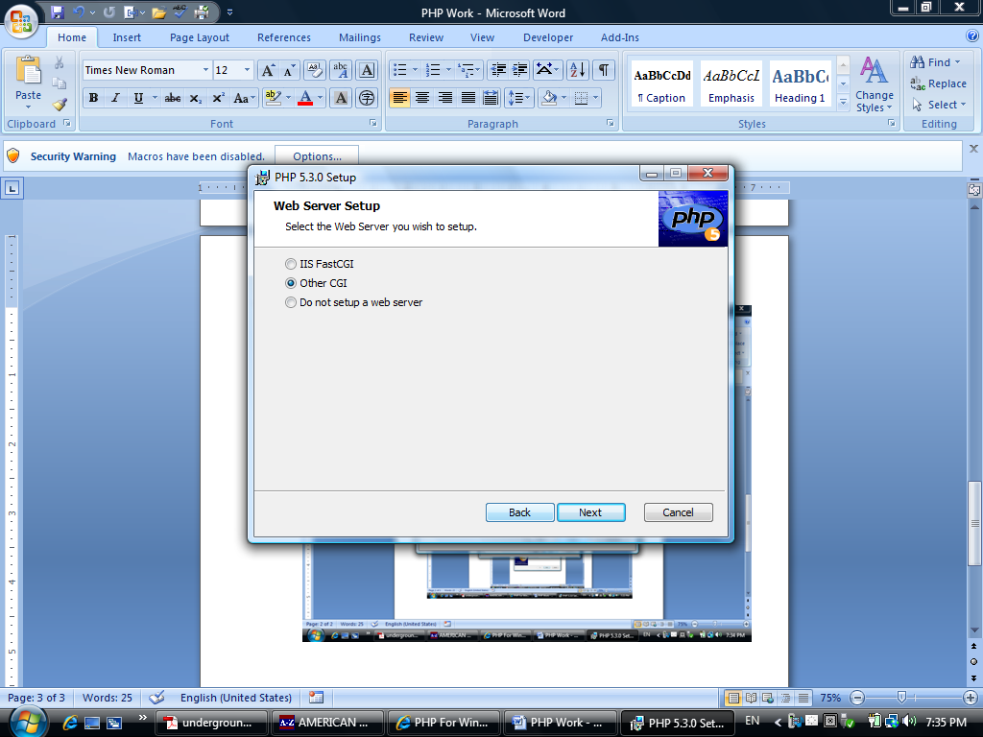

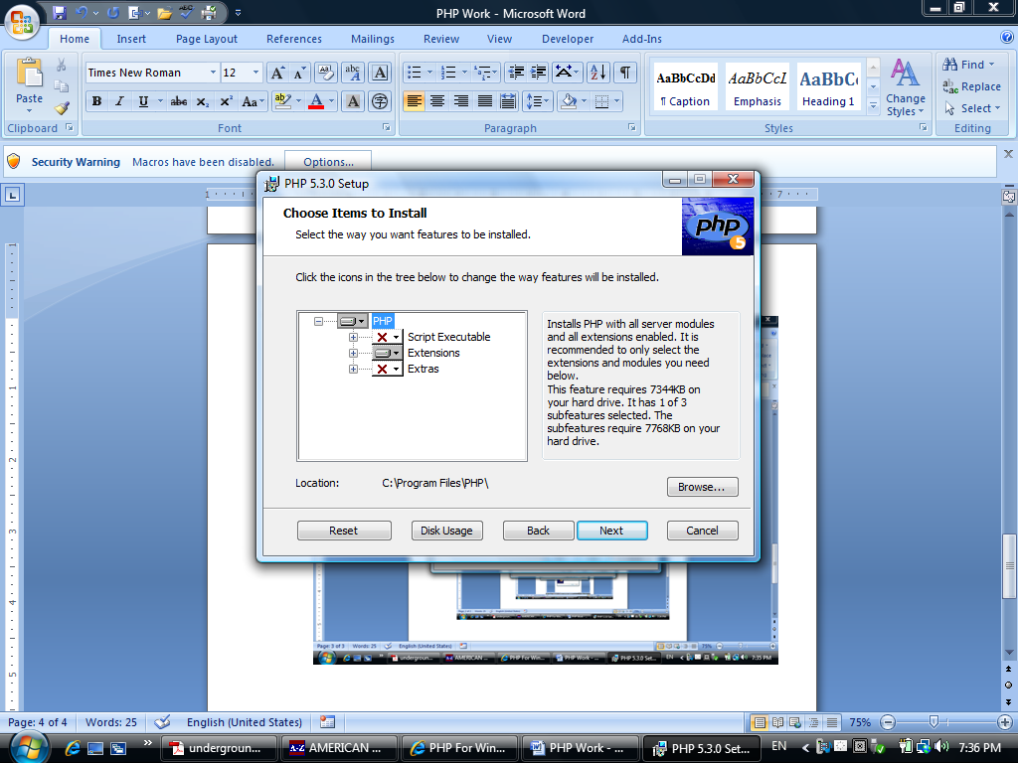
v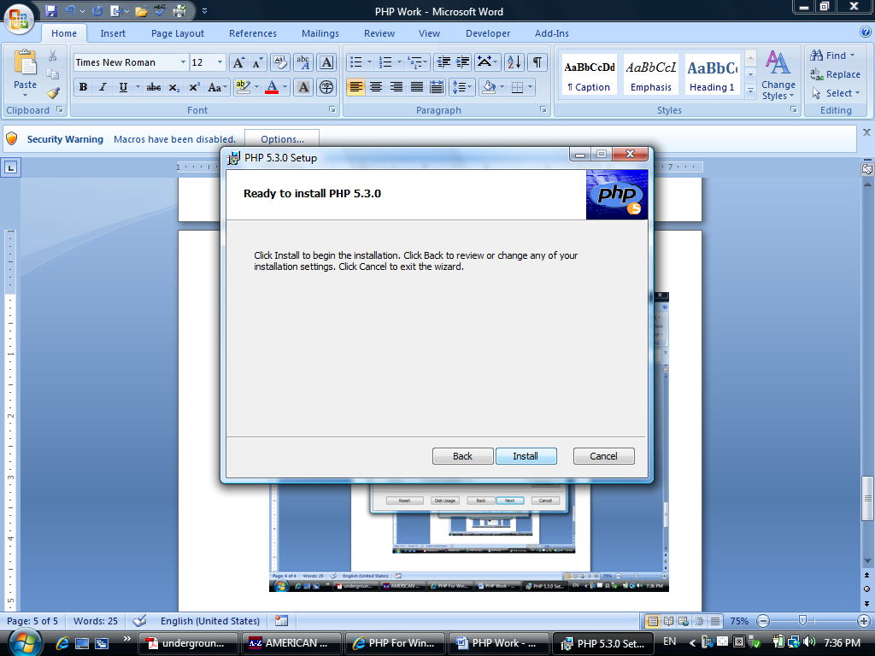

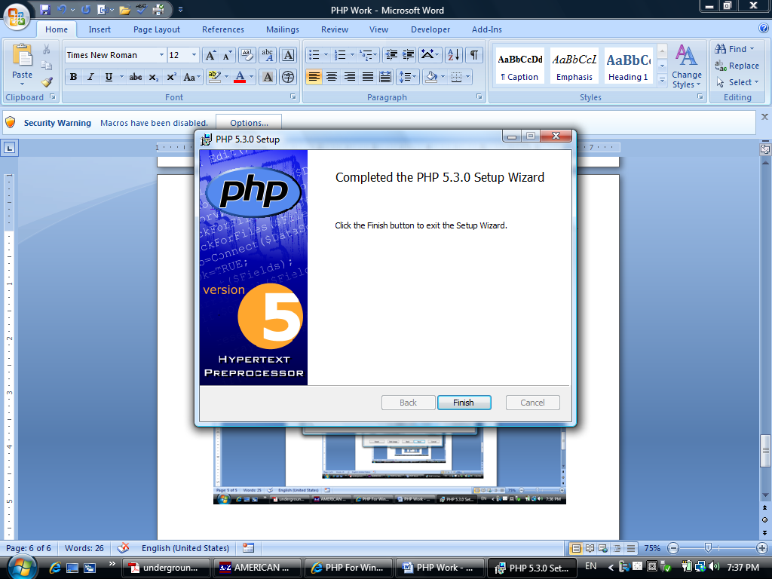

It seems to be a good idea to have Apache server before setting up PHP.

- Download Zend Server Community Edition. (Apache server is included.)
Run the downloaded file.

Installation not successful, Reason: no service pack installed.

To find the latest service pack:

http://support.microsoft.com/kb/935791/

Download Service Pack 2, released May 2009.

Automatic update has been turned off.

.

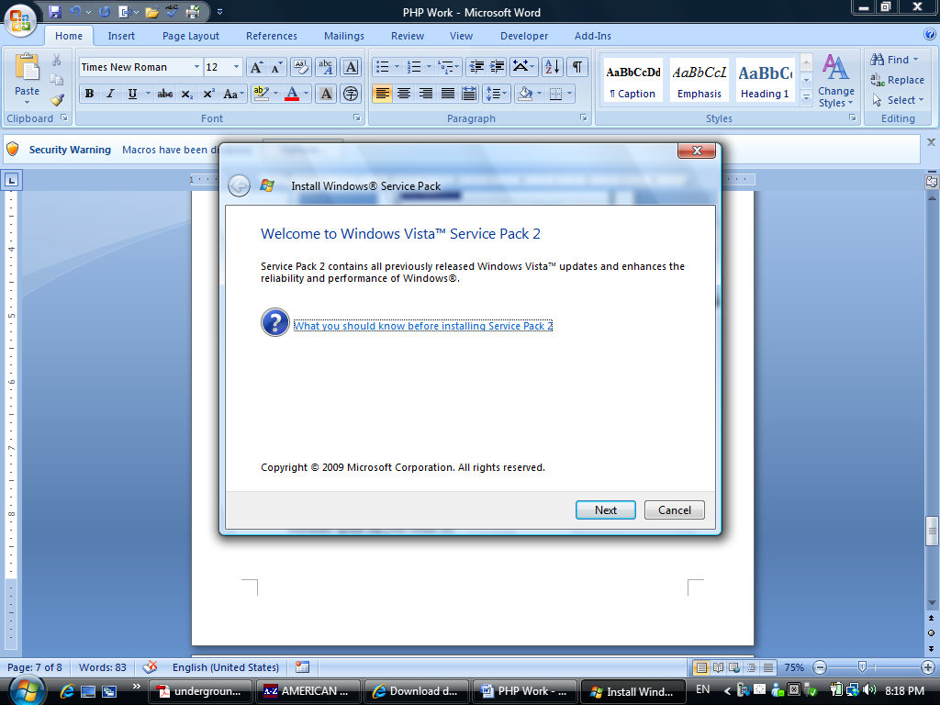
Need service pack 1 before installing service pack 2.

Use Windows Automatic Update to update all service packs

Windows Update completed. However, it did not include Service Pack 1 and Service Pack 2

Service Pack 1 is required before installing Service Pack 2.

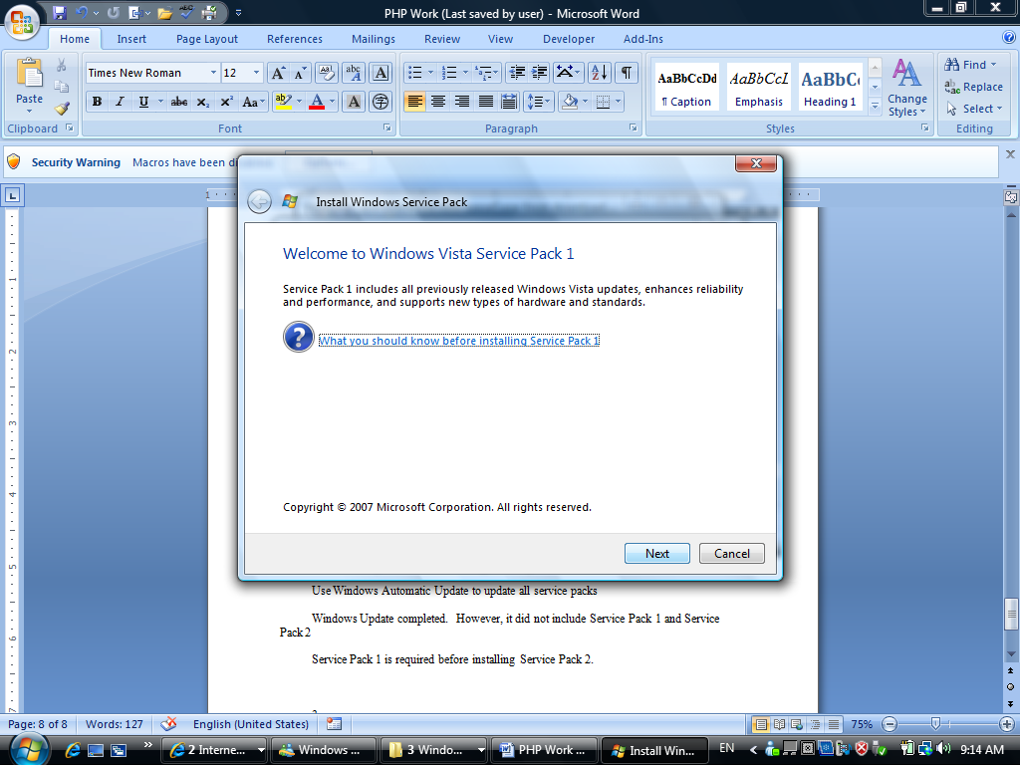
s
After installing service pack 1,

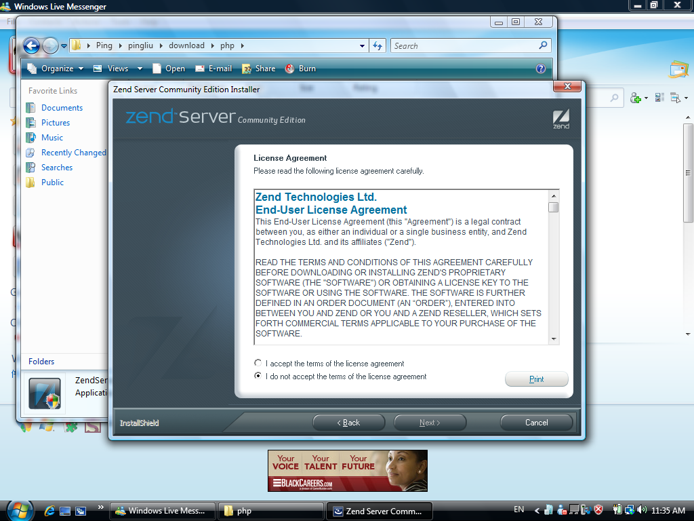

v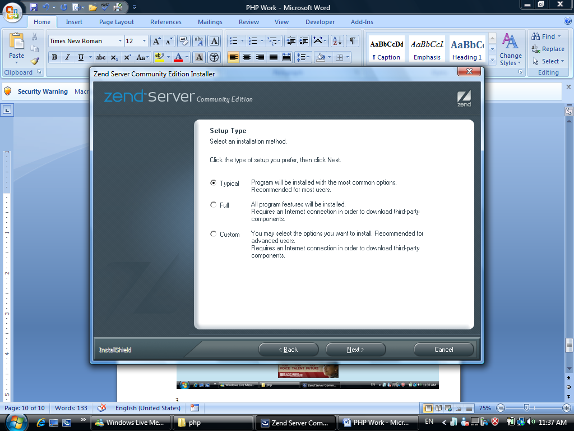

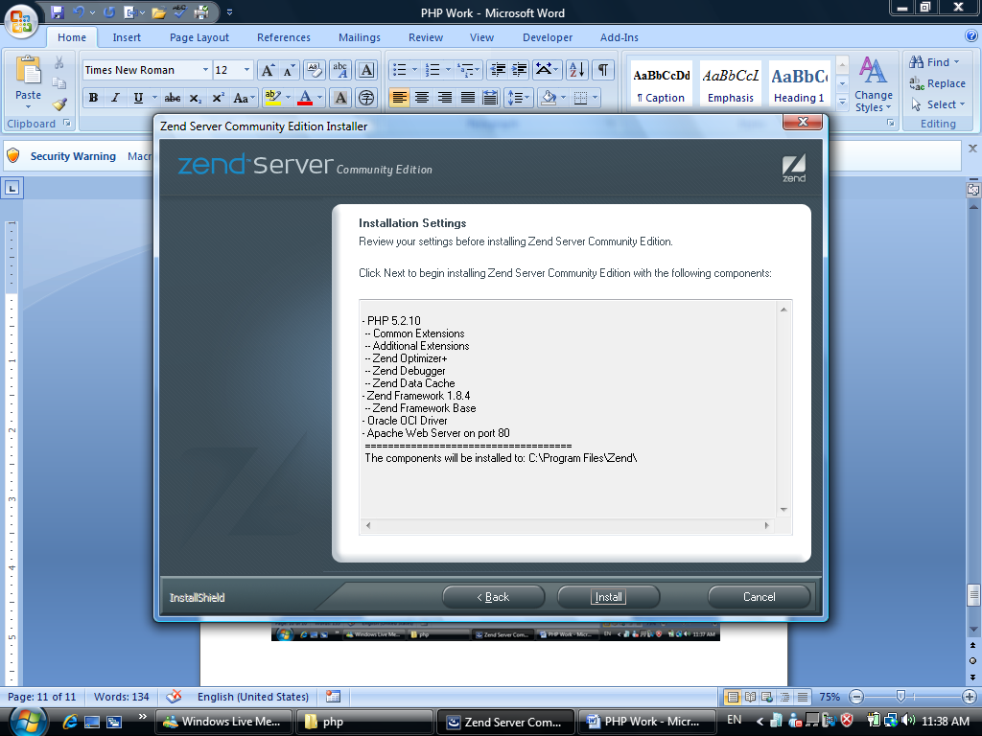

PHP 5.2.10
-- Common Extensions
-- Additional Extensions
-- Zend Optimizer+
-- Zend Debugger
-- Zend Data Cache
- Zend Framework 1.8.4
-- Zend Framework Base
- Oracle OCI Driver
- Apache Web Server on port 80
====================================
The components will be installed to: C:\Program Files\Zend\

Completed installation.

http://localhost/ZendServer/Login#1249233084707

The location of your default Zend Server document root depends on the operating system and the Web server you are using:
- On Microsoft Windows:
  - If Zend Server is running on Microsoft IIS - C:/inetpub/wwwroot
  - If Zend Server is running on Apache - C:/Program Files/Zend/Apache2.2/htdocs
  - If you changed the location of your Zend Server installation, your document root will be located at <Zend_Server_installation_directory>/Apache2.2/htdocs, where <Zend_Server_installation_directory> is the location of the directory in which your Zend Server is installed.

Zend server admin password: anniegina

In Windows, Zend Server Community Edition comes with Apache web server and PHP. There is no need to install those two separately.

Once the Zend Server is installed, the computer is ready to take PHP files.

For example,

http://localhost/php/hello.php

hello.php was placed in hotdoc directory.

C:\Program Files\Zend\Apache2\htdocs

The default port is: 80.

The Apache setup (configuration) file is at:

C:\Program Files\Zend\Apache2\conf\httpd.conf

Where above parameters are specified. It is a good idea to study the file to understand the web server configuration. The file can be edited using Notepad.

Big Trick in using Notepad or Wordpad:

While saving the file, save it as in “text document format.” Unicode document has caused problem for php to run.

Php tip:
//Comment only works within PHP

//the comment does not work in html. It will be recognized as html code not comment.

//Java script is case sensitive. document.getElementById is different from document.getElementByID.

Php Configuration file in Zend Server:

C:\Program Files\Zend\ZendServer\etc\php.ini

- Display-error directive can be modified directly in the above file.
- It can also be changed with Zend Server CE:

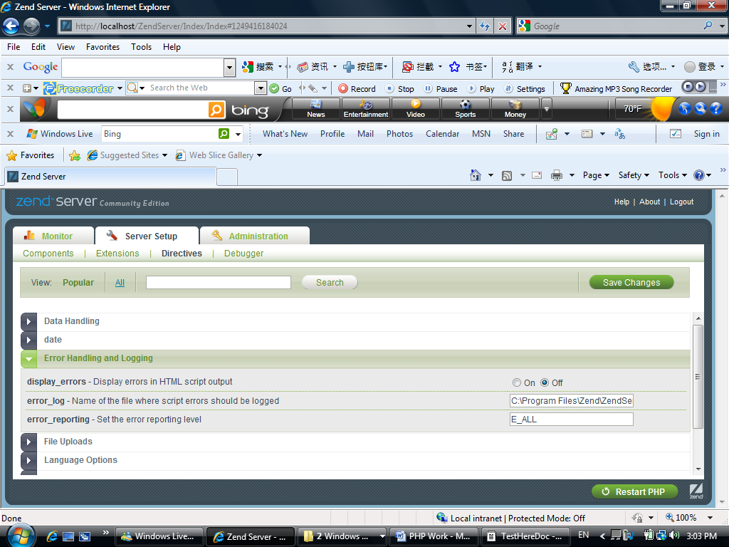

Under Directives—Error Handling and Logging.

Save changes.

Restart PHP.

