Record of PHP Work for Office Computer

OS: Windows XP Professional Version 2003, Service Pack 3

Database: Oracle 11g already installed.

8/3/09

Download Zend Server Community Edition (CE):

<http://www.zend.com/en/products/server-ce/downloads?hpb=server_CE_Download>

Run to install

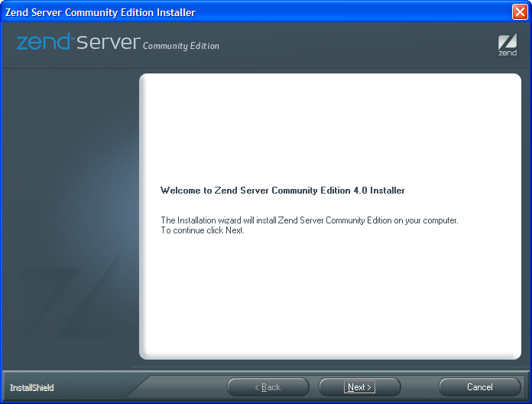

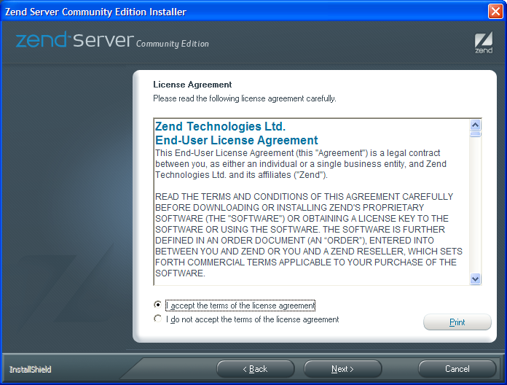

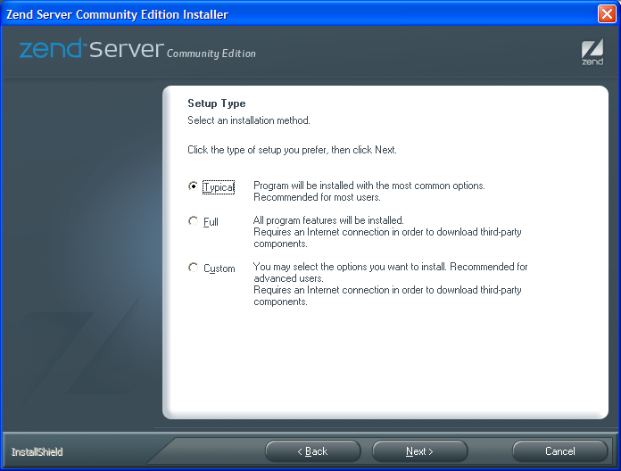

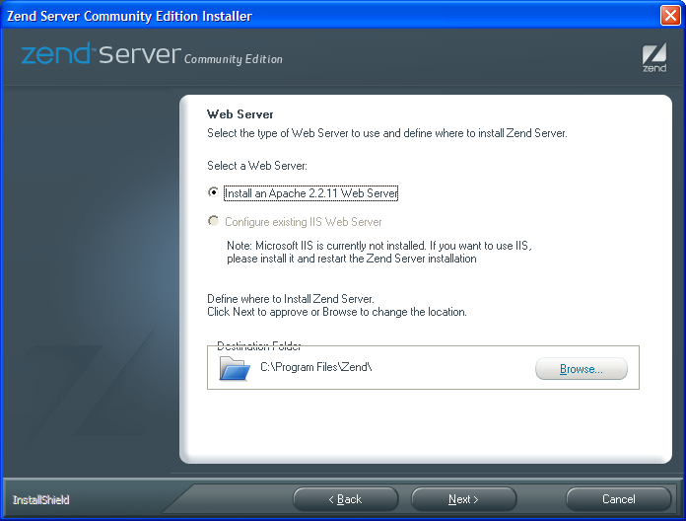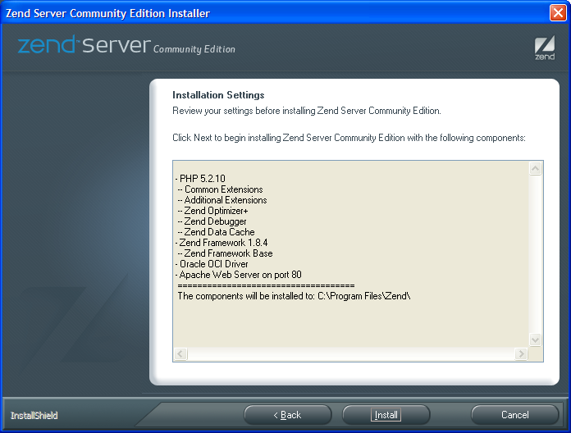

- PHP 5.2.10

-- Common Extensions

-- Additional Extensions

-- Zend Optimizer+

-- Zend Debugger

-- Zend Data Cache

- Zend Framework 1.8.4

-- Zend Framework Base

- Oracle OCI Driver

- Apache Web Server on port 80

====================================

The components will be installed to: C:\Program Files\Zend\

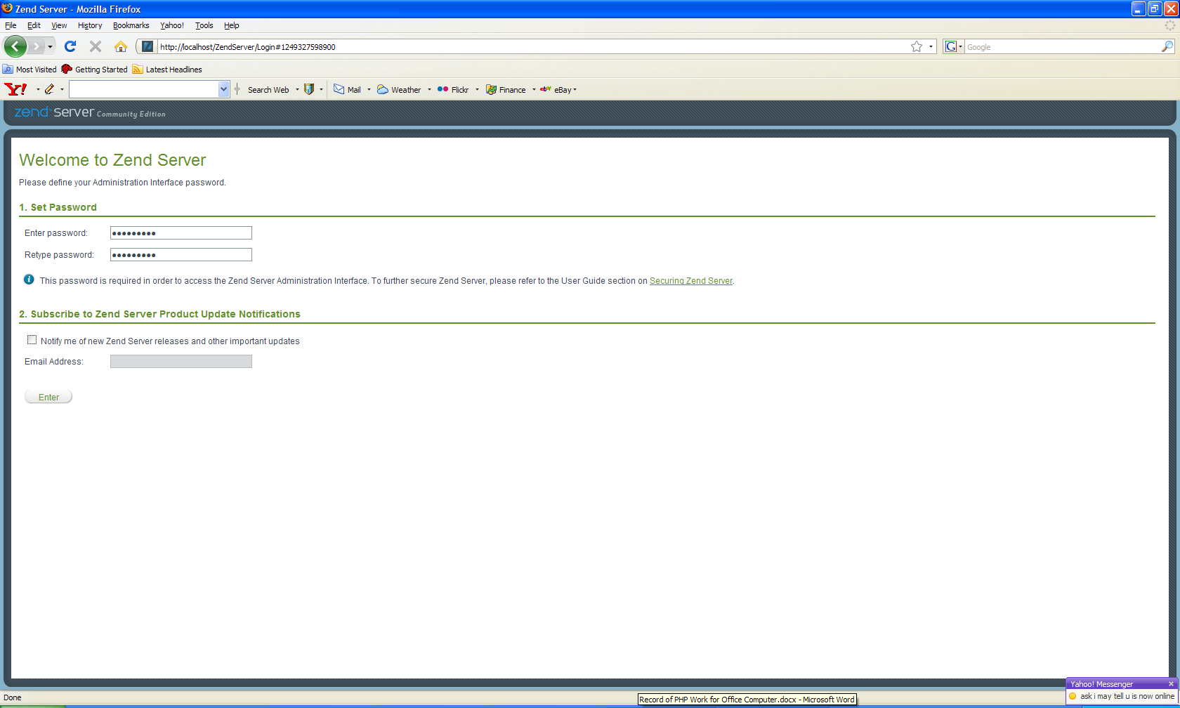

Password: pingliu (for the desktop computer in office)

Zend Server:

<http://localhost/ZendServer/Index/Index#1249327664029>

Apache HTTPD server: <http://localhost/>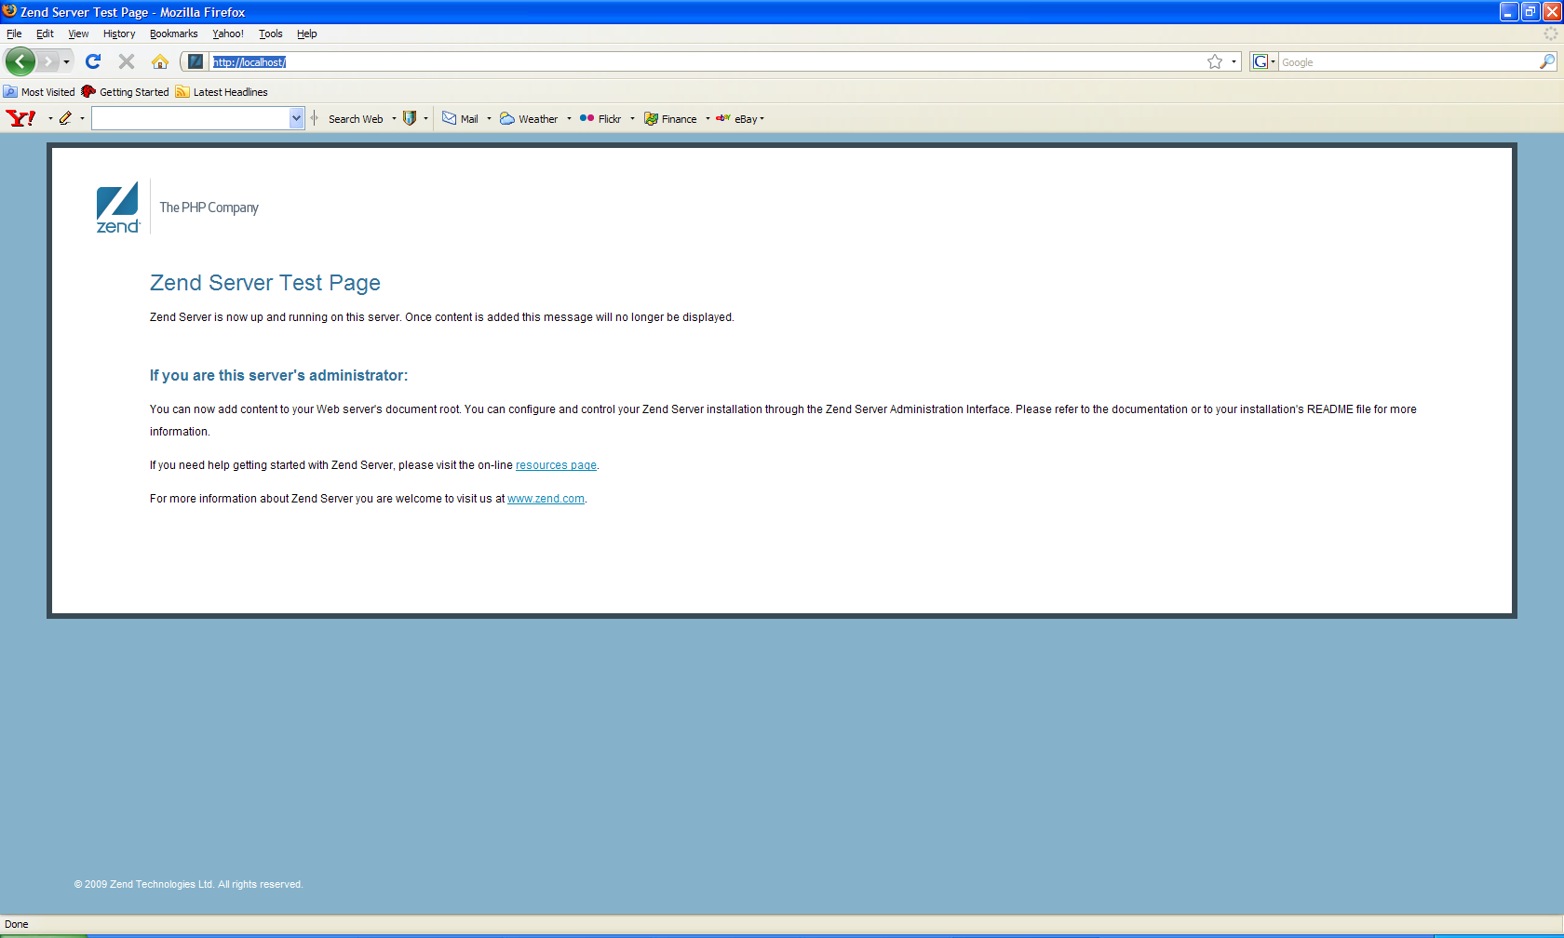

Virtual File Folder at Apache:

C:\Program Files\Zend\Apache2\htdocs

Create php folder: C:\Program Files\Zend\Apache2\htdocs\php

Created TestPHP.php file under the above directory, using Word Pad.

<http://localhost/php/TestPHP.php>

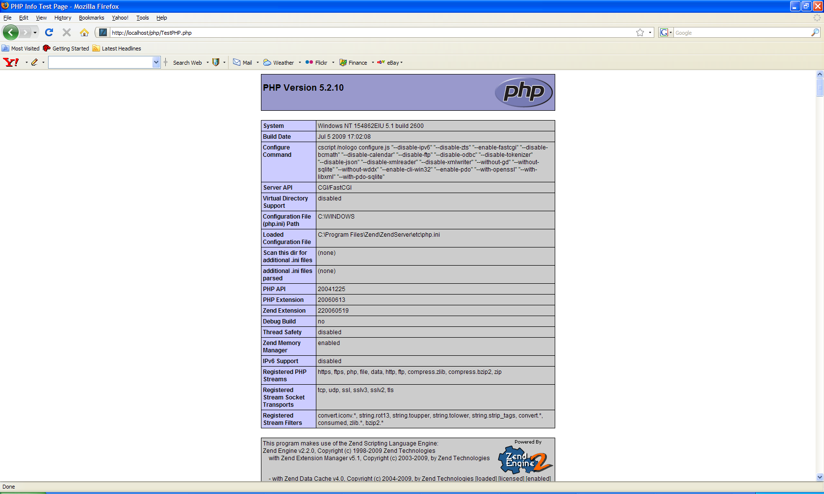

Login Oracle database:

Create a user php using

@C:\PingLiu\web\php\sql\user.sql

OCI8 in Zend Server should be turned on:

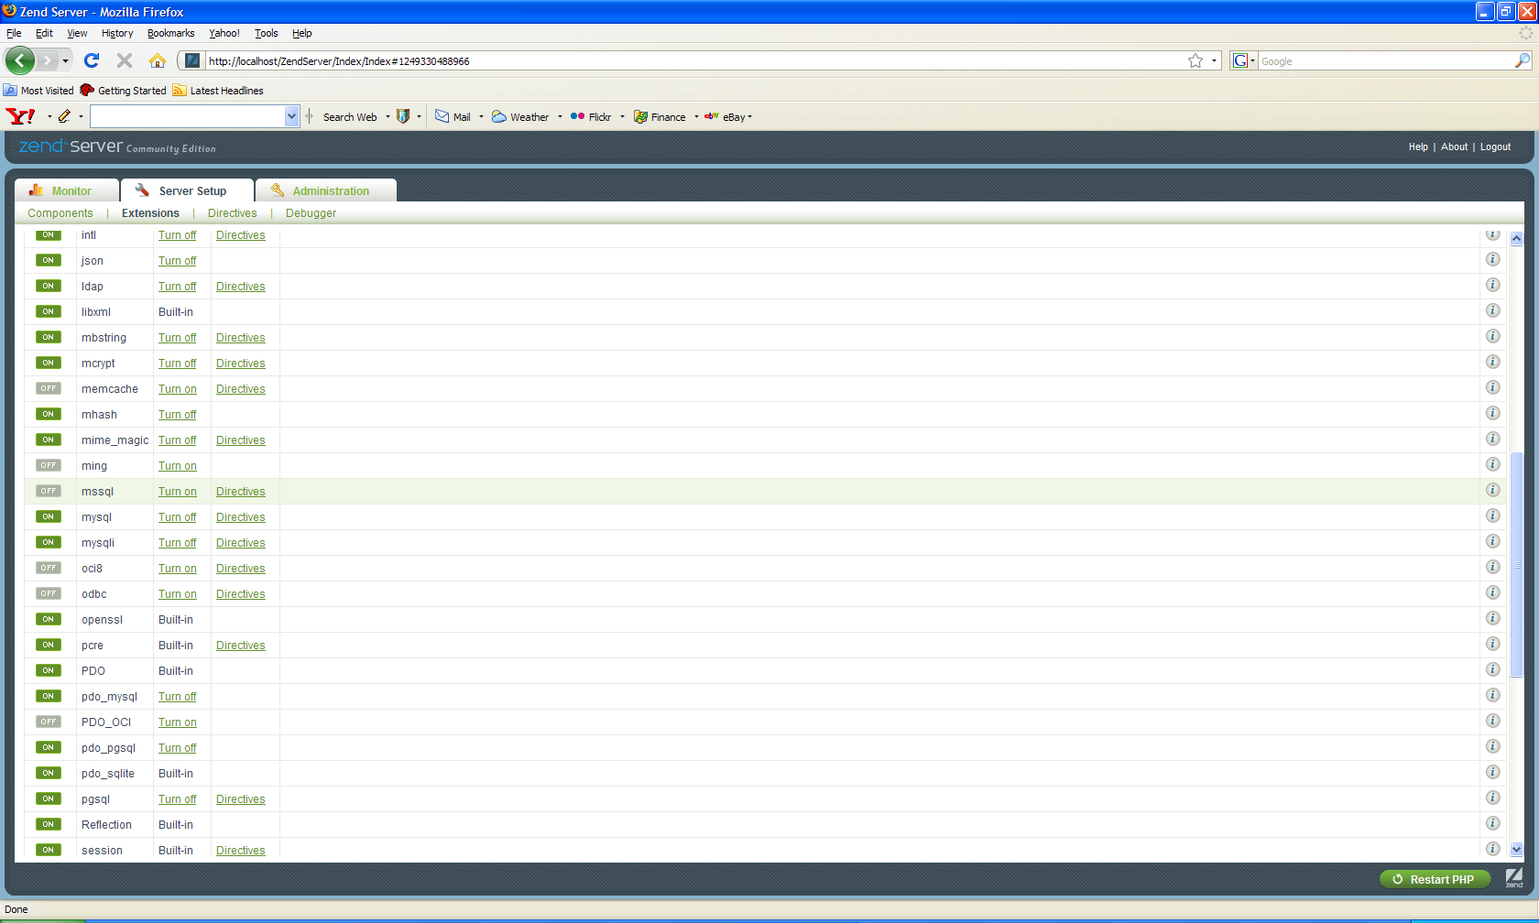

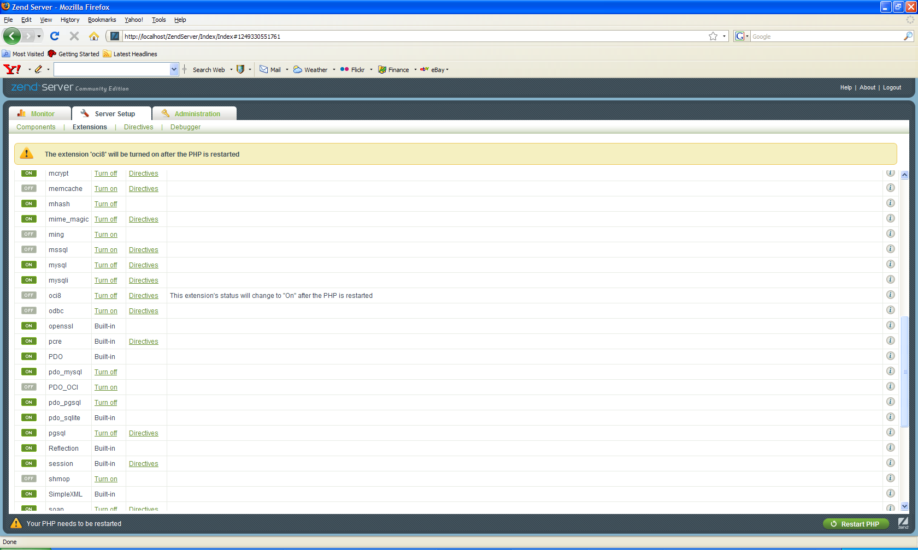

Restart PHP (at the lower right corner).

Still cannot make connection to Oracle.

Download:

**Oracle Database Instant Client**

From <http://www.oracle.com/technology/tech/oci/instantclient/index.html>

In C:\Download\php

Unzip the file to

C:\instantclient\instantclient_11_1

Set PATH to the above folder.

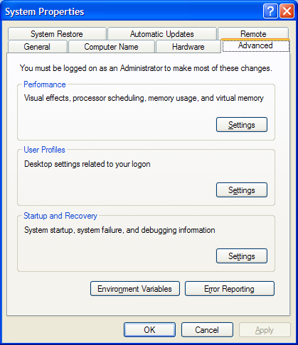

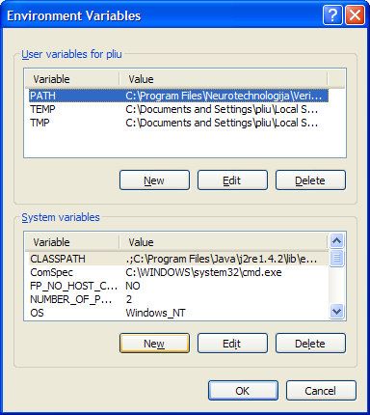

In Both User Variable and System Variable

Oracle Listener is on:

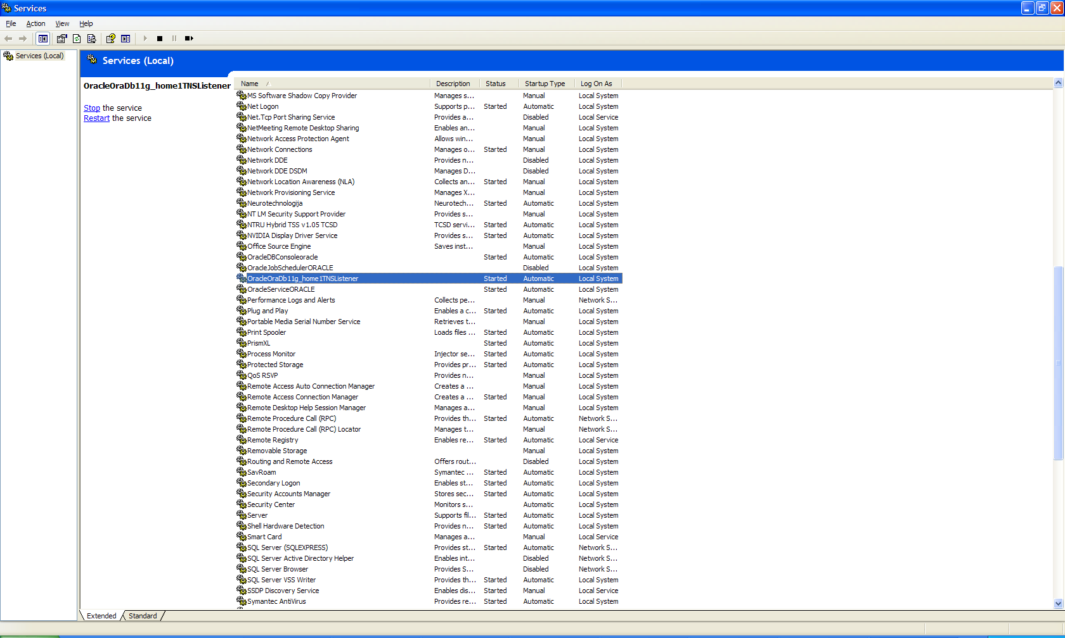

TNSPING to make sure the listener is on and “oracle” database is reachable.

C:\>tnsping oracle

TNS Ping Utility for 32-bit Windows: Version 11.1.0.6.0 - Production on 05-AUG-2009 08:47:14

Copyright (c) 1997, 2007, Oracle. All rights reserved.

Used parameter files:

C:\app\pliu\product\11.1.0\db_1\network\admin\sqlnet.ora

Used TNSNAMES adapter to resolve the alias

Attempting to contact (DESCRIPTION = (ADDRESS_LIST = (ADDRESS = (PROTOCOL = TCP)(HOST = 154862EIU.eiuad.eiu.edu)(PORT =

1521))) (CONNECT_DATA = (SERVER = DEDICATED) (SERVICE_NAME = oracle) (INSTANCE_NAME = oracle)))

OK (10 msec)

The database oracle can be connected on:

C:\>sqlplus php/php@oracle

SQL*Plus: Release 11.1.0.6.0 - Production on Wed Aug 5 09:13:42 2009

Copyright (c) 1982, 2007, Oracle. All rights reserved.

Connected to:

Oracle Database 11g Enterprise Edition Release 11.1.0.6.0 - Production

With the Partitioning, OLAP, Data Mining and Real Application Testing options

SQL>

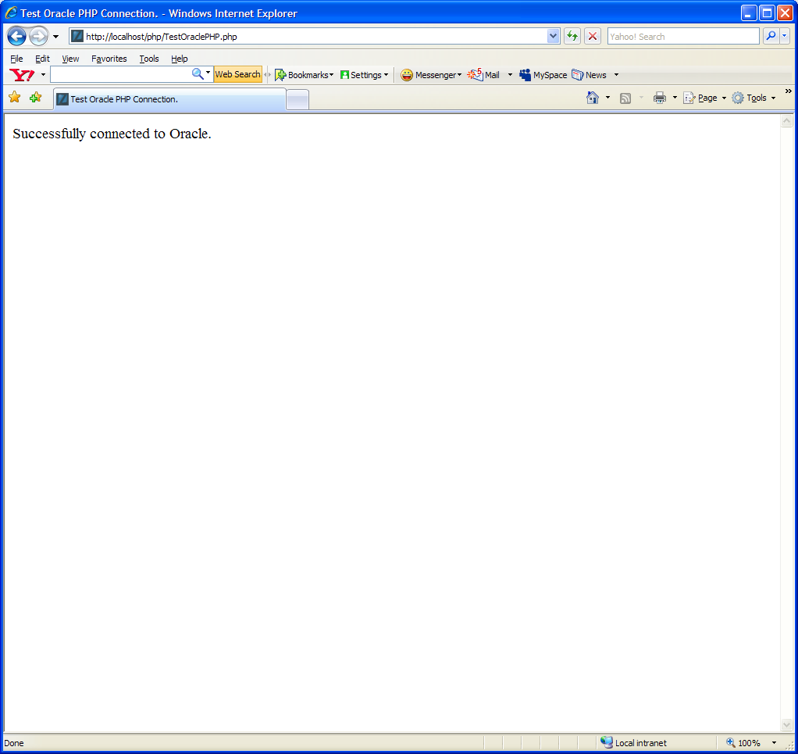

Trouble shooting notes:

The following code segment caused problem on connection:

****

$db="oracle";

if ($c = OCILogon("php","php",$db))

…

*****

**Warning**: ocilogon() [[function.ocilogon](http://localhost/php/function.ocilogon)]: ORA-12154: TNS:could not resolve the connect identifier specified in **C:\Program Files\Zend\Apache2\htdocs\php\TestOraclePHP.php** on line **25**  
  
**Notice**: Use of undefined constant text - assumed 'text' in **C:\Program Files\Zend\Apache2\htdocs\php\TestOraclePHP.php** on line **39**  
  
**Notice**: Undefined index: text in **C:\Program Files\Zend\Apache2\htdocs\php\TestOraclePHP.php** on line **39**  
Oracle Connect Error.

The problem get resolved using:

$db="localhost/oracle";

if ($c = OCILogon("php","php",$db))

…

The following will facilitate troubleshooting as well:

C:\>lsnrctl status

LSNRCTL for 32-bit Windows: Version 11.1.0.6.0 - Production on 06-AUG-2009 13:53:41

Copyright (c) 1991, 2007, Oracle. All rights reserved.

Connecting to (DESCRIPTION=(ADDRESS=(PROTOCOL=IPC)(KEY=EXTPROC1521)))

STATUS of the LISTENER

------------------------

Alias LISTENER

Version TNSLSNR for 32-bit Windows: Version 11.1.0.6.0 - Production

Start Date 05-AUG-2009 08:16:09

Uptime 1 days 5 hr. 37 min. 34 sec

Trace Level off

Security ON: Local OS Authentication

SNMP OFF

Listener Parameter File C:\app\pliu\product\11.1.0\db_1\network\admin\listener.ora

Listener Log File c:\app\pliu\diag\tnslsnr\154862EIU\listener\alert\log.xml

Listening Endpoints Summary...

(DESCRIPTION=(ADDRESS=(PROTOCOL=ipc)(PIPENAME=\\.\pipe\EXTPROC1521ipc)))

(DESCRIPTION=(ADDRESS=(PROTOCOL=tcp)(HOST=154862EIU.eiuad.eiu.edu)(PORT=1521)))

Services Summary...

Service "oracle" has 1 instance(s).

Instance "oracle", status READY, has 1 handler(s) for this service...

Service "oracle.154862EIU.eiuad.eiu.edu" has 1 instance(s).

Instance "oracle", status UNKNOWN, has 1 handler(s) for this service...

Service "oracleXDB" has 1 instance(s).

Instance "oracle", status READY, has 1 handler(s) for this service...

Service "oracle_XPT" has 1 instance(s).

Instance "oracle", status READY, has 1 handler(s) for this service...

The command completed successfully

Using Control Panel, we will be able to the following services running:

