- Oracle 10g Express Edition,
- Zend (php) Server Community Edition,
- Notepad PP
- Oracle Connection Test
----
Oracle 10g Express Edition Installation:

SYSTEM password: pingliu

Destination Folder: C:\oraclexe\
Port for 'Oracle Database Listener': 1521
Port for 'Oracle Services for Microsoft Transaction Server': 2030
Port for HTTP Listener: 8080
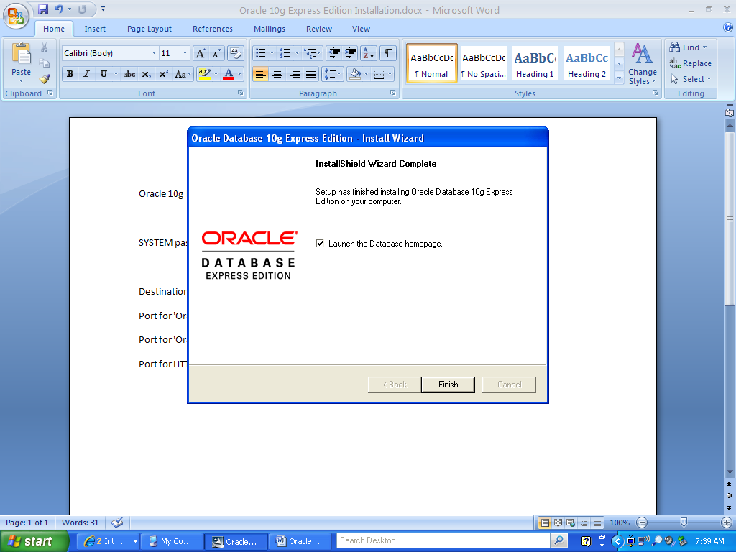

Oracle 10g Express Homepage:
http://localhost:8080/apex/f?p=4550:11:2673215407902047::NO:::
127.0.0.1 did not work.
Download and Install Zend Server Community Edition:
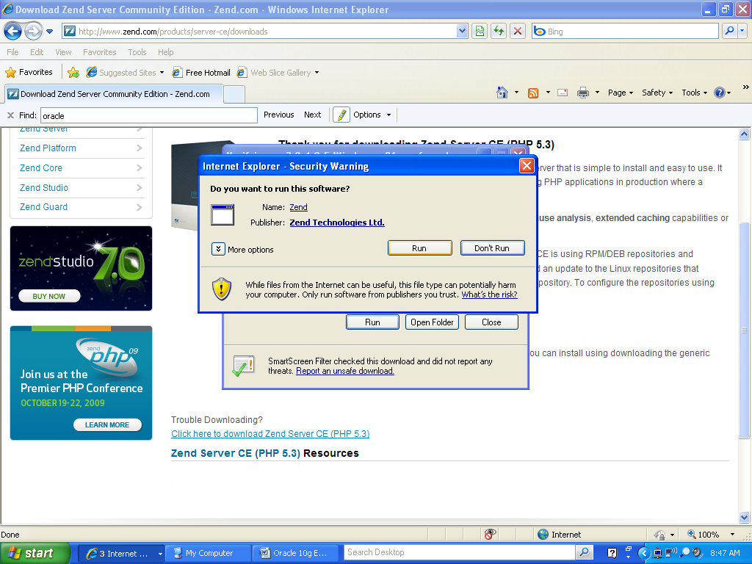

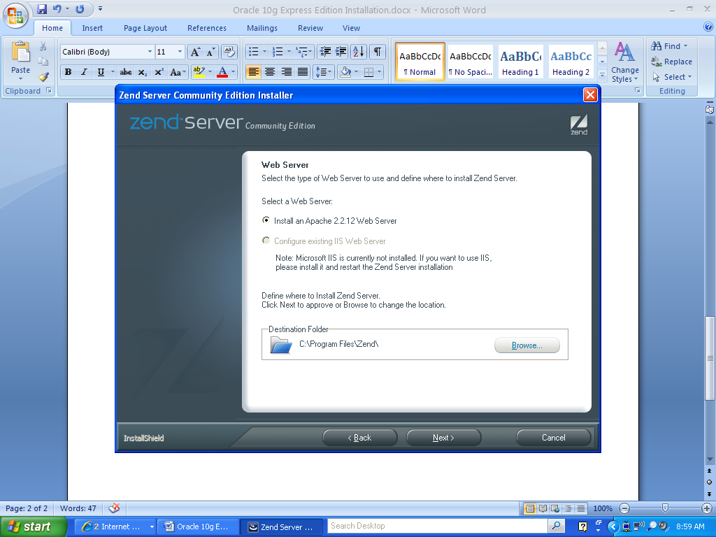
- PHP 5.3.0
-- Common Extensions
-- Additional Extensions
-- Zend Optimizer+
-- Zend Debugger
-- Zend Data Cache
- Zend Framework 1.9.0
-- Zend Framework Base
- Oracle OCI Driver
- Apache Web Server on port 80
====================================
The components will be installed to: C:\Program Files\Zend\

Zend server access: http://localhost/ZendServer/Index/Index#1255616074919

Administrator password: pingliu
Notepad ++
The installer version format does not install.
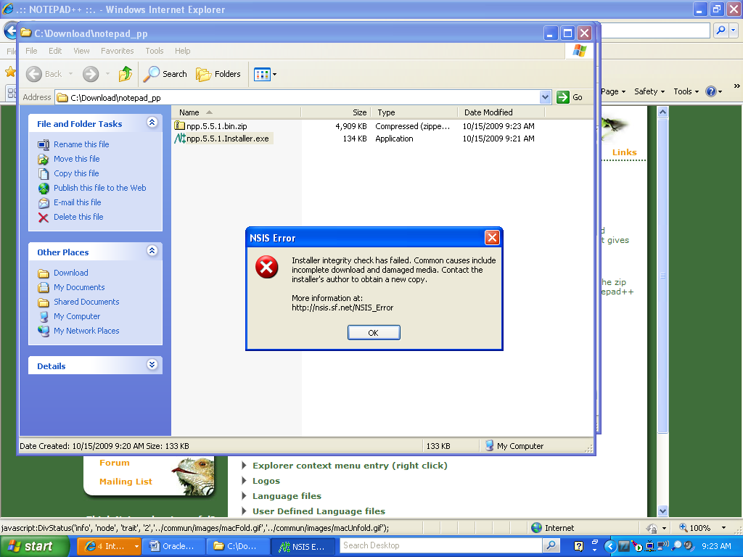

Use Zip format:
Unzip the file into: C:\Download\notepad_pp\npp.5.5.1.bin\

Use exe file to run notepad ++:
C:\Download\notepad_pp\npp.5.5.1.bin\ansi\notepad++.exe
Run SQL Plus to create user: (p 44 textbook)
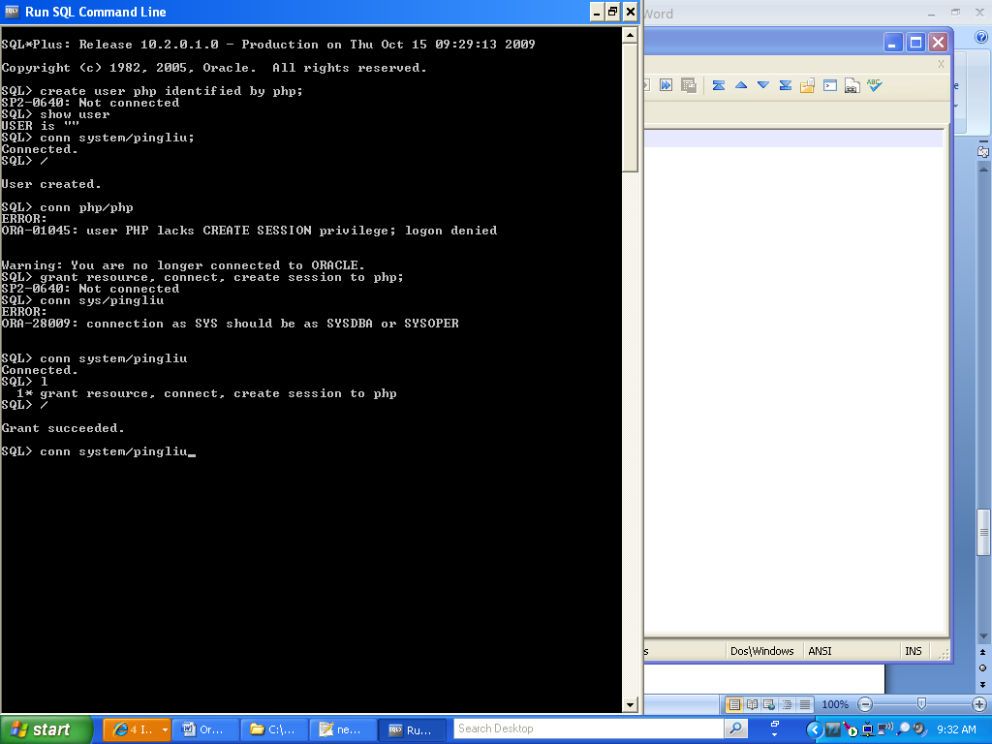-----
Write a php file and save it in:
C:\Program Files\Zend\Apache2\htdocs\php
http://localhost/php/OracleStandardConnection.php

“if ($c=oci_connect("php", "php","xe"))”

Error Message:
ORA-12154: TNS:could not resolve the connect identifier specified
In SQL Plus: conn php/php@xe, works

The following statement resolved the problem:
if ($c=oci_connect("php", "php","localhost/xe"))

